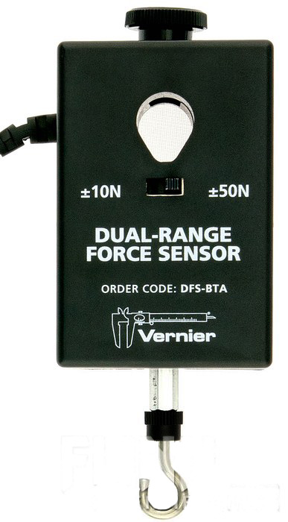
INSTRUCTIONS FOR CALIBRATING THE
DUAL RANGE FORCE SENSOR
 Please do not remove this sheet from the table.
 Follow these instructions only if you open a Logger Pro file which involves
measuring forces using a Dual Range Force Sensor.
 You need to follow this calibration procedure before you start the experiment.

Follow the instructions below to calibrate the Dual Range Force Sensor (FS).

Open the Logger Pro file that you will be working with. Remember, the calibration needs to be done only if the file uses a Dual Range Force Sensor.

Make sure a Dual Range FS is connected to CH 1 (or CH 2) of the LabQuest interface box.

On the Logger Pro main window, click on the LabQuest Set Up Sensors icon. See Figure 1.

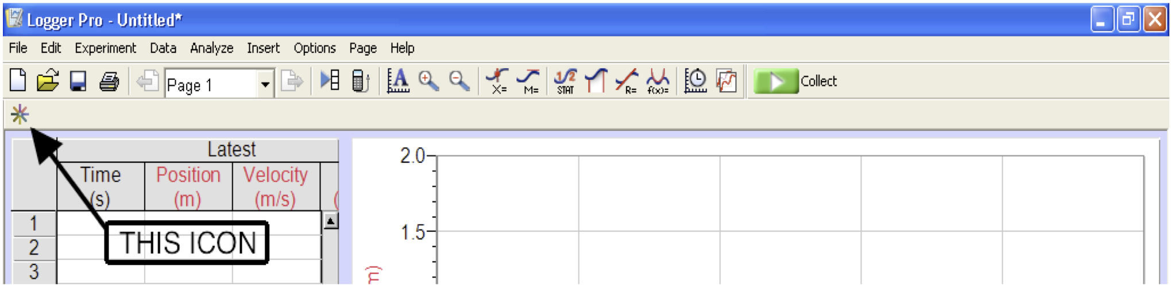
Figure 1

In the window that pops open you should be able to see the icon of the Dual Range FS on CH 1 (or CH 2). Click on the black triangle of that icon. A menu pops up. See Figure 2.
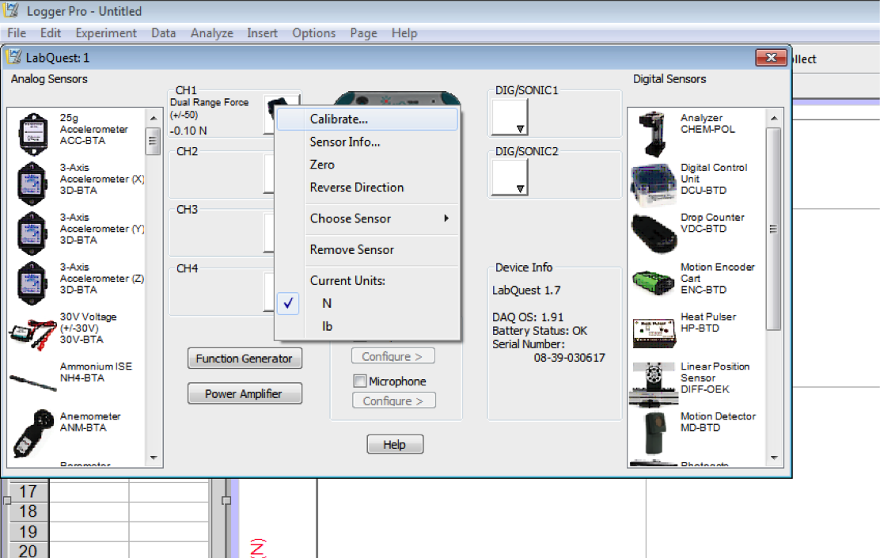
Figure 2

Remove all strings and weights from the hook of the Dual Range FS attached to CH 1 (or CH 2) and hold it vertically. There must be nothing suspended from its hook: no masses, no pulley, nothing.

Click on Zero.

You are done with calibrating the Dual Range Force Sensor. You may now return to your experiment.

