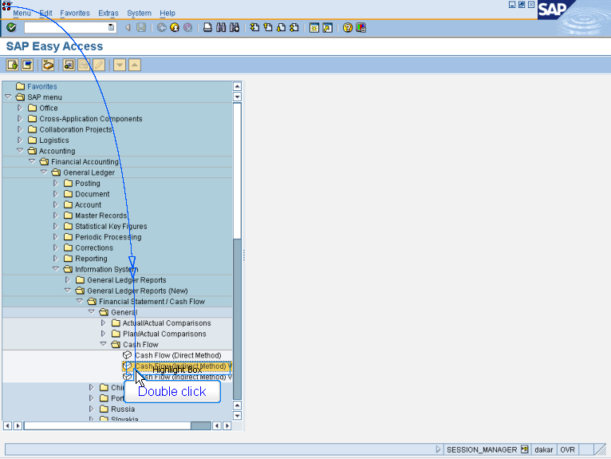

- Accounting > Financial Accounting
> General Ledger > Information System
> General Ledger Reports (New)
> Financial Statement/Cash Flow
> General > Cash Flow
- Double Click Cash Flow (Indirect Method) Variant 1

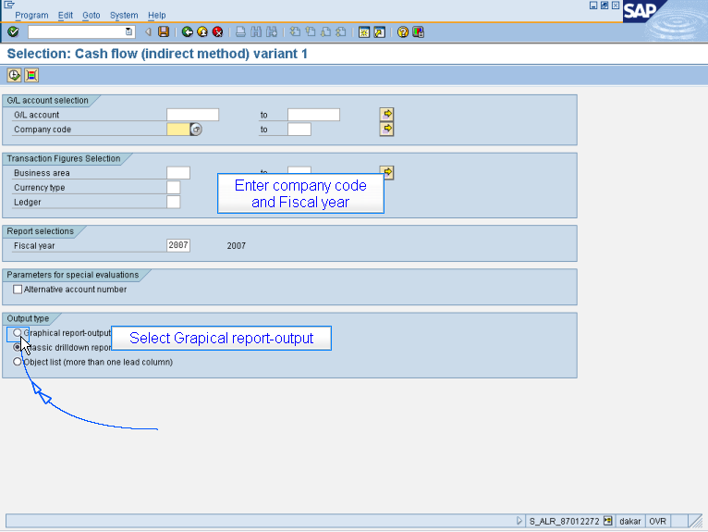

Enter company code
and Fiscal year
Select Grapical report-output

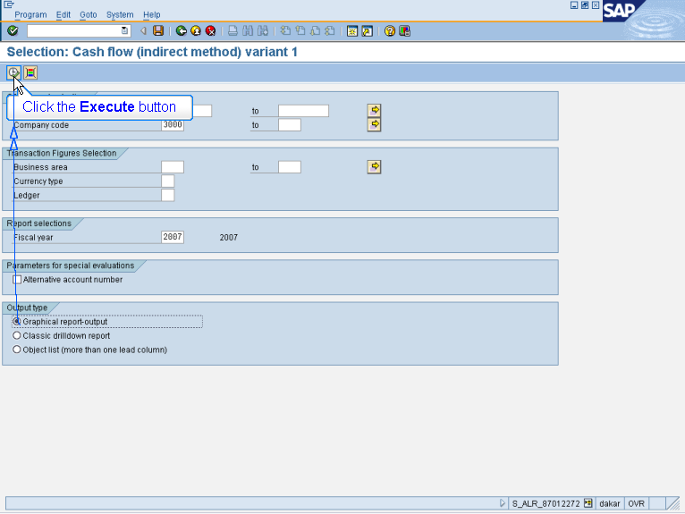

Click the Execute button

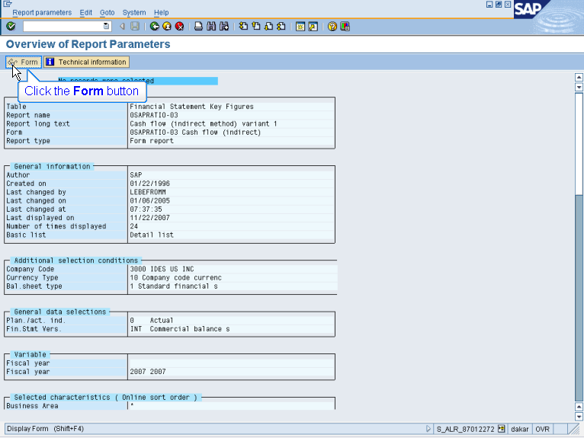

Click the Form button

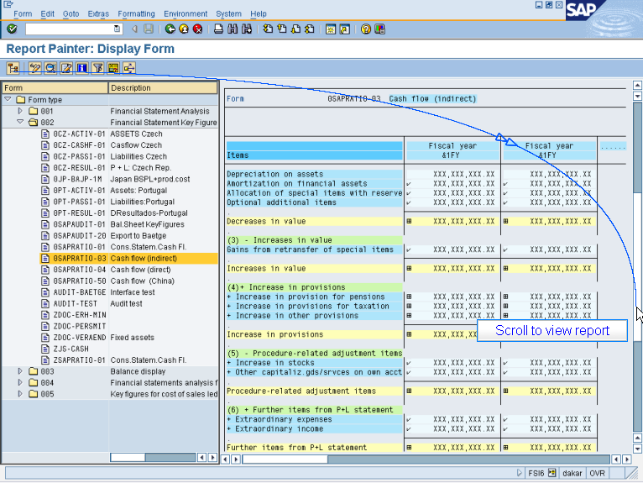

Scroll to view report

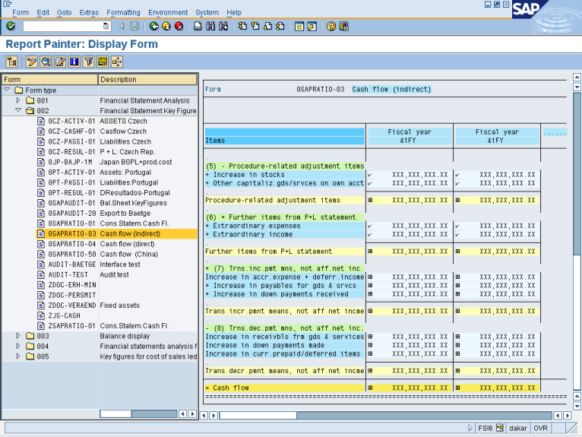

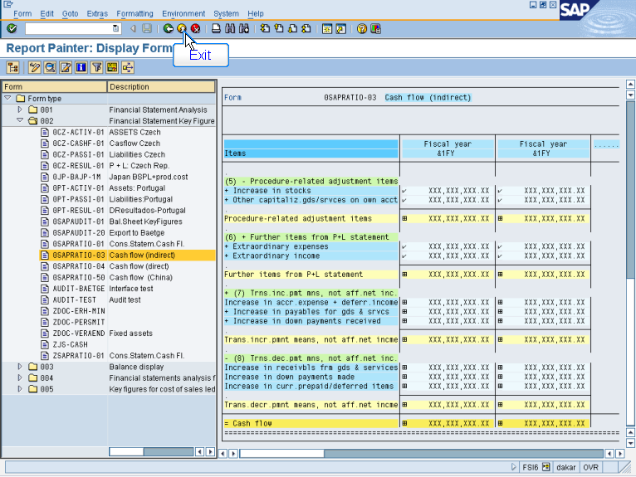

Exit

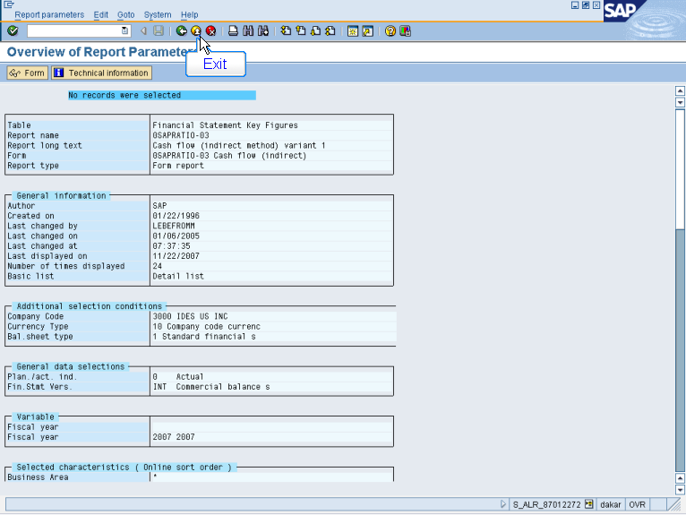

Exit

