How to Change Fiscal Periods

Slide 16
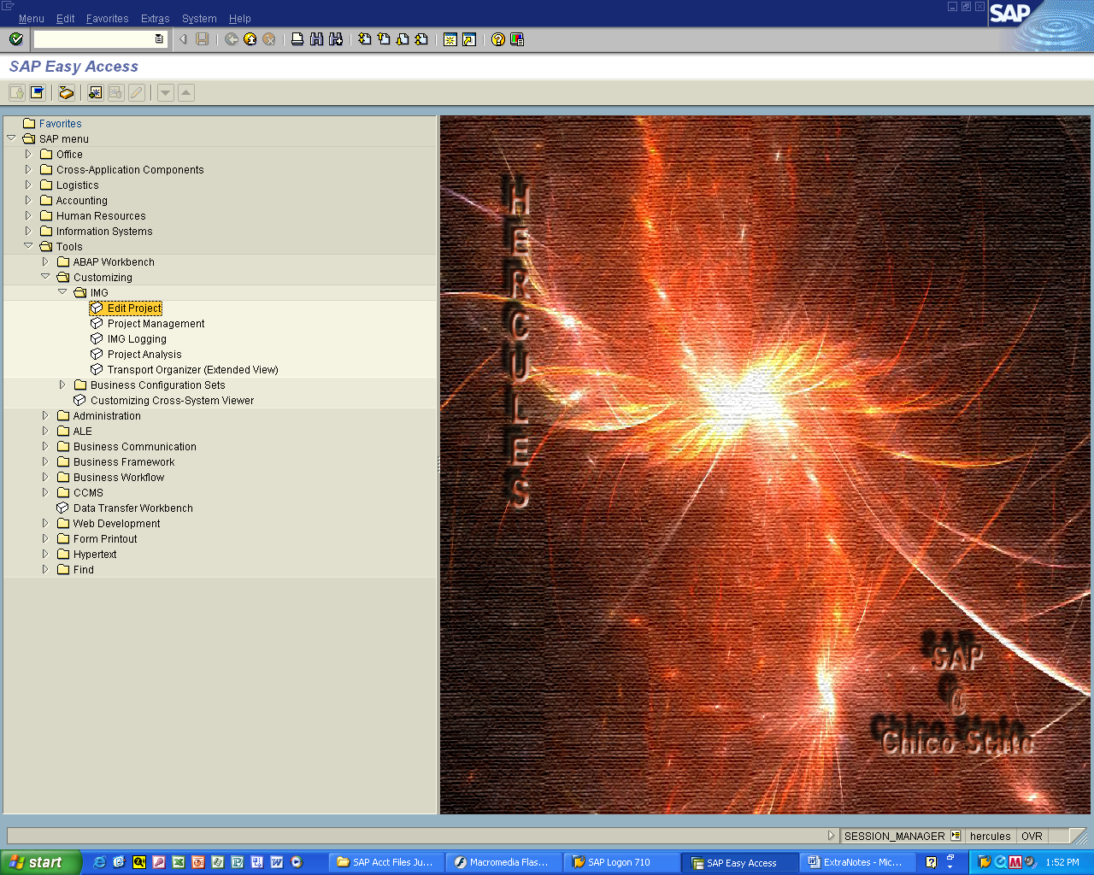

Tools > Customizing > IMG

Double click EXECUTE OR EDIT Project
Slide 17
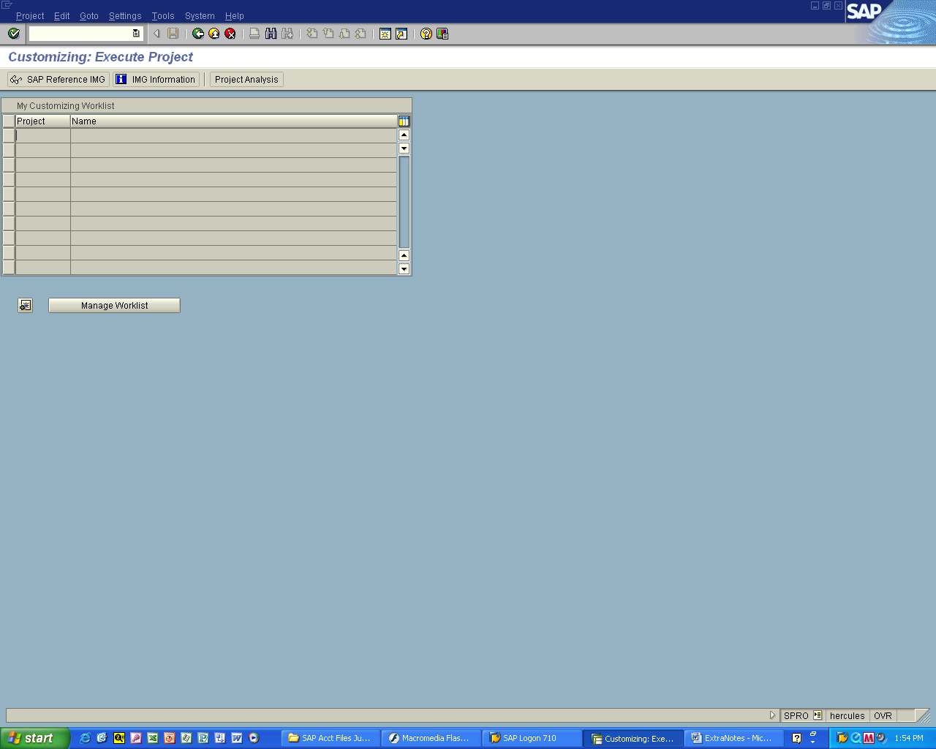

Click SAP Reference IMG
Slide 18
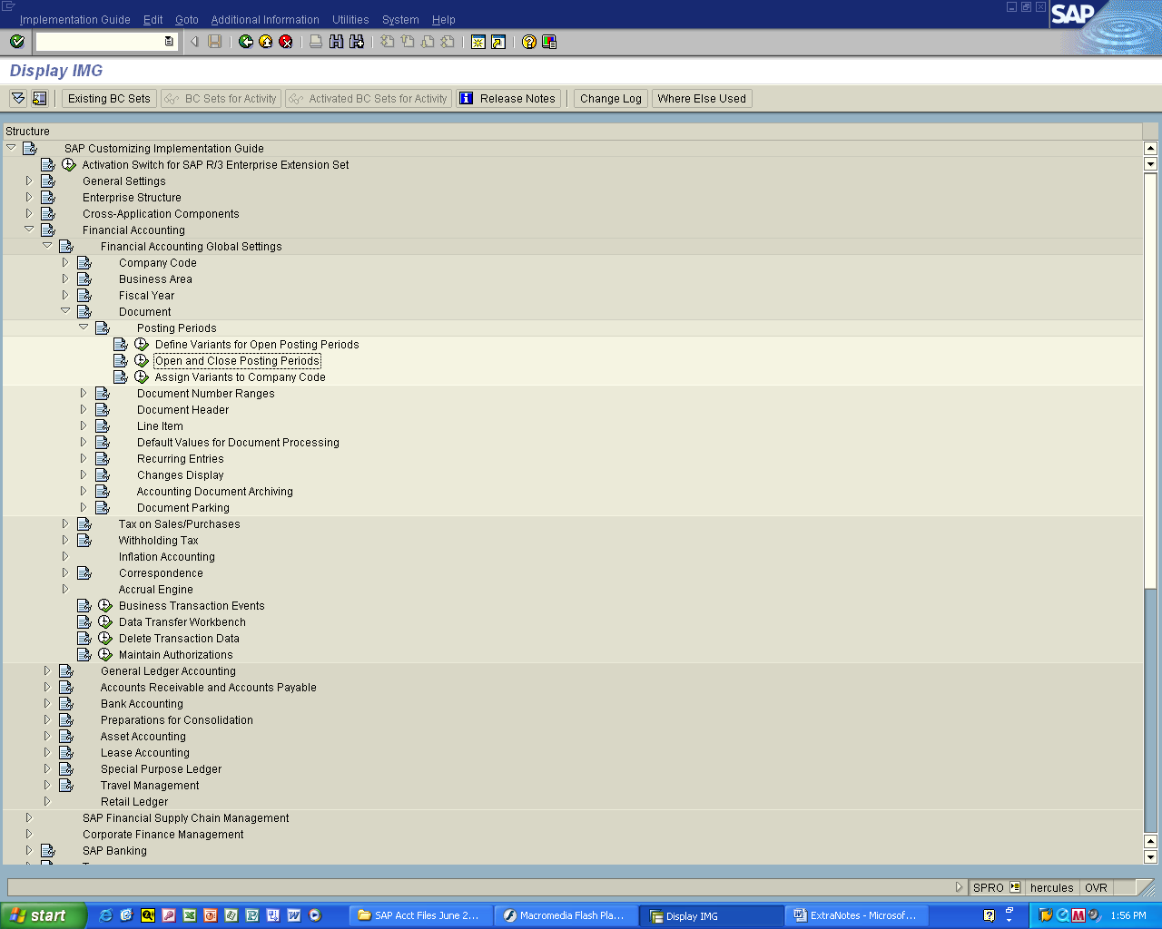

Financial Accounting > Financial Accounting Global Settings
- Document > Posting Periods

Click on Clock to Execute the
Open and Closing Periods option
Slide 19
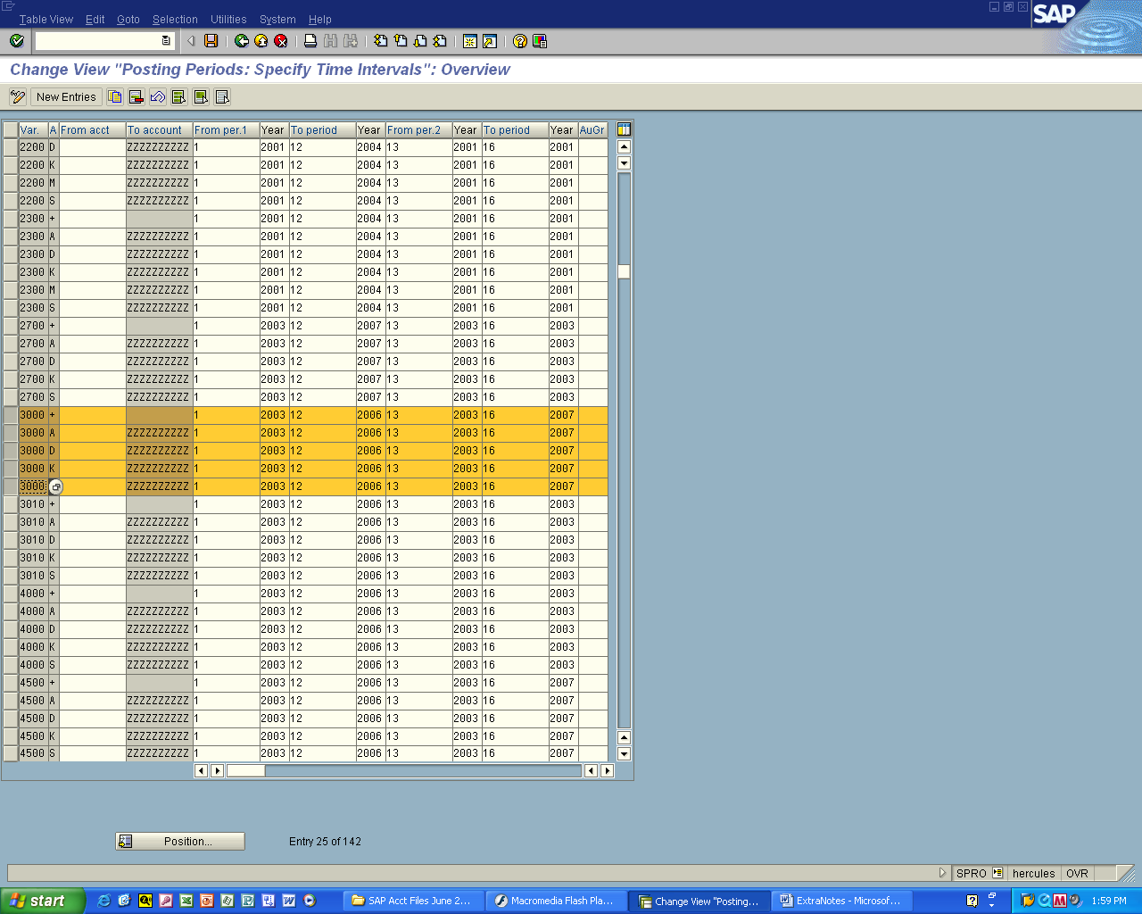
Change this

Locate the company code that you are working with
(ie: 3000 above)

Change the To Period to the year that you would like to use
For the end of the posting periods

Click on Save when done

No values for this selection message
You are unable to search and get a result

Slide 20
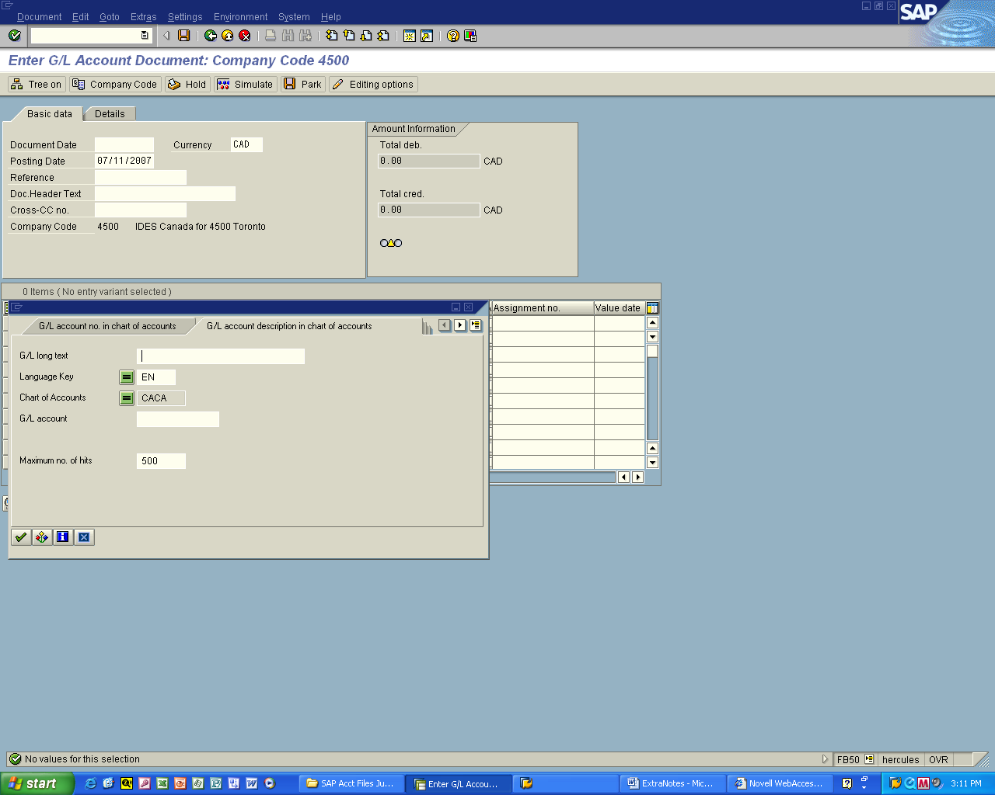

You see the above message when searching and
Cannot get a listing then do the following
Slide 21
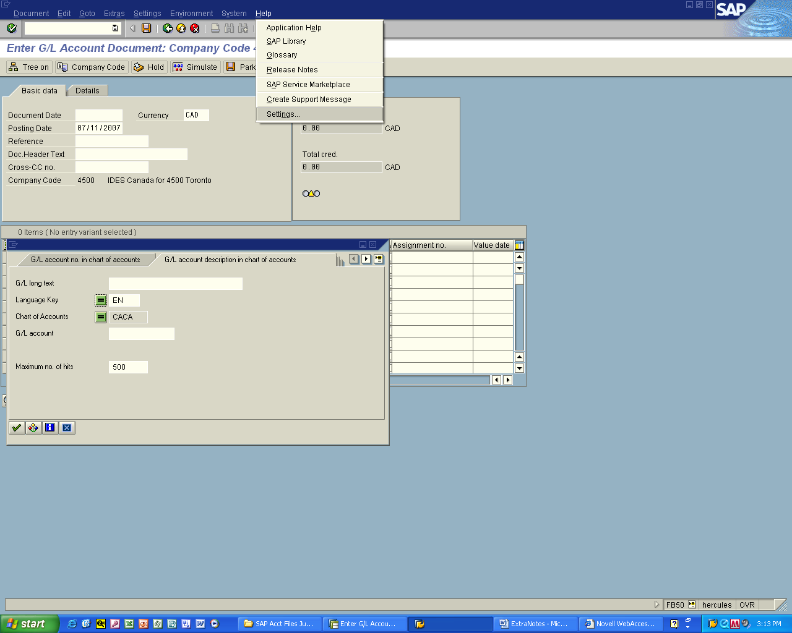

Select Help from Menu

And then Setting…
Slide 22
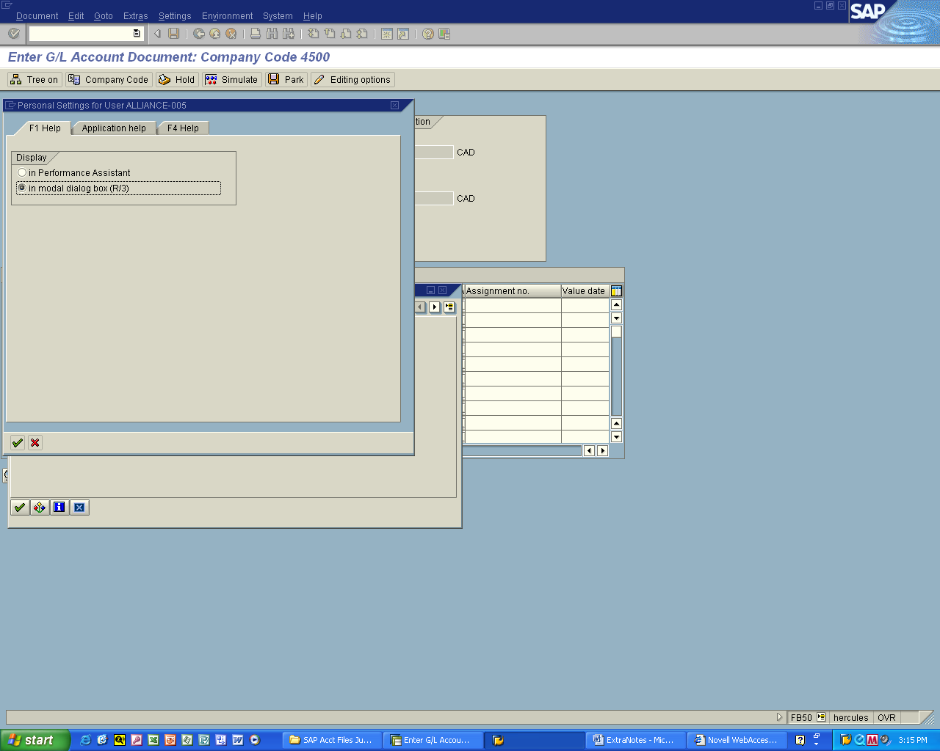

Click on radio button

In modal dialog box (R/3)

And then click on green checkmark

