How to get details on postings (when, who, etc)

Slide 10
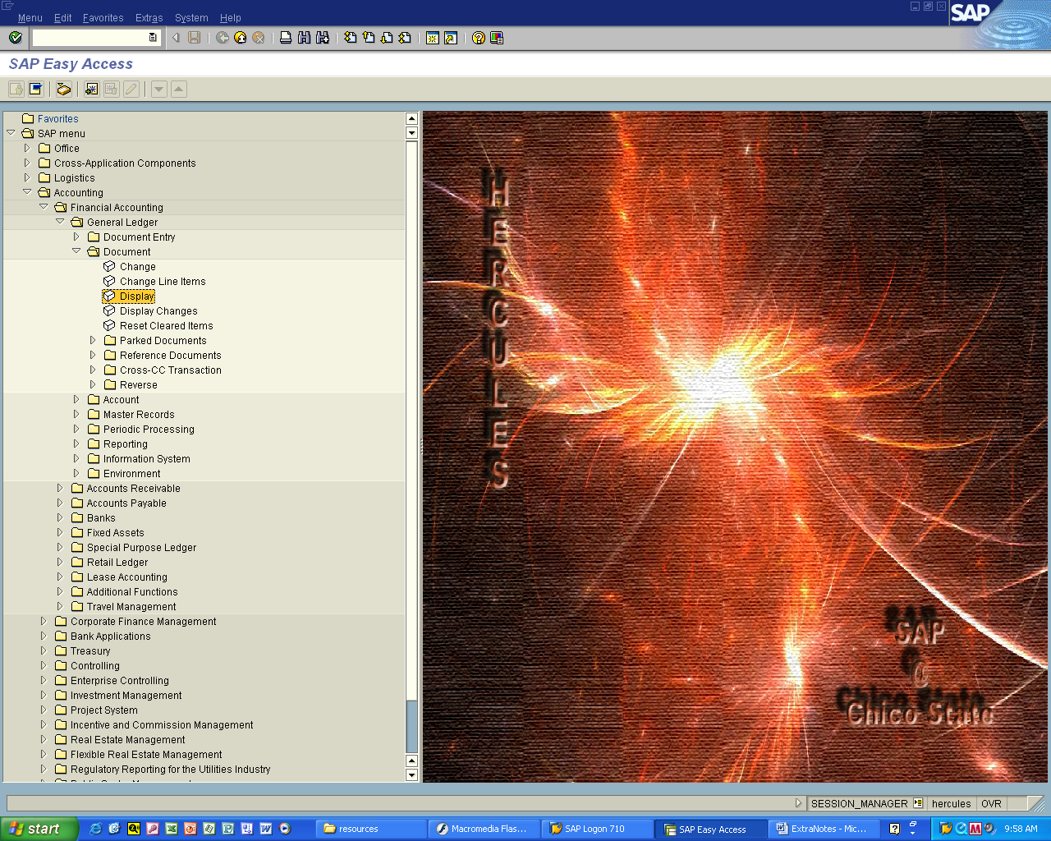

Accounting > Financial Accounting > General Ledger > Document

Double click Display

Slide 11
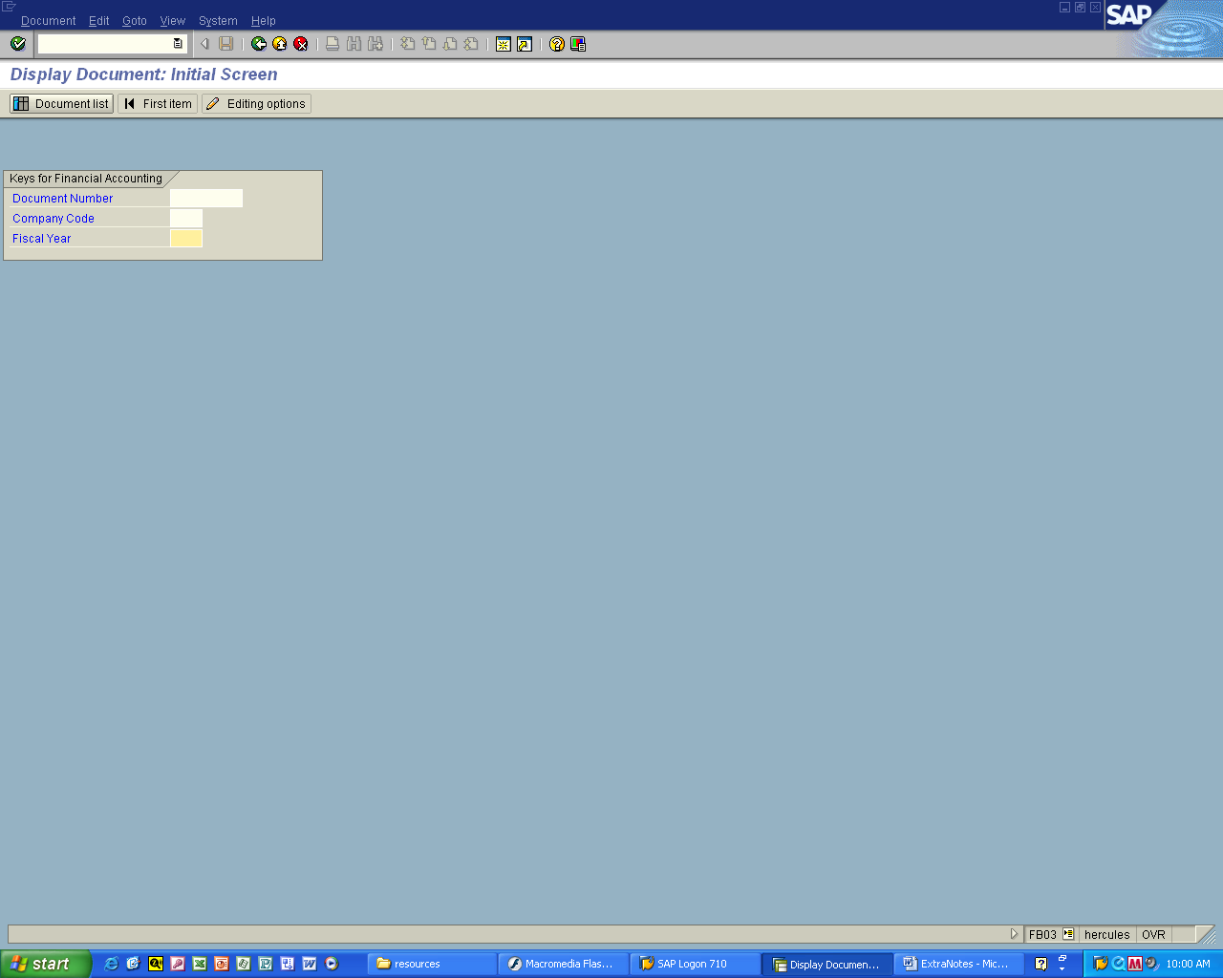

Click on Document list
Slide 12
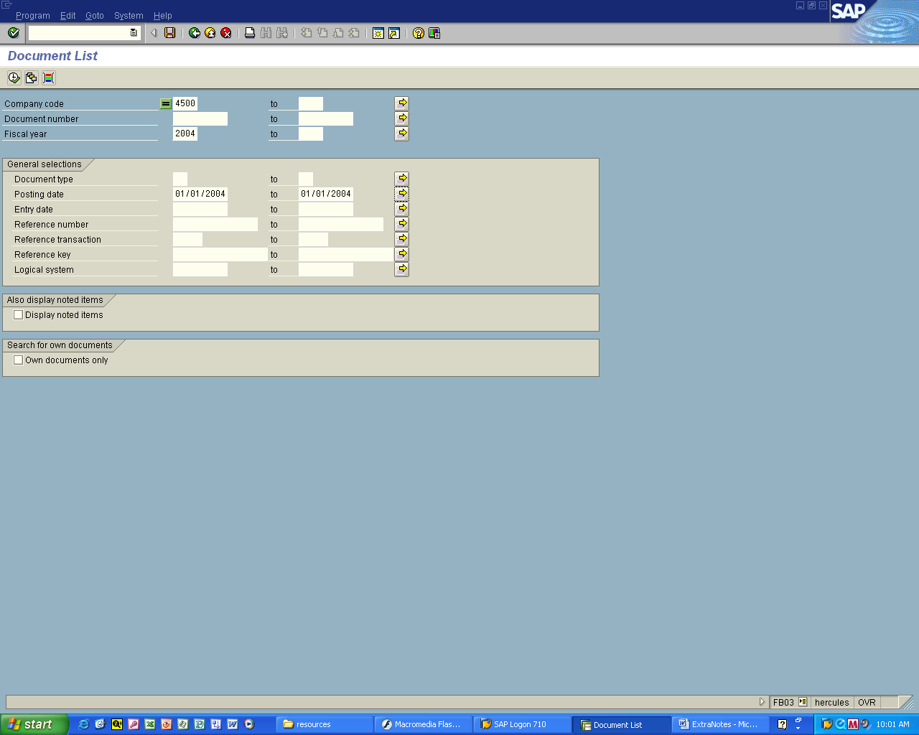

1. Enter company code
Fiscal Year
Posting date(s)

2. Click the Execute Button
Slide 13
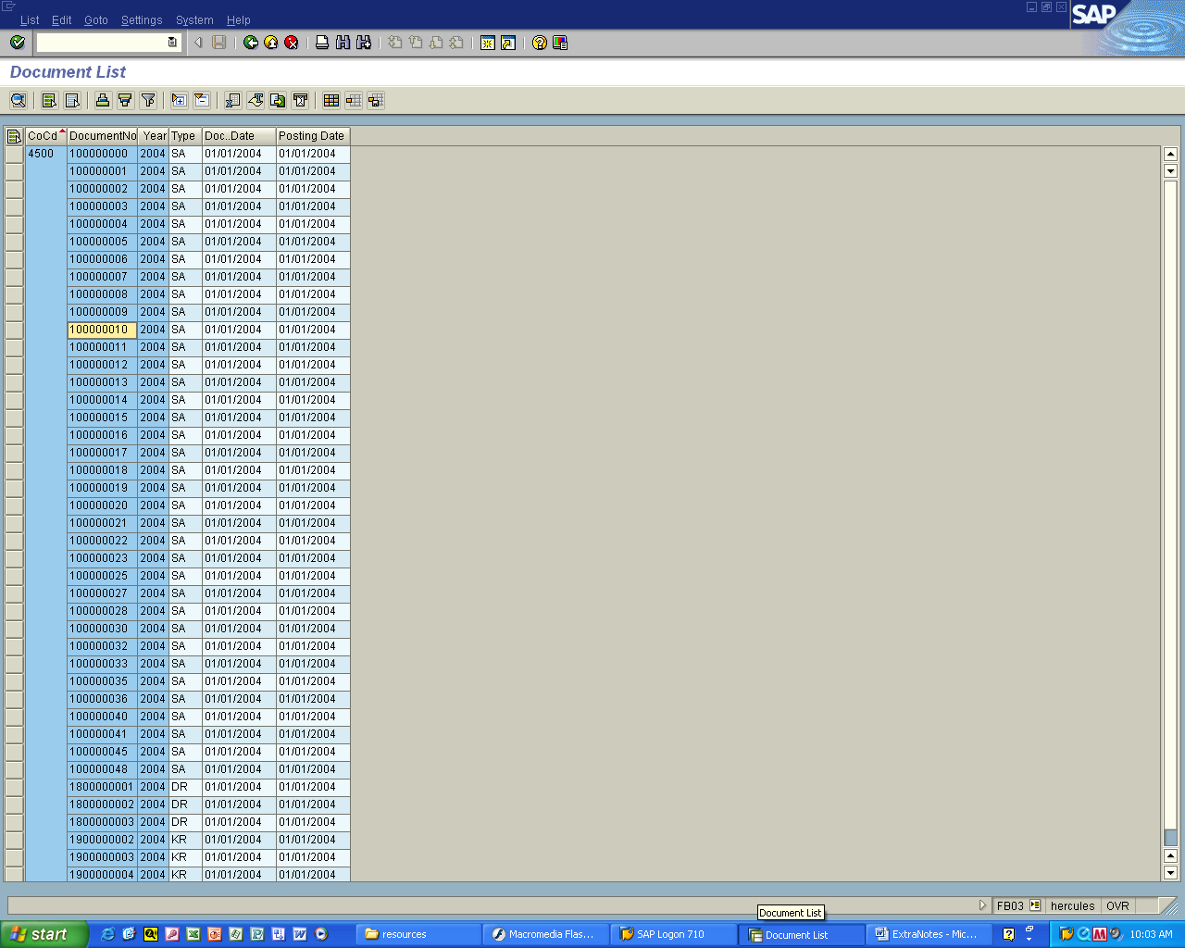

You will see the document number in sequence order

If you know your document number

Double Click it (ie: 100000010)
Slide 14
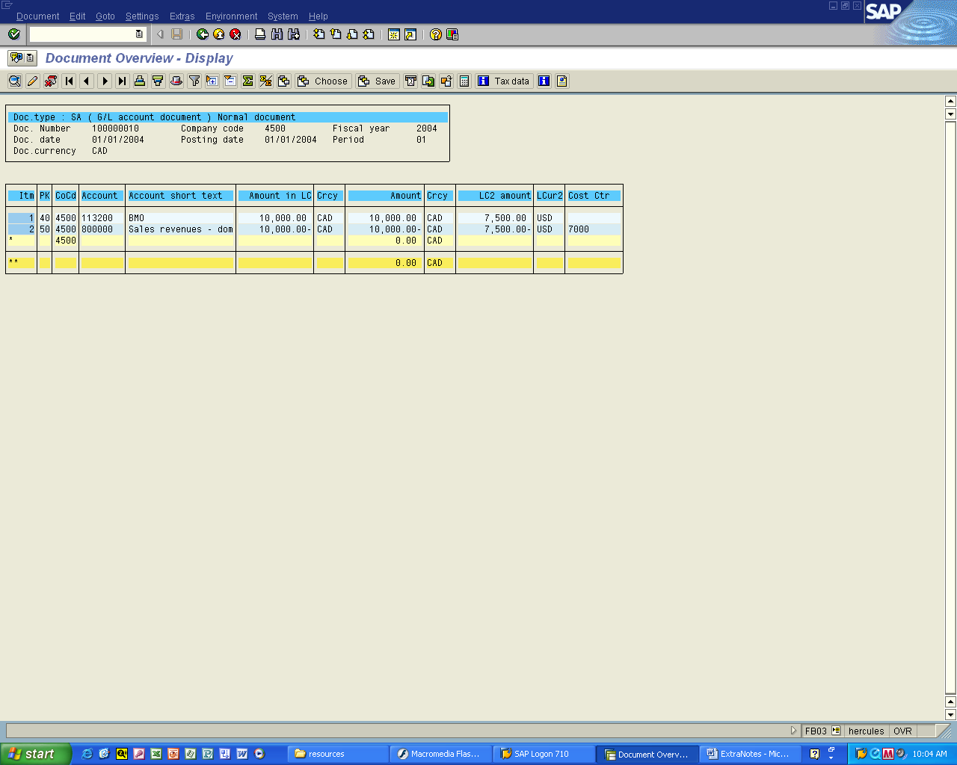
Click here (the Hat)

Click on the Hat

Otherwise known as

Display document header

Slide 15
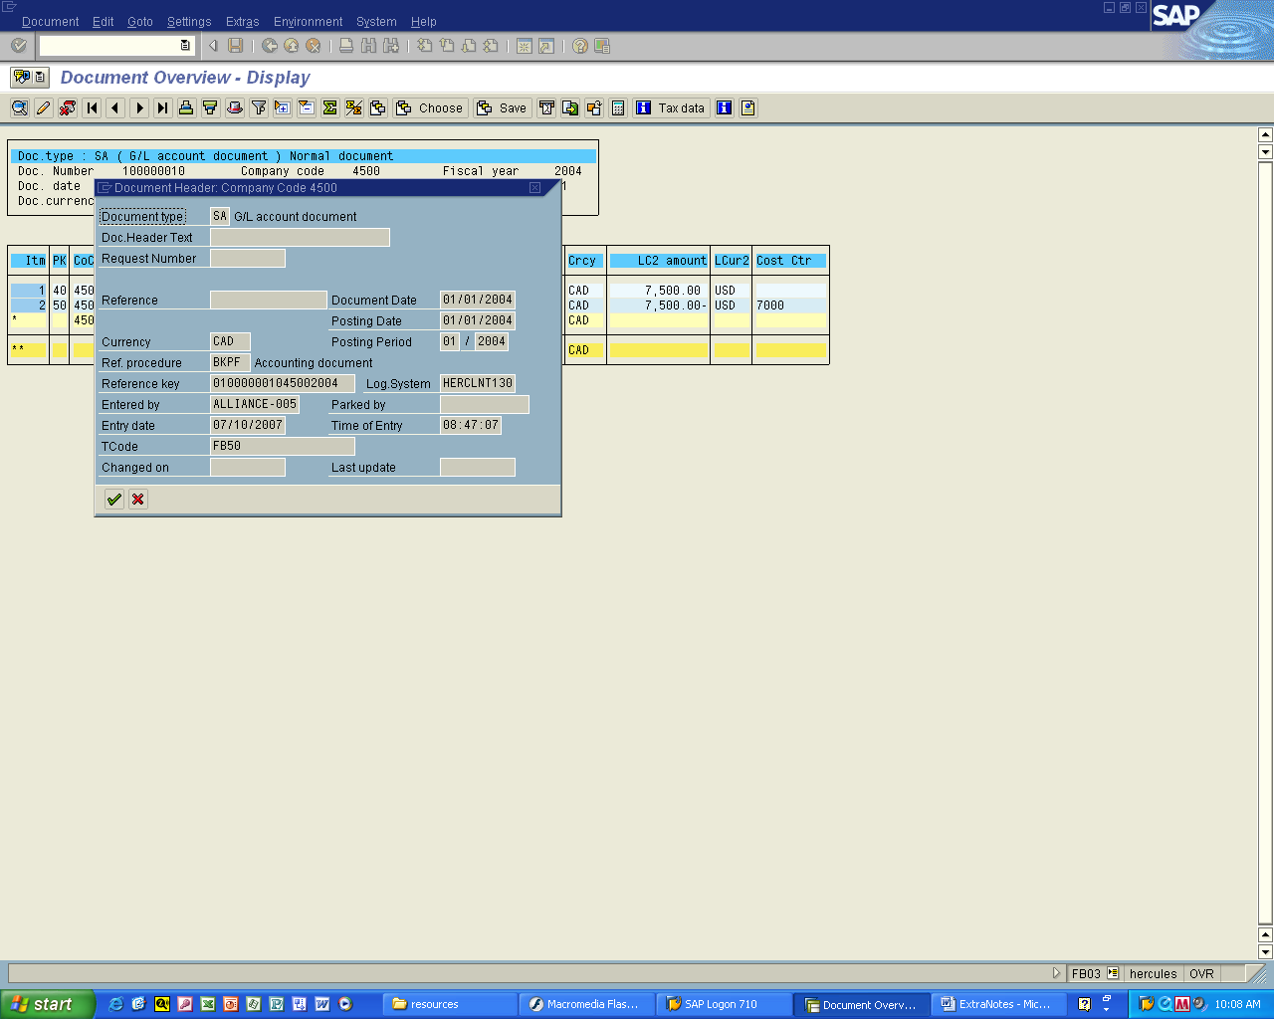

You will see this display that shows who entered the transaction, the date entered, etc

