Intended Use

Module 1 – SAP INTRODUCTION
Instructor’s Notes
Last Revised 8/1/2008

This module will introduce the student to SAP fundamentals that are needed to complete the demonstrations and exercises in Modules Two to Twelve.

Module Learning Objectives

After completing this module, students should be able to:
- Explain the meaning of SAP
- R/3
- Applications
- IDES

  - Describe how to logon and navigate within the SAP menu system
  - Identify SAP screen components
  - Practice entering data into SAP fields
  - Identify and interpret SAP system messages

Instructor Outline

ERP is defined and briefly described.

The SAP system is defined

The meaning of R/3 is described, as well as clients and applications

How to navigate the SAP interface is covered. Explanations of the following are provided:
- Logging On and Off
- Screen Features
- Navigation
- Entering Data and Reporting
- Working with Sessions
- On-line Help and System Messages

Students will now be able log in to SAP system, navigate a path in the system and enter data into the SAP screen fields.

SAP Demonstration

The SAP demonstration shows students how to login to SAP and navigate the Easy Access Menu. To start the demonstration:
- Students will either:
  - copy the files, from the CD provided by you to them, on to their computers
  - use the files directly from the CD
- Start the Flash program (requires Flash Player to be installed on the computer) by clicking on AccountingWithSAP.exe file
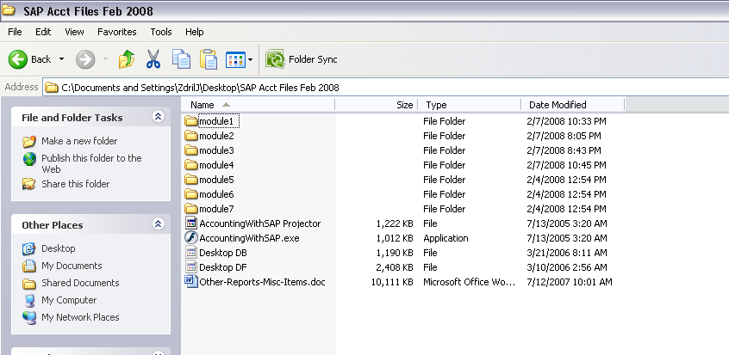

- Then open the first module and start at the Introduction/Objectives option

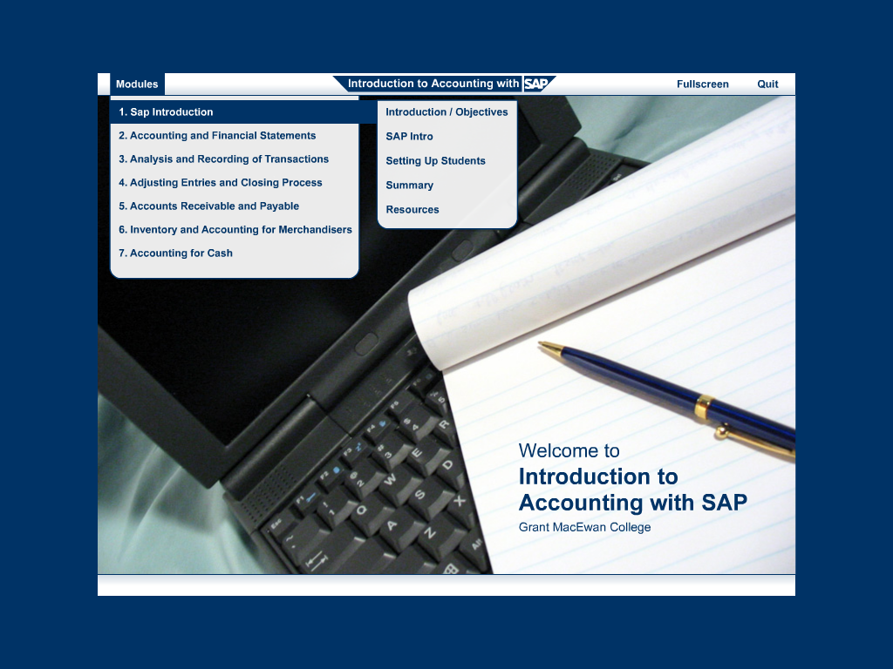
- Use this Icon to continue to the next step

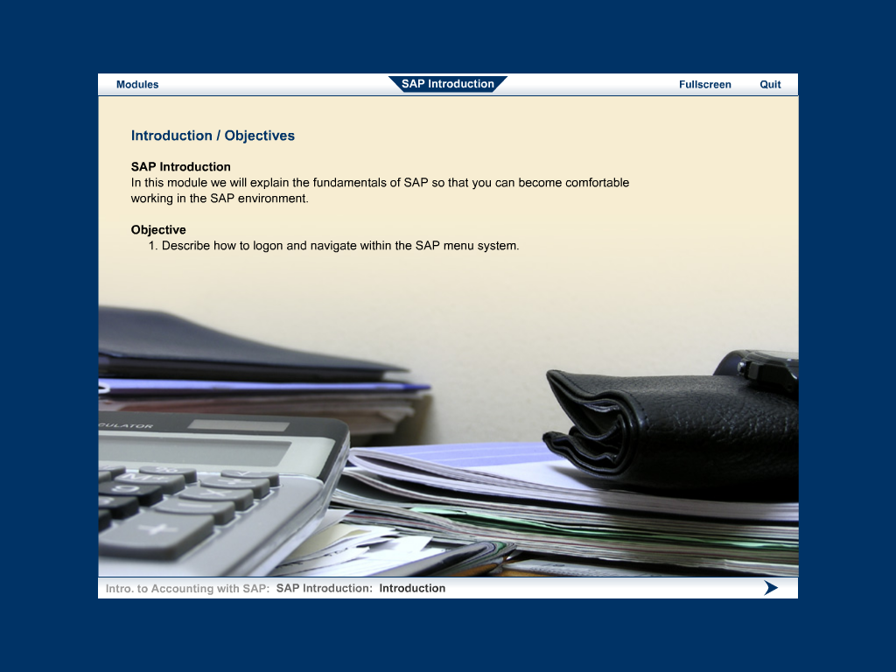
- Students can control the player with these buttons

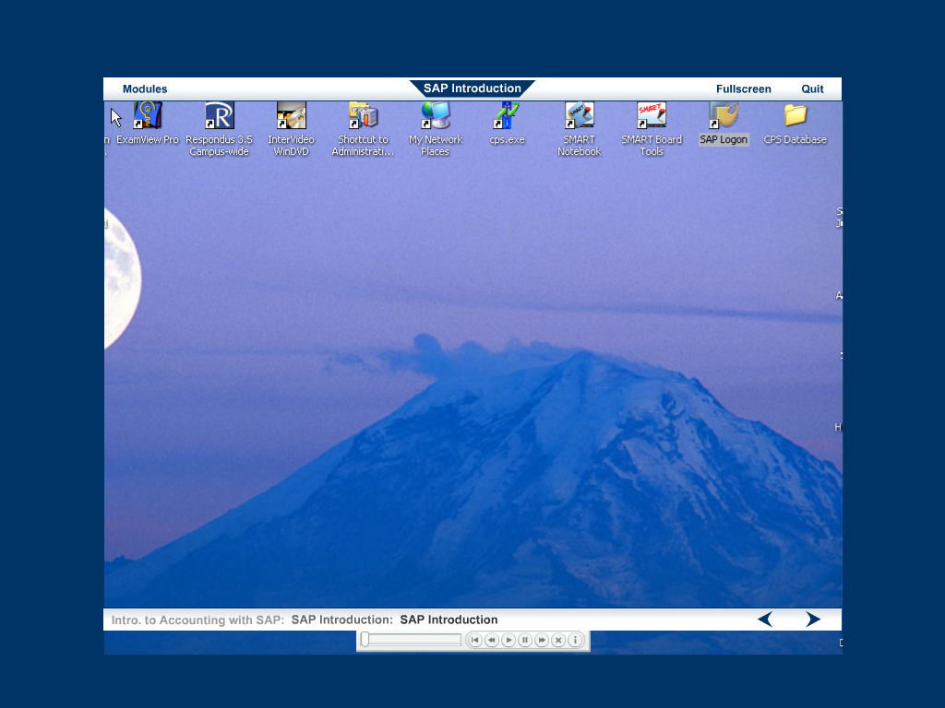
The students will be able to repeat this demo as often as they would like to.

The demonstration is in two parts.
- Part one is self timed and demonstrates the logon procedure and how to navigate in SAP
- Part two is a simulation that enables students to follow the demonstration example on their own. It requires students to match the correct selections to produce the desired end result

Setting Up Students
This section is intended for instructors only. In the event that you are self hosted and may need to set up your own student list, this demonstration takes you through the steps necessary to accomplish that task

THIS ITEM WILL NOT BE AVAILABLE FOR STUDENTS

