Slide 1
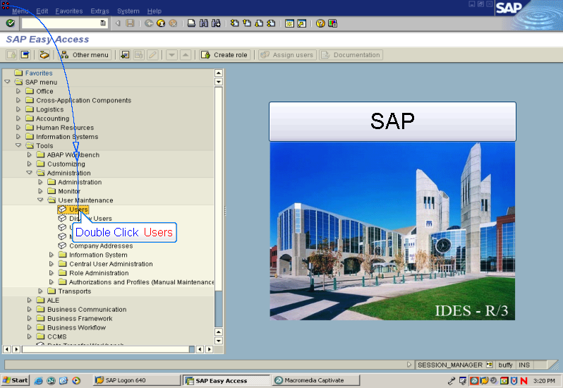

Tools > Administration > User Maintenance

Double Click Users
Slide 2
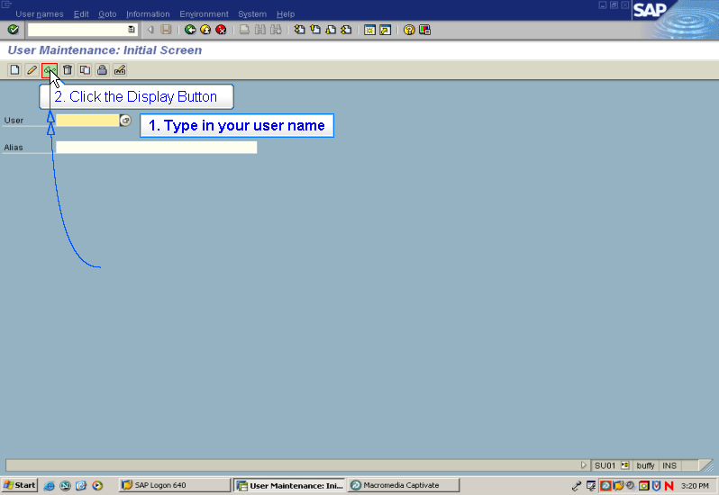

1. Type in your user name

2. Click the Display Button

Slide 3
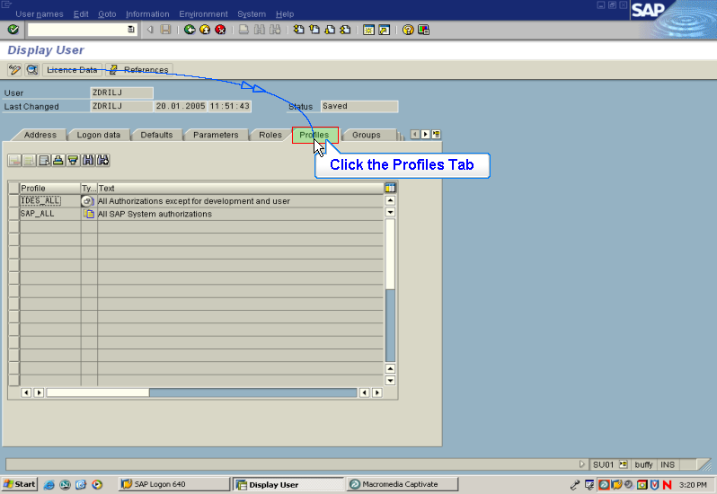
Text Captions

Click the Profiles Tab

Ensure that you have SAP_ALL and IDES_ALL profiles
assigned here.

If you do not, contact your system administrator

Click Back
Slide 4
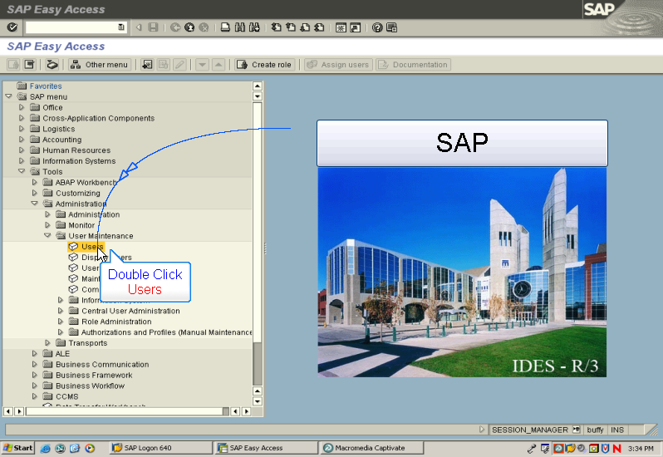

Double Click
Users
Slide 5
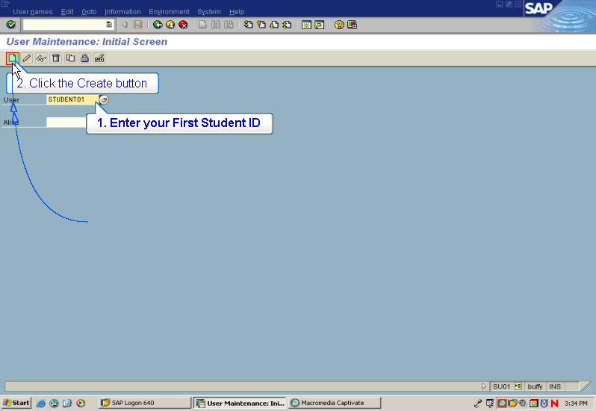

1. Enter your First Student ID

IE: Student01

2. Click the Create button

Slide 6
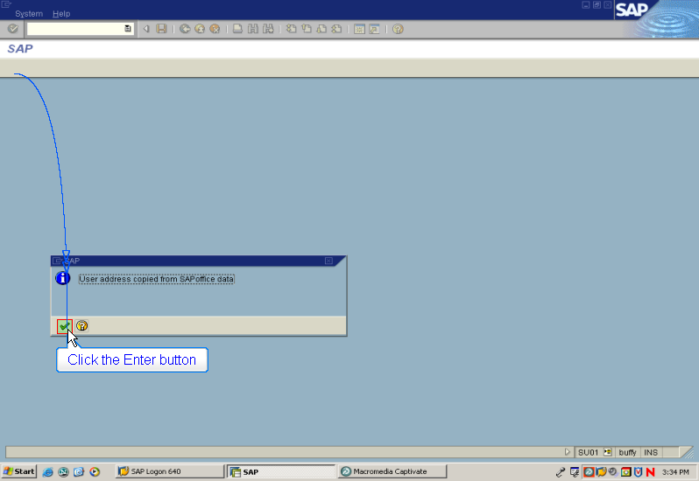

Click the Enter button
if this message appears
Slide 7
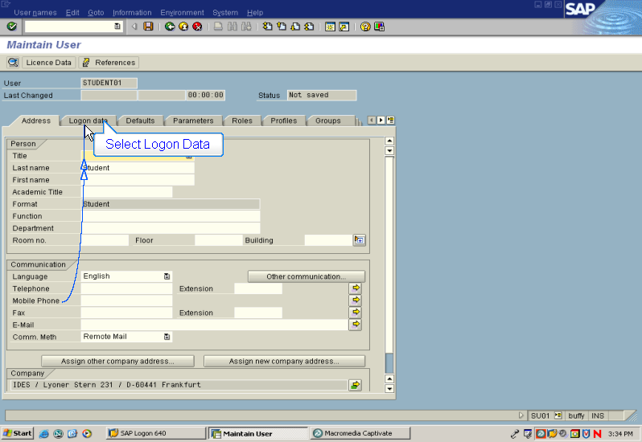

Select Logon Data tab
Slide 8
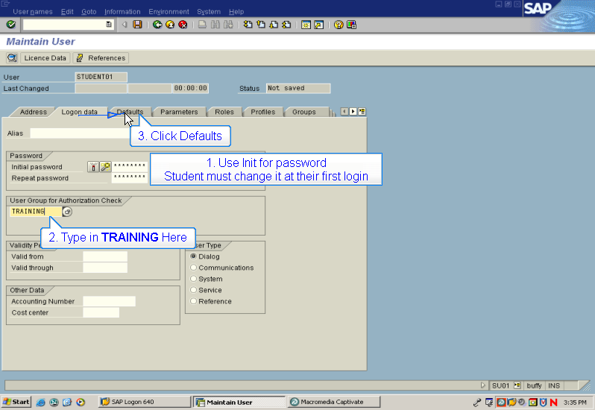

1. Use Init for both passwords – Initial and Repeat
Students must change this password when completing their first login

2. Type in TRAINING as the Group for Authorization Check

3. Click Defaults
Slide 9
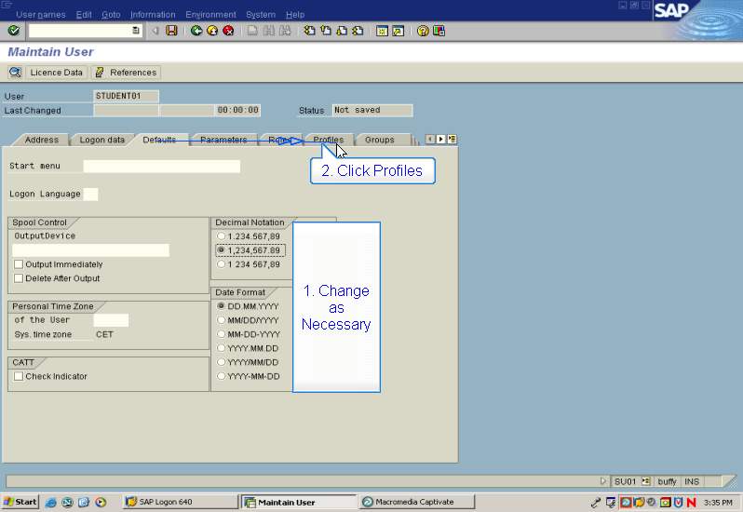
Text Captions

1. Change as Necessary

2. Click Profiles tab
Slide 10
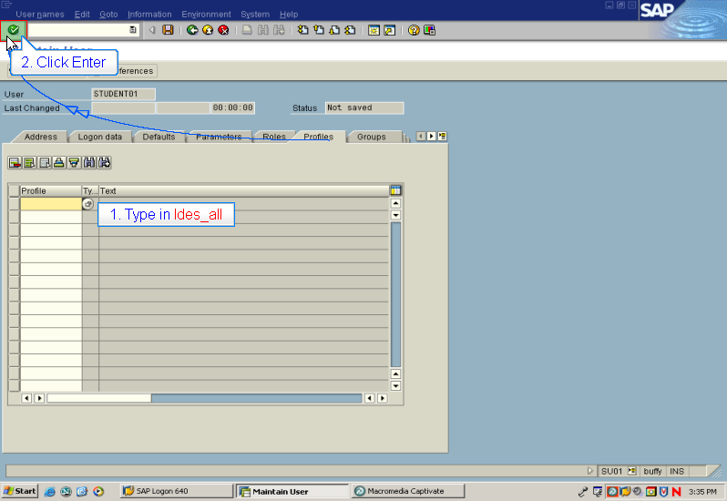

1. Type in Ides_all in Profile column

2. Click Enter
Slide 11
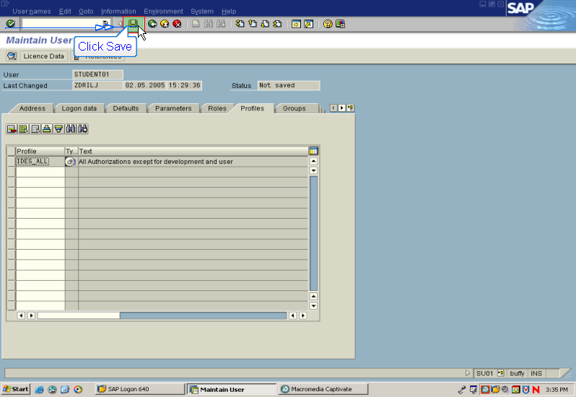

Click Save
Slide 12
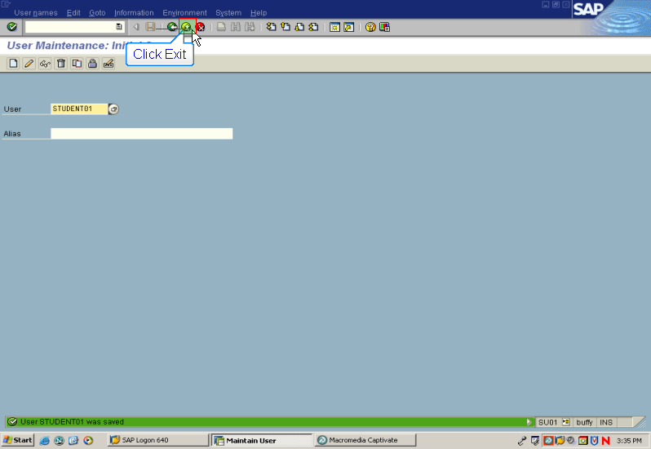

Click Exit
Slide 13
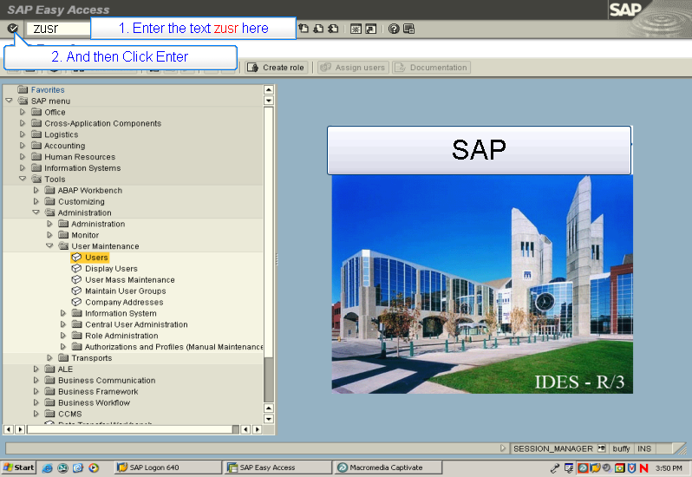

1. Enter the text zusr in field next to check mark

2. And then Click Enter

zusr
Slide 14
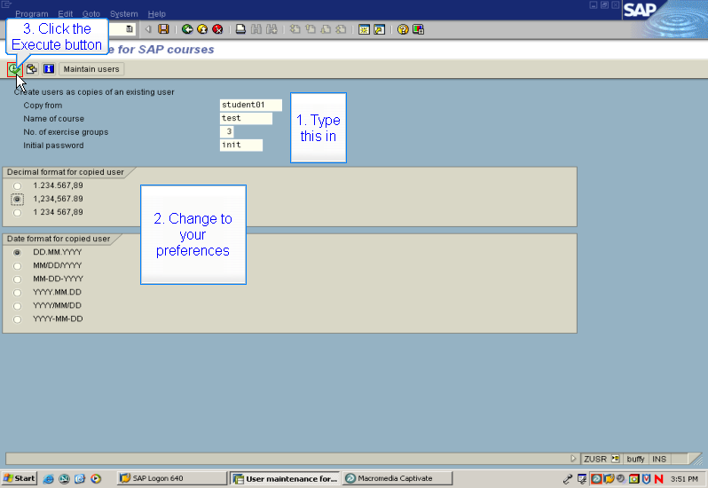

You are now going to make copies of your Student01 account

1. Type in
- The name of your course – ie: test
- The number of students in your class – add 5 to that number for extras
- Use init as the Initial password

2. Select
- The appropriate Decimal format
- The appropriate Date format

3. Click the Execute button
Slide 15
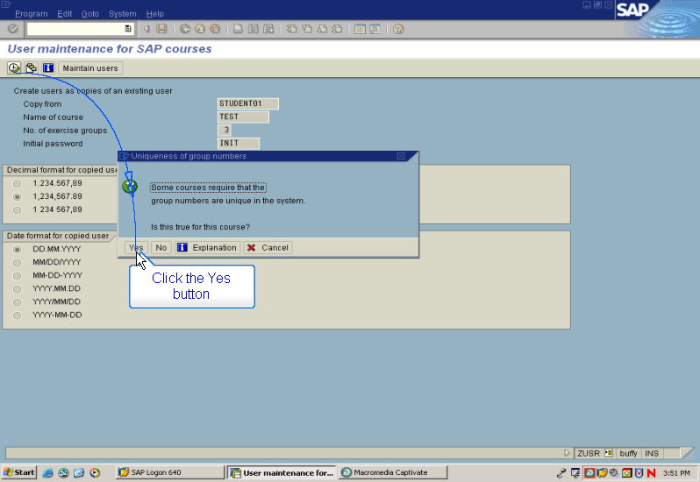

Click the Yes button to accept this message
Slide 16
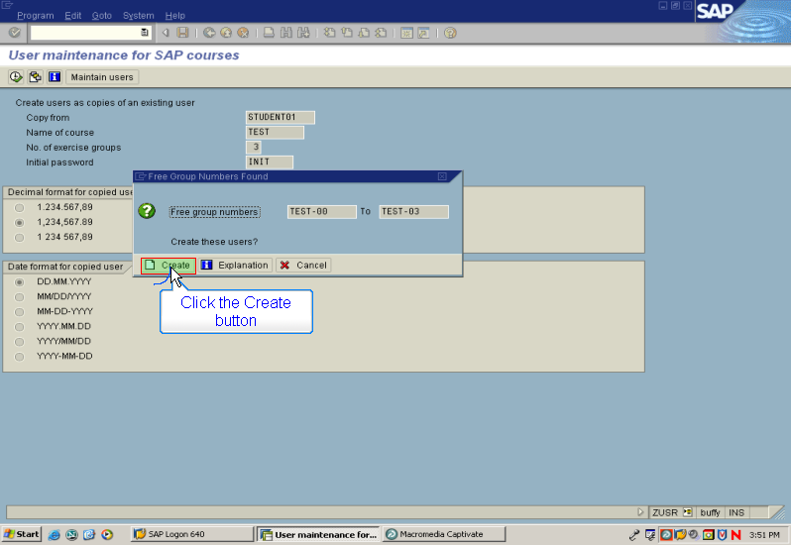

Click the Create button
Slide 17
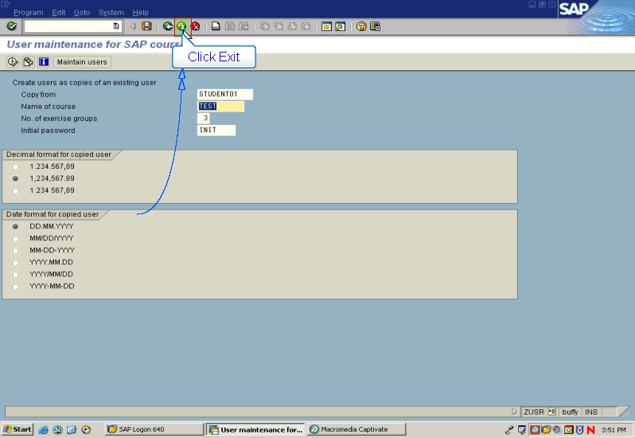

Click Exit
Slide 18
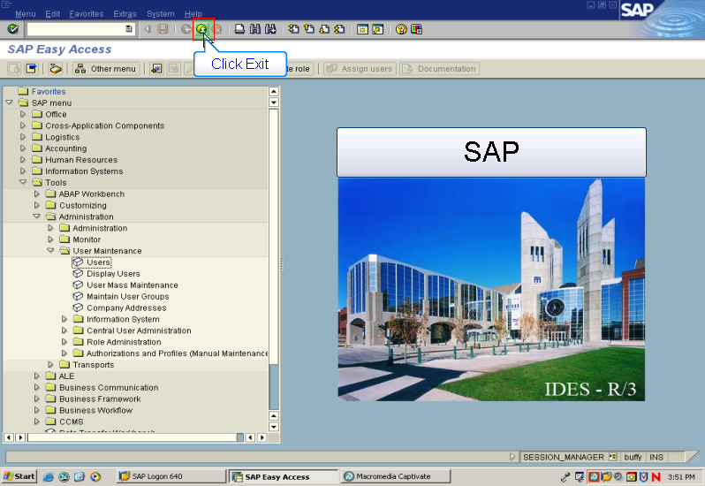

Click Exit
Slide 19
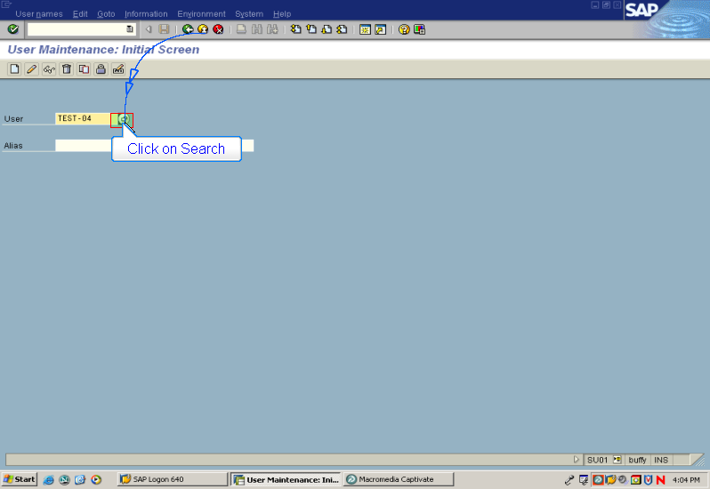

This step will enable you to confirm that the students have been created

Click on Search
Slide 20
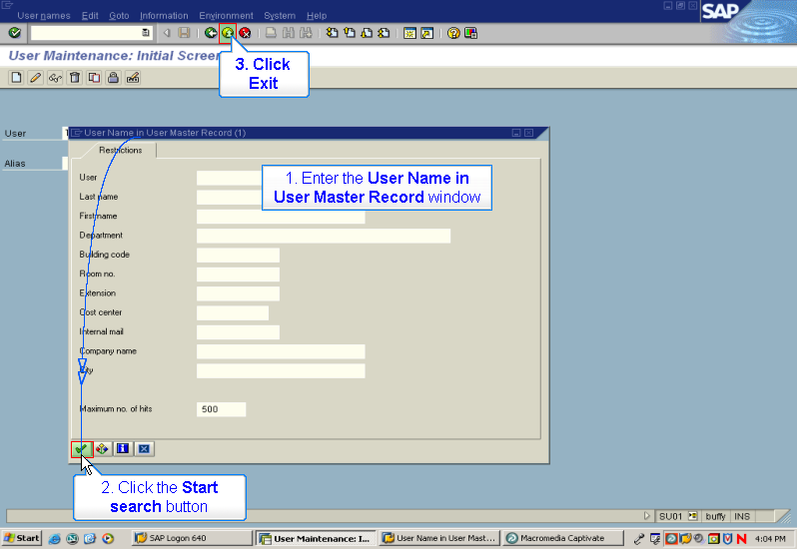

Enter TEST* (insert your course name for TEST) in the user field

Click the Start search button

Your list of students should appear on the screen that follows

If they do not, repeat the creation steps ZUSR (slide 13 to 17) again

Click Exit
Slide 21
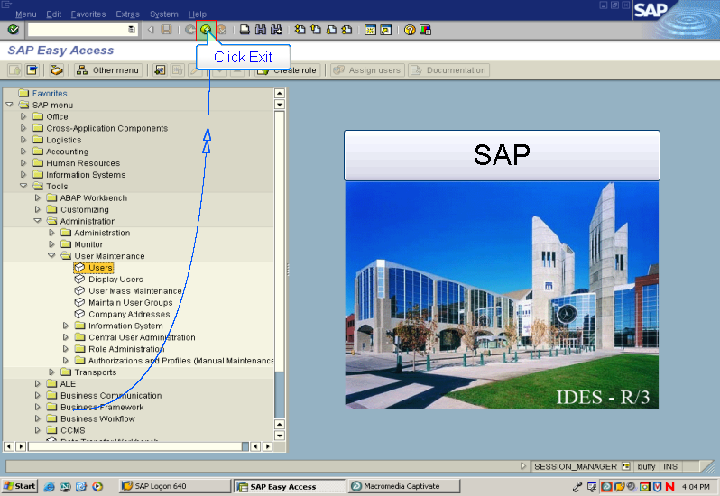

Click Exit

You have completed this module

