Report on Posted Transactions - 1
Slide 1
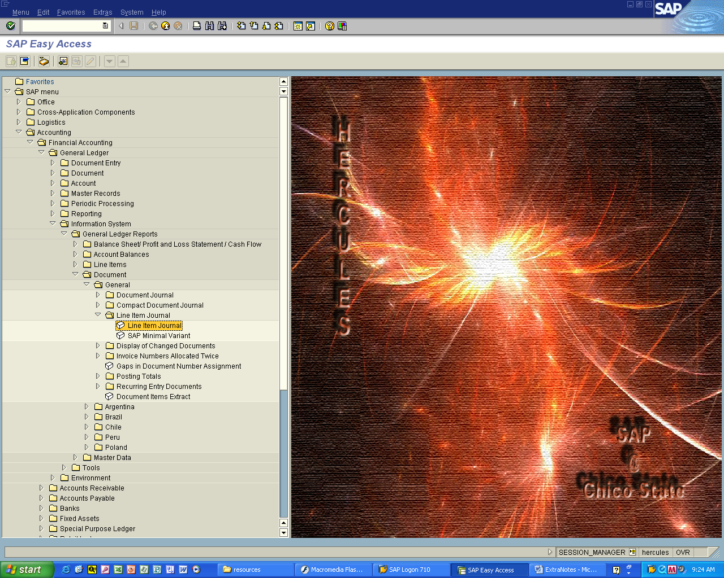

Accounting > Financial Accounting > General Ledger > Information System
- General Ledger Reports > Document > General > Line Item Journal

Double click Line Item Journal

Slide 2
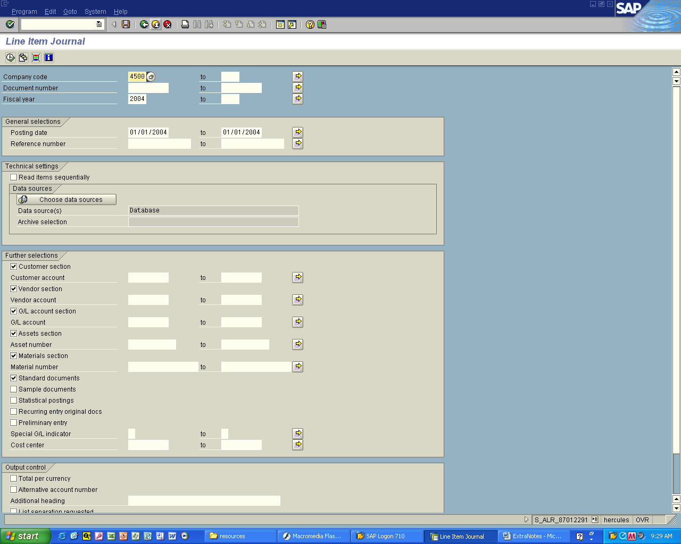

1. Enter company code
Fiscal Year
Posting date(s)

2. Click the Execute Button

Slide 3
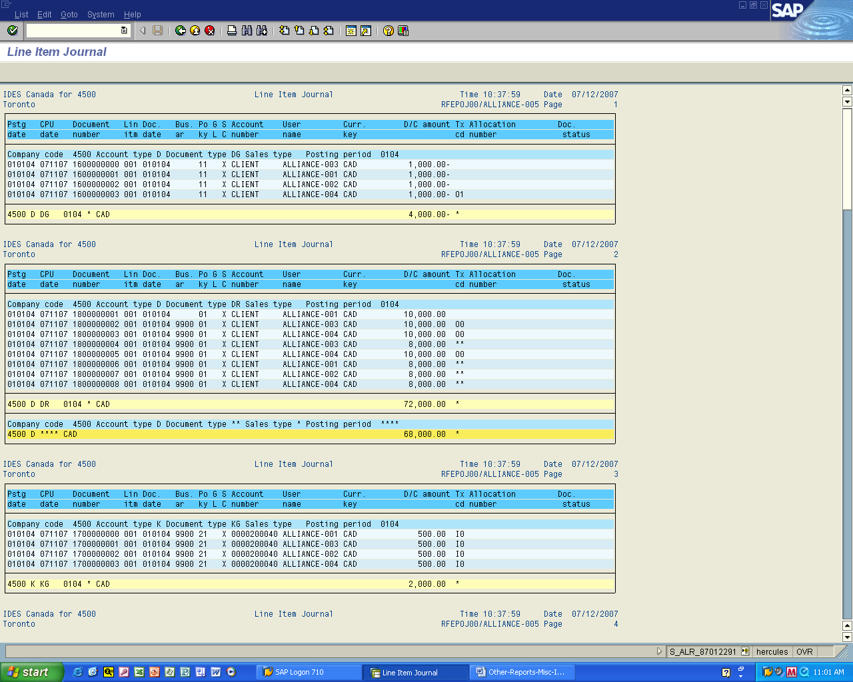

You will see the list of transactions by sequence number
(this is automatically assigned by SAP)

Note the user name is identified for each transaction
Report on Posted Transactions – 2

Slide 4
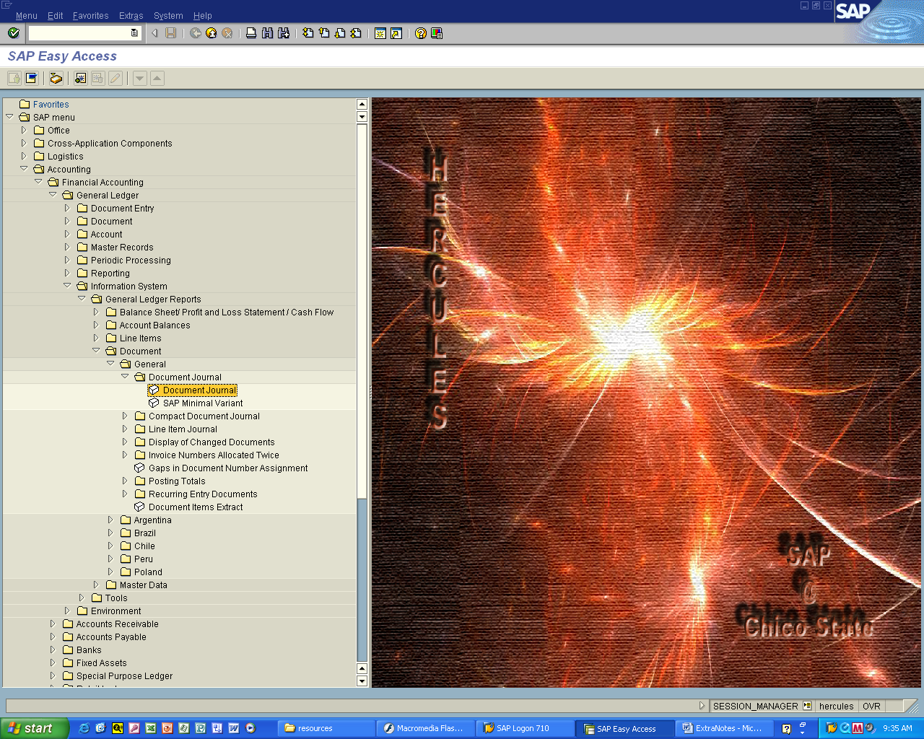

Accounting > Financial Accounting > General Ledger > Information System
- General Ledger Reports > Document > General > Document Journal

Double click Document Journal

Slide 5
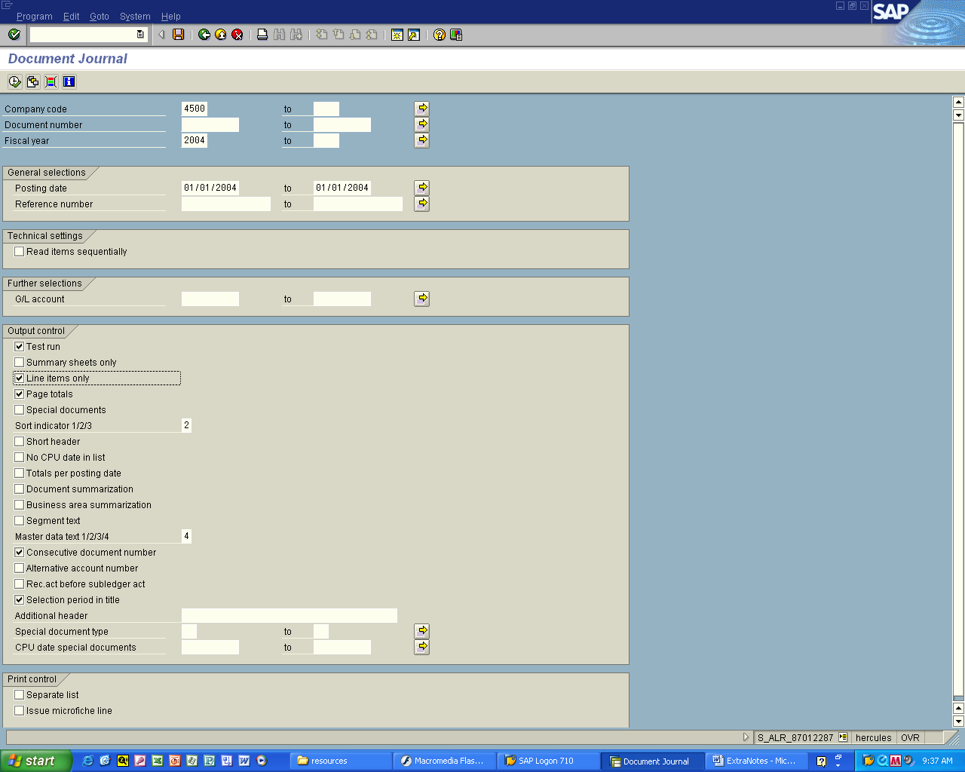

1. Enter company code
Fiscal Year
Posting date(s)

Check off the Line Items only option in Output Control

2. Click the Execute Button
Slide 6
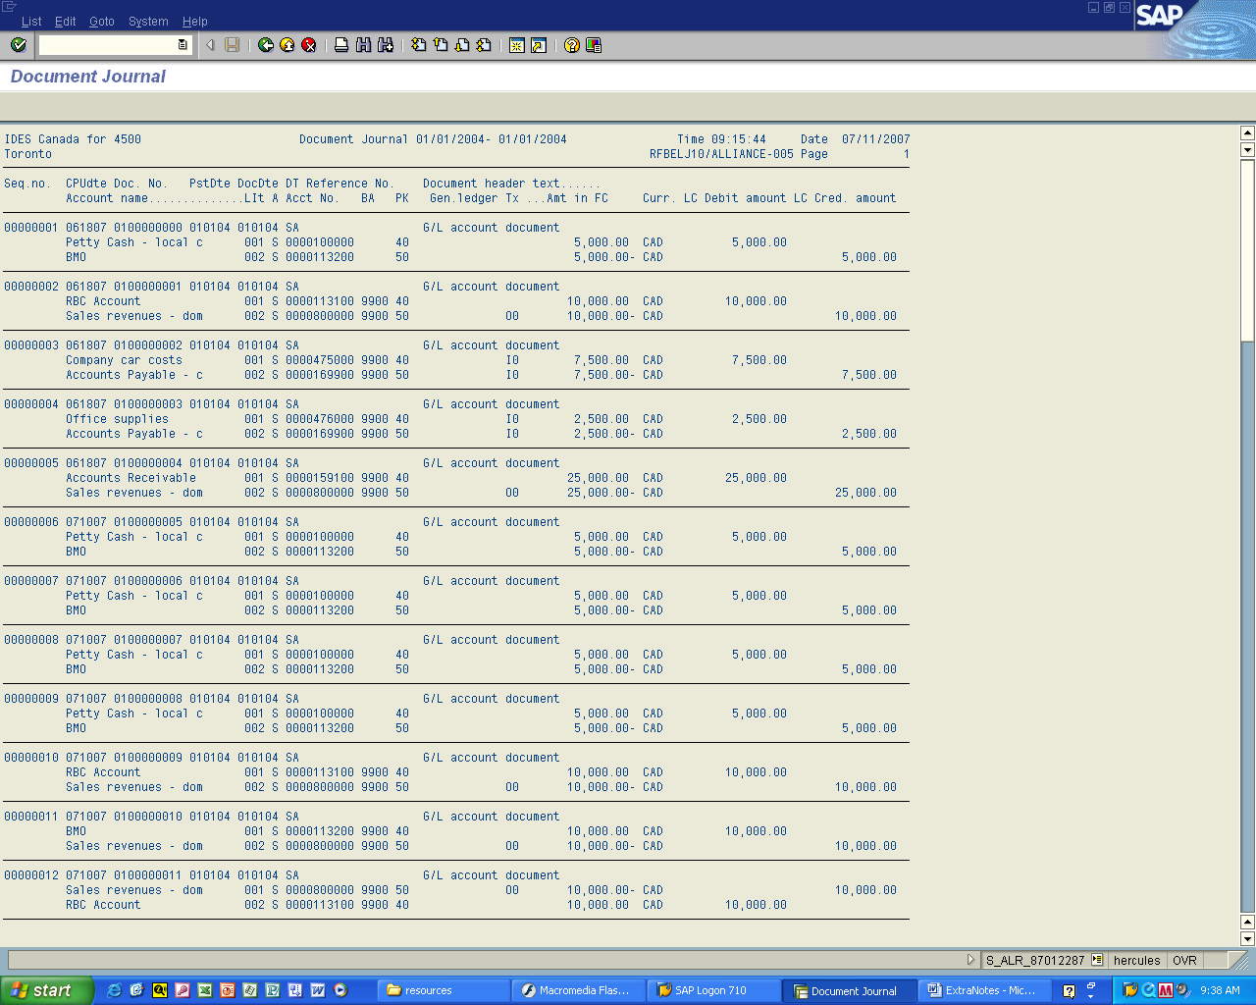

You will see the list of transactions (by Debit and Credit ) by sequence number

