SAP Demonstration 1 –Transactions
The Demonstration 1 Transactions demonstrates to the students how to enter a transaction into an SAP general journal and then simulate the journal entry. The students will be able to play this demo as often as they would like to. It provides examples of the steps to follow when they practice journalizing entries on their own.

SAP Demonstration2 –Reports
The Demonstration 2 Reports shows students how to display a report that will show their posted entries from the Demonstration 1 Transaction example.

SAP Simulation
The Simulation enables students to follow an example of a journal entry on their own. It simulates the steps required to create a journal entry. The student practices the steps with guidance by the program

Practice Exercises in SAP
Use January 1, 2007 (01.01.2007) for all dates in all entries

- Perform the same series of steps to create the journal entry that was created in the SAP Simulation exercise. You are increasing the Petty Cash fund by $5,000 from the Bank of America – AP check disbursements account
Capture and paste into Word document the simulation screen produced prior to posting the transaction
- Enter a Sale in the amount of $10,000 with the funds being deposited to Cash account. Assume that no taxes (0% or Tax Exempt) are involved in this transaction.
Capture and paste into Word document the simulation screen produced prior to posting the transaction
- After this entry, display the posted entry in the GL Account Balance screen
Capture and paste into Word document the GL Account Balance screen
- Car maintenance costs of $7,500 must be entered and payment will be made later. Use Accounts Payable account. Assume that no taxes (0% or Tax Exempt) are involved in this transaction.
Capture and paste into Word document the simulation screen produced prior to posting the transaction
- Office supplies for $2,500 were purchased on account. Assume that no taxes (0% or Tax Exempt) are involved in this transaction.
Capture and paste into Word document the simulation screen produced prior to posting the transaction
- A $25,000 Sale was made on credit. Assume that no taxes (0% or Tax Exempt) are involved in this transaction.
Capture and paste into Word document the simulation screen produced prior to posting the transaction
- After this entry, display the posted entry in the GL Account Balance screen
Capture and paste into Word document the GL Account Balance screen

- Prepare a GL Document Journal summarizing your transactions. (See example below)

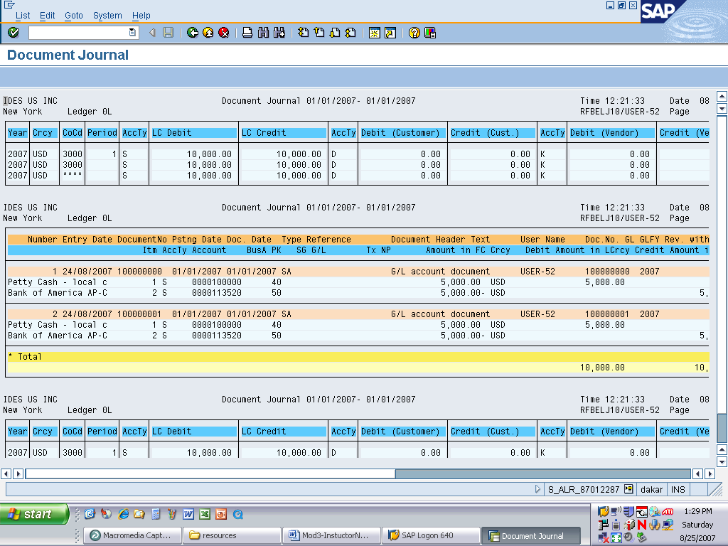
Capture Screen capture and paste into Word document the GL Account Balance screen
- Use the following settings to produce a Balance Sheet/P+L Statement

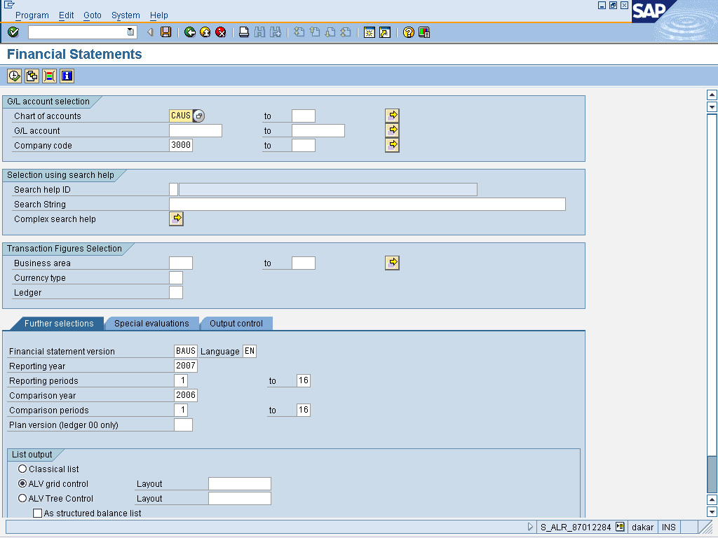

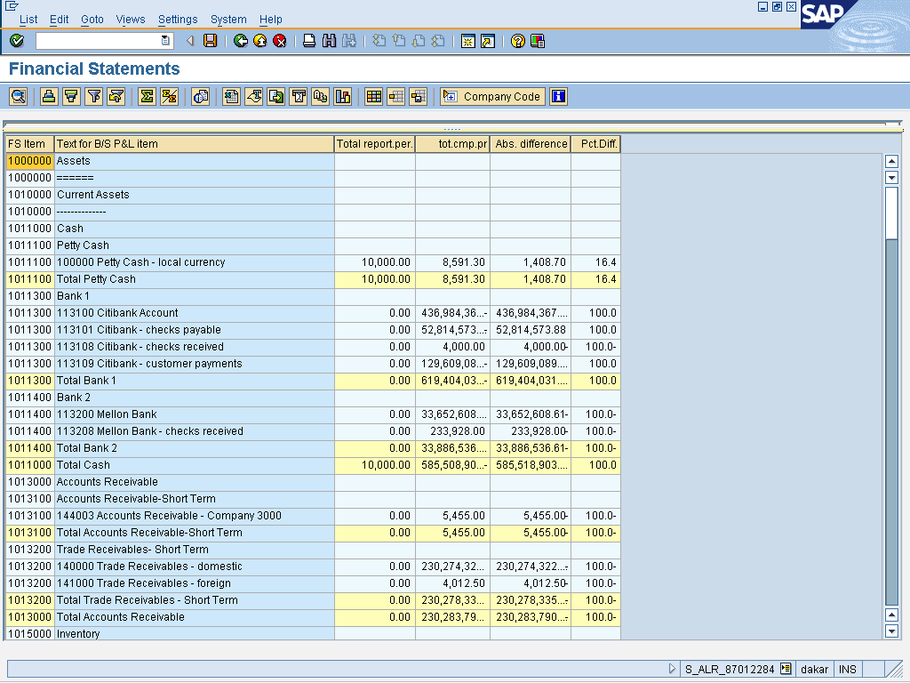

Capture Screen capture and paste into Word document this report screen

