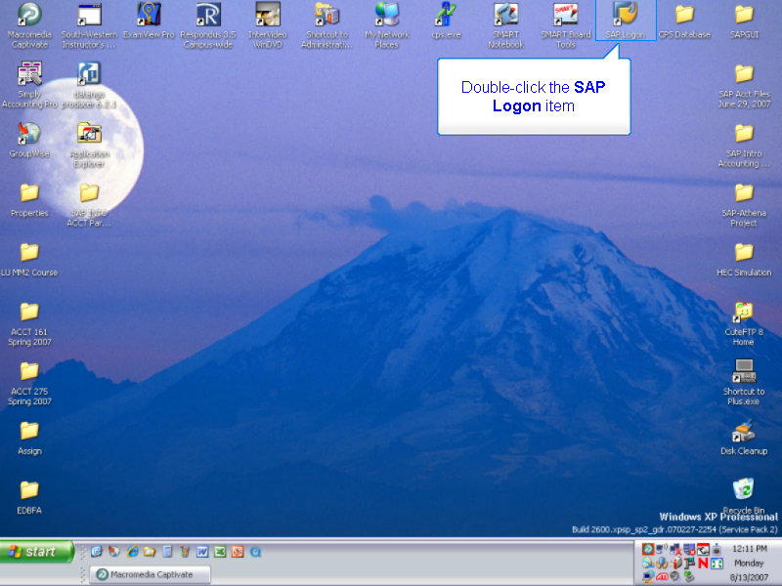

Double-click the SAP Logon item

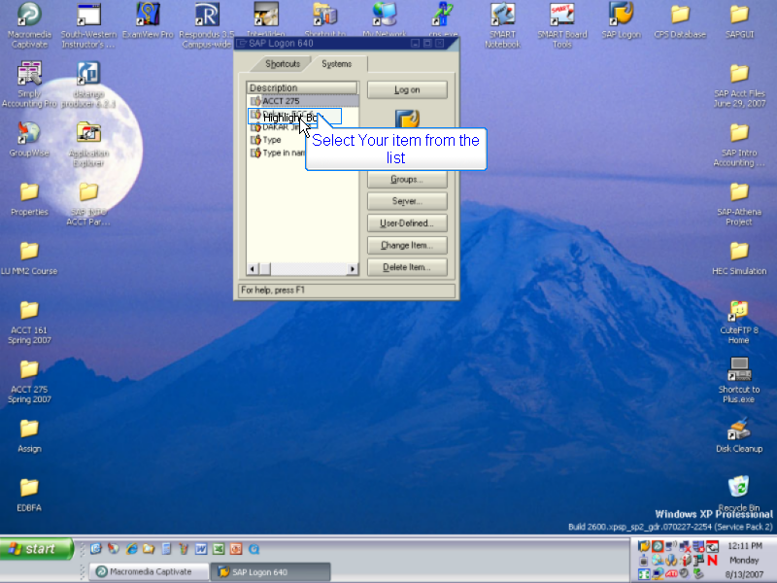

Select Your item from the list

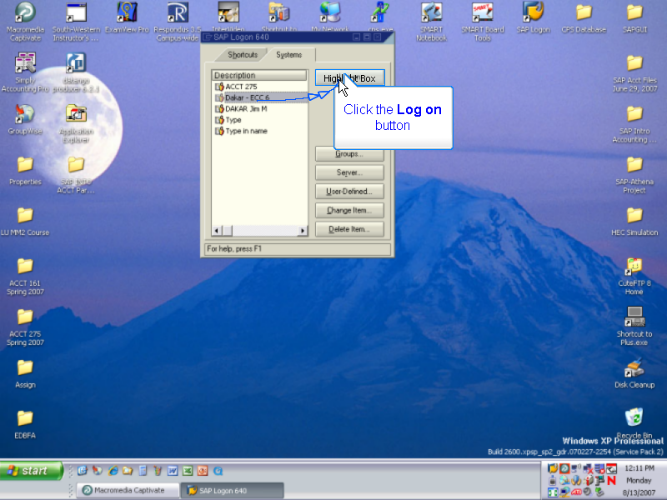

Click the Log on button

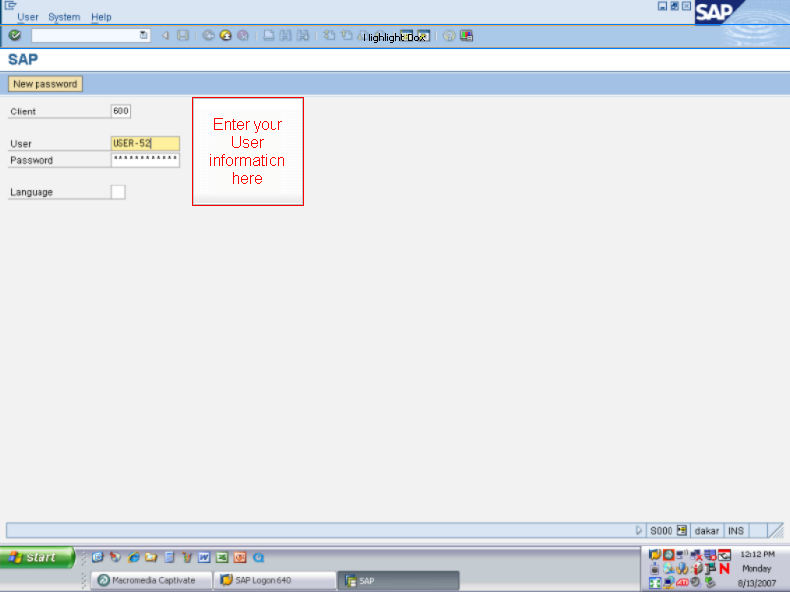

Enter your User information here

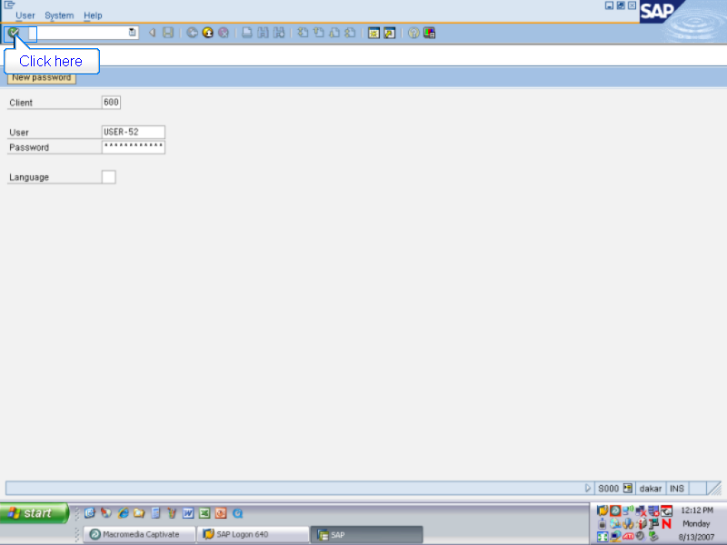

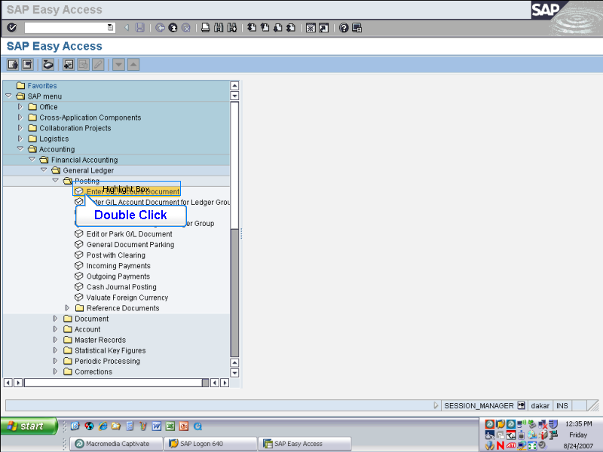
> Accounting
> Financial Accounting
> General Ledger > Posting

Double click
Enter G/L Account Document

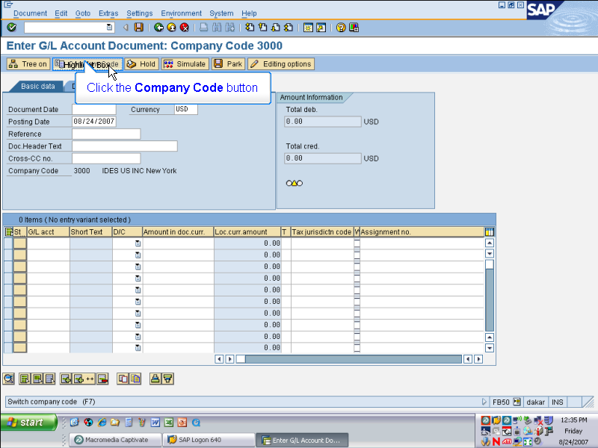

Click the Company Code button

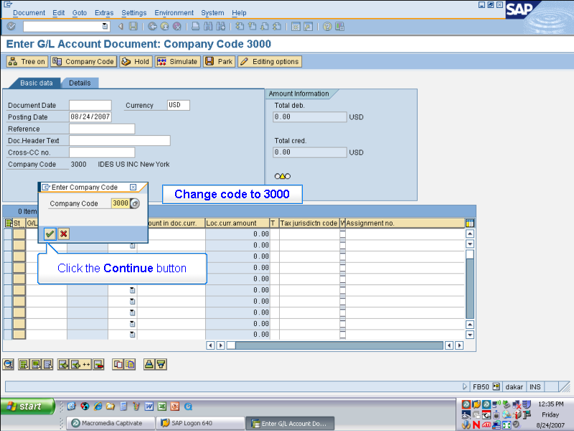

Change code to 3000

Click the Continue button

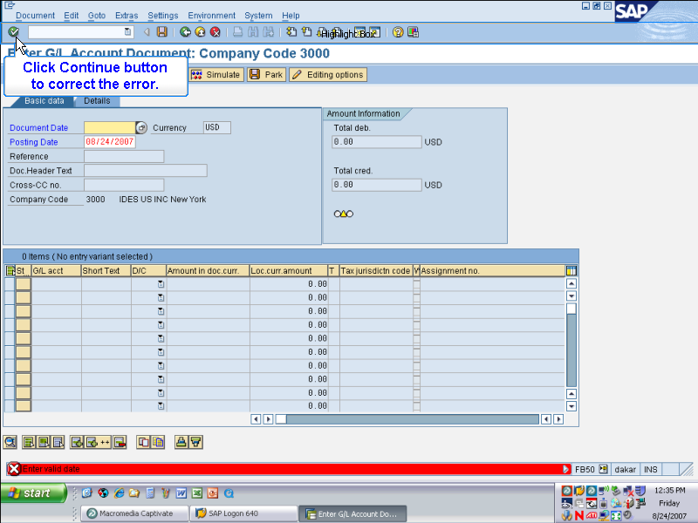

Click Continue button
to correct the error.

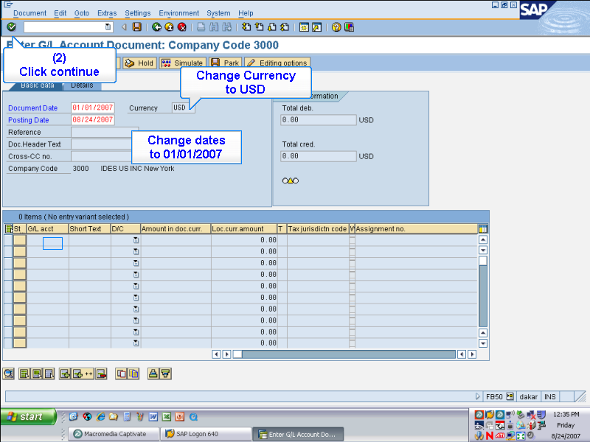

Change Currency to USD

Change dates to 01/01/2007

(2) Click continue

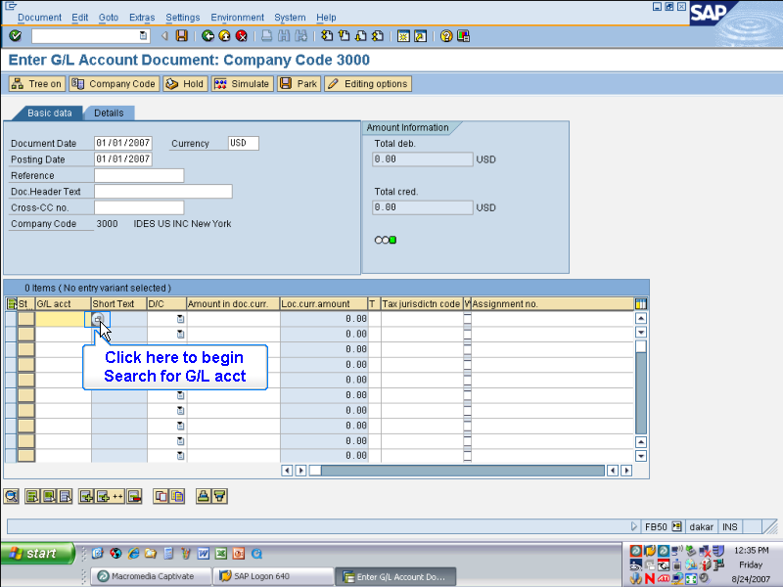

Click here to begin
Search for G/L acct

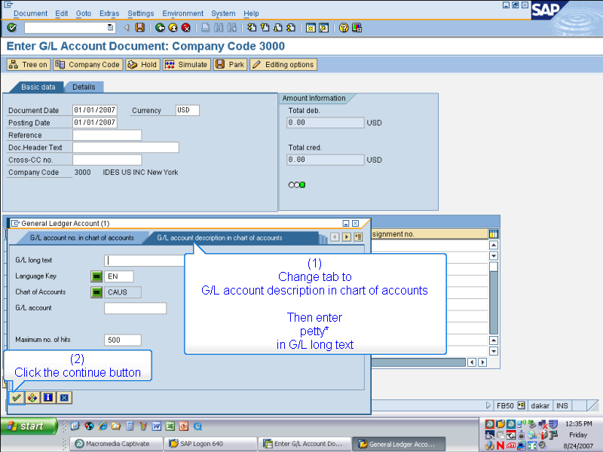

(1)
Change tab to
G/L account description
in chart of accounts
then enter petty* in G/L long text
(2)
Click the continue button

Then enter
petty*
in G/L long text

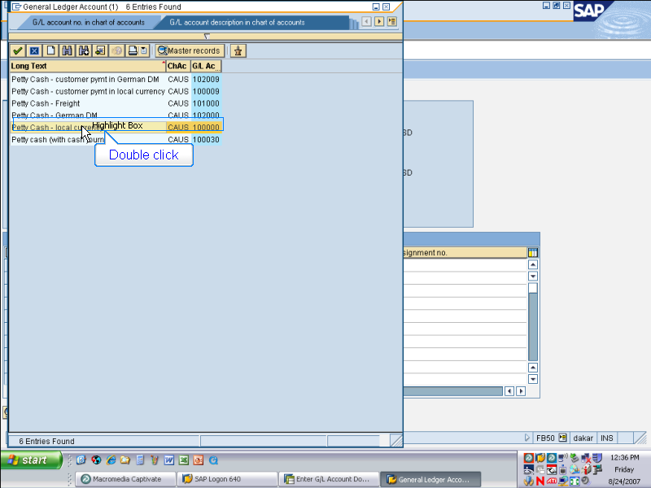

Double click

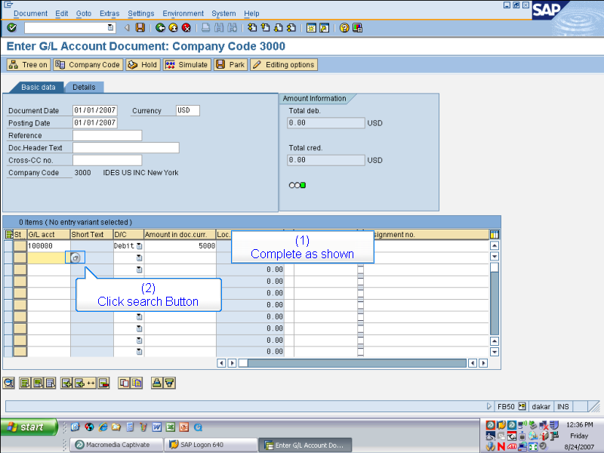

(1)
Complete as shown

(2)
Click search Button

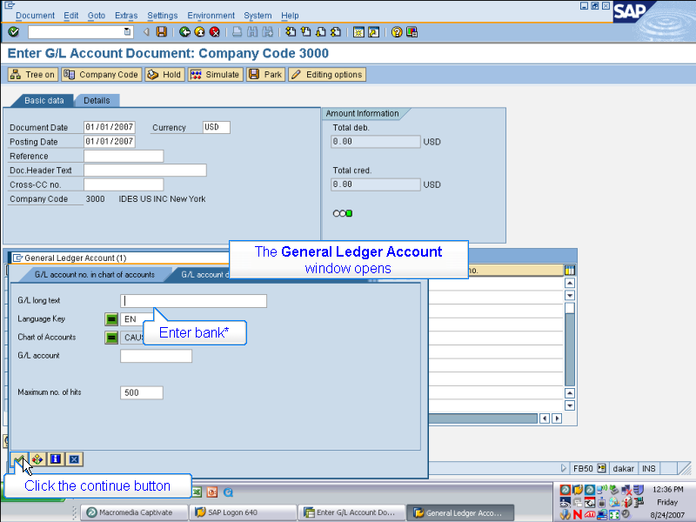

General Ledger Account window opens

Enter bank*

Click the continue button

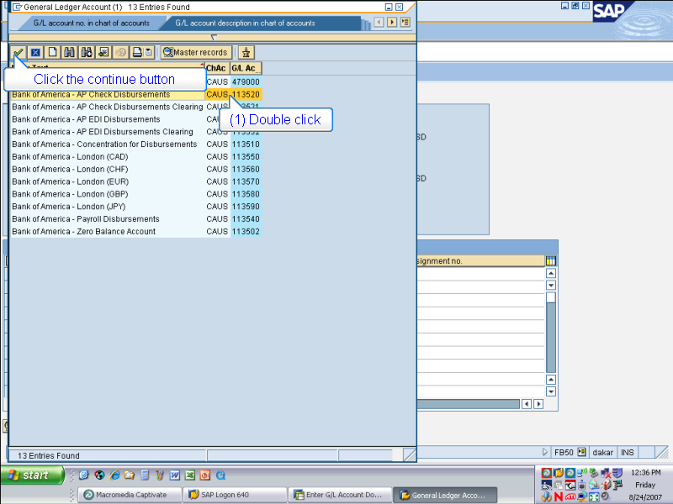

(1) Double click on Bank of America – AP check disbursements

(2) Click the continue button

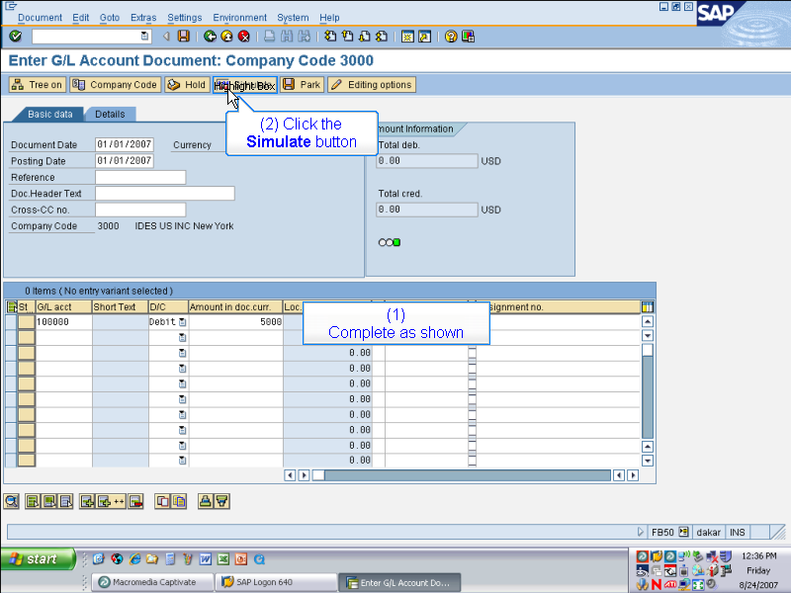

(1) Complete as shown

(2) Click the Simulate button

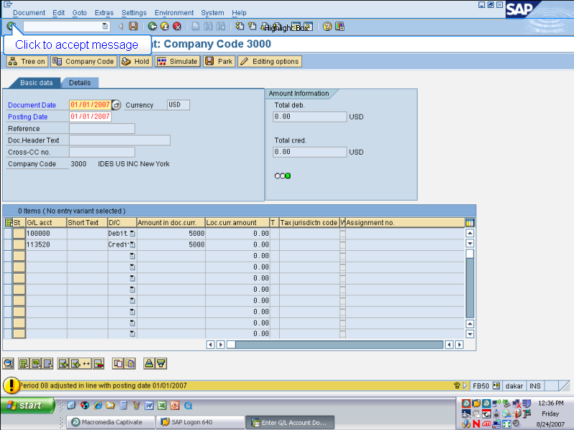

Click to accept message

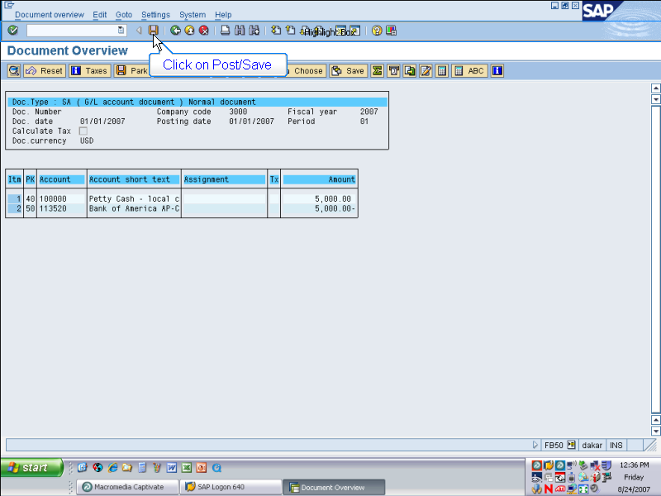

Click on Post/Save

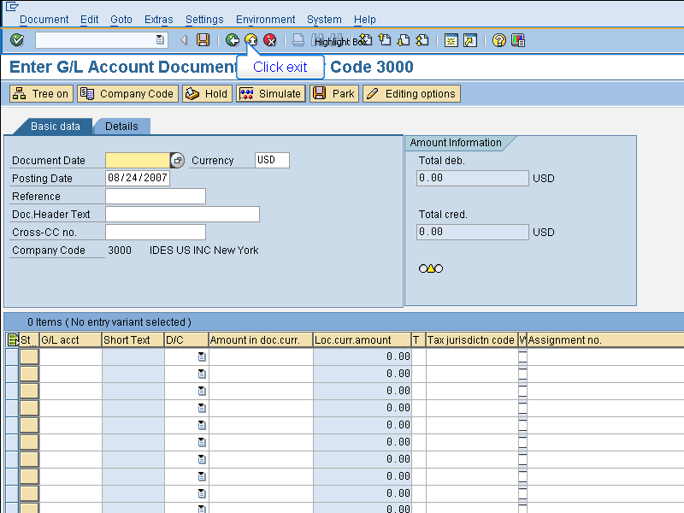

Click exit

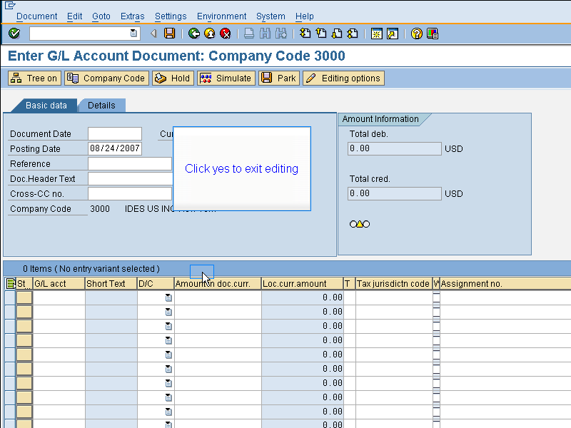

Click yes to exit editing

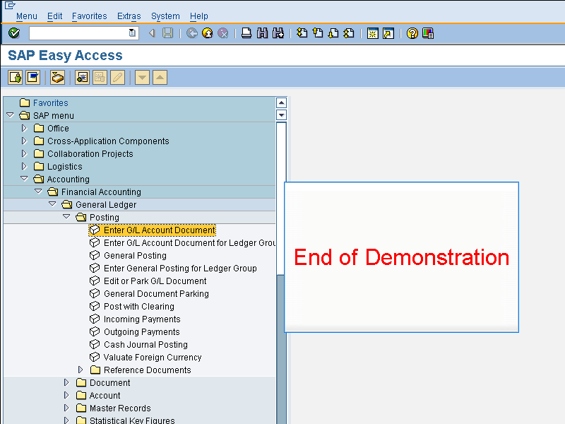

End of Demonstration

