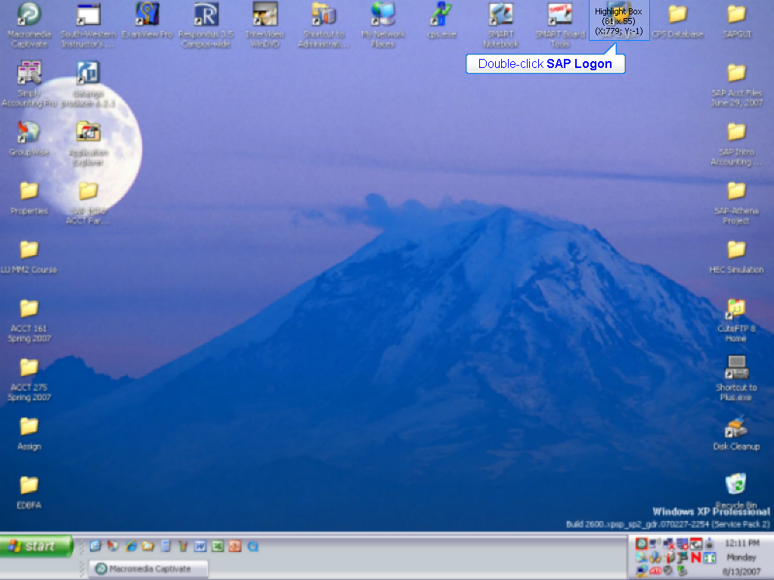

Double-click SAP Logon

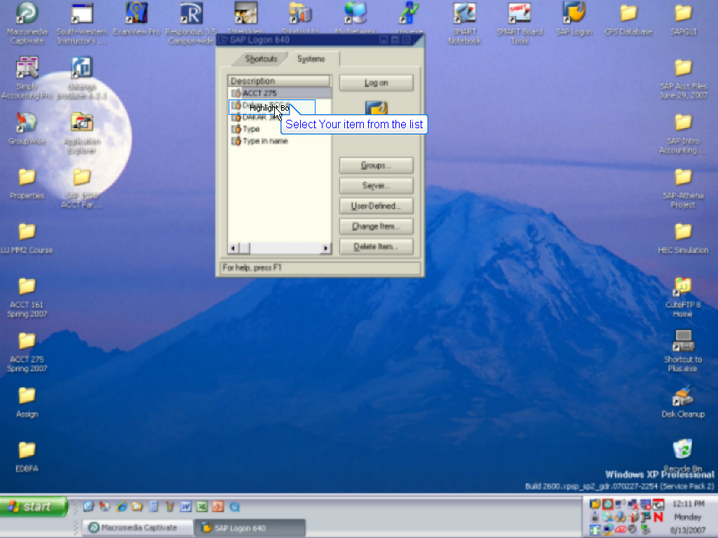

Select Your item from the list

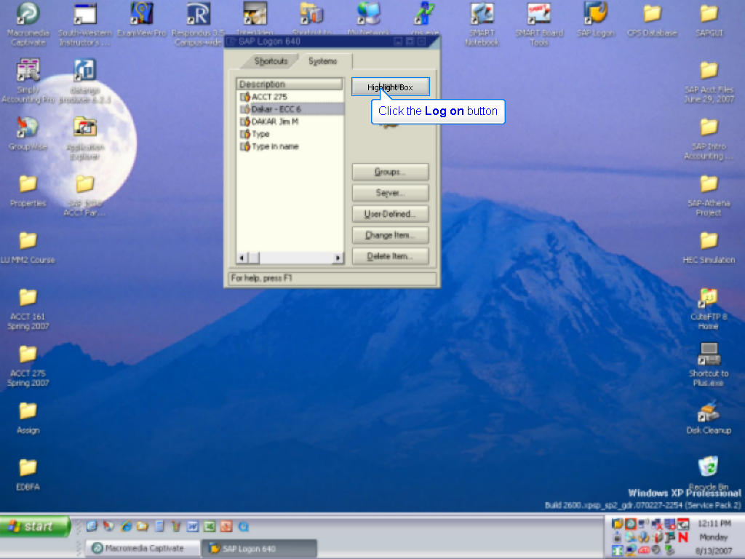

Click the Log on button

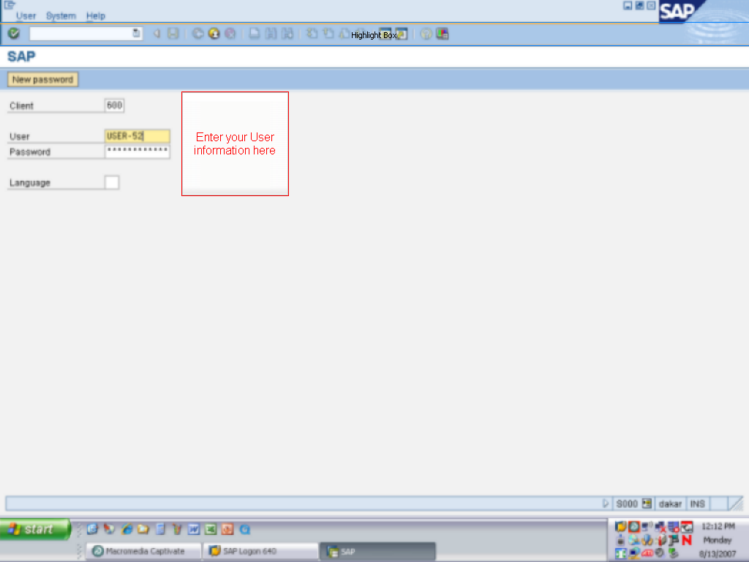

Enter your User information here

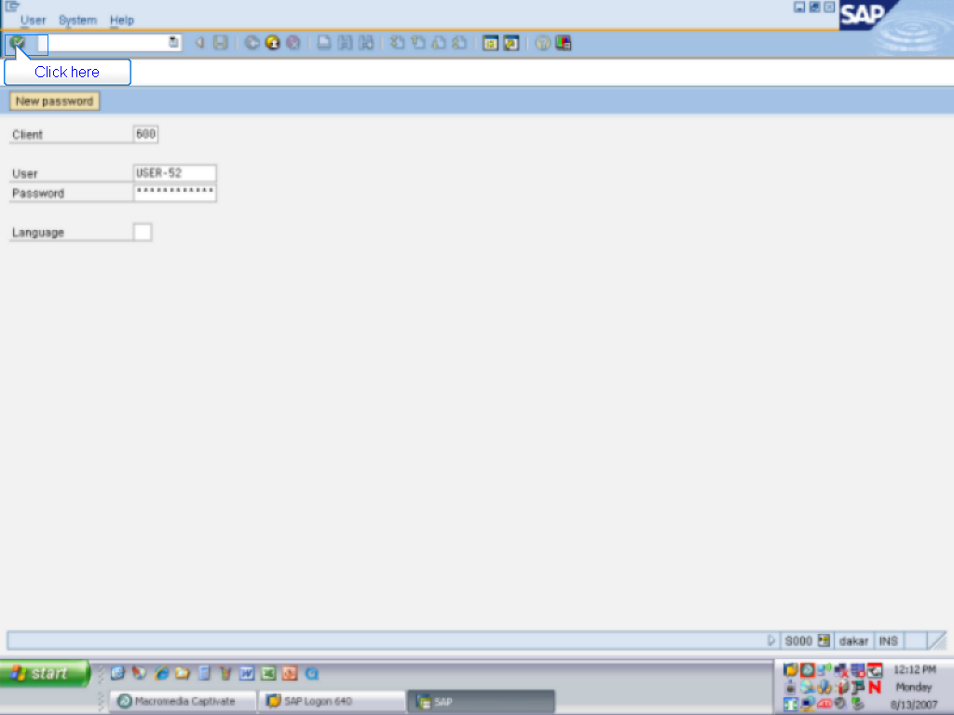

Click here

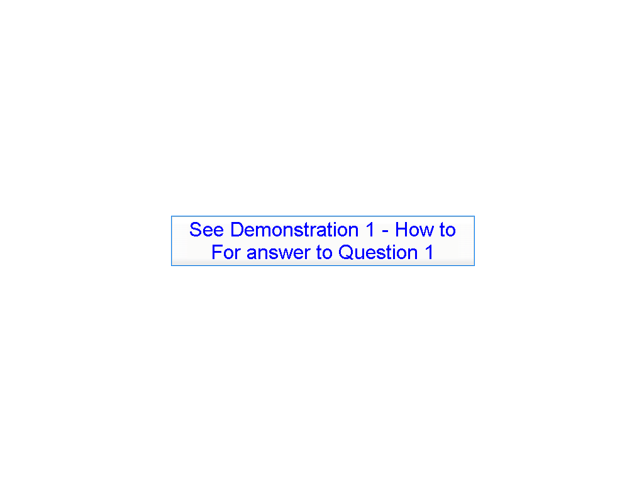

See Demonstration 1 - How to For answer to Question 1

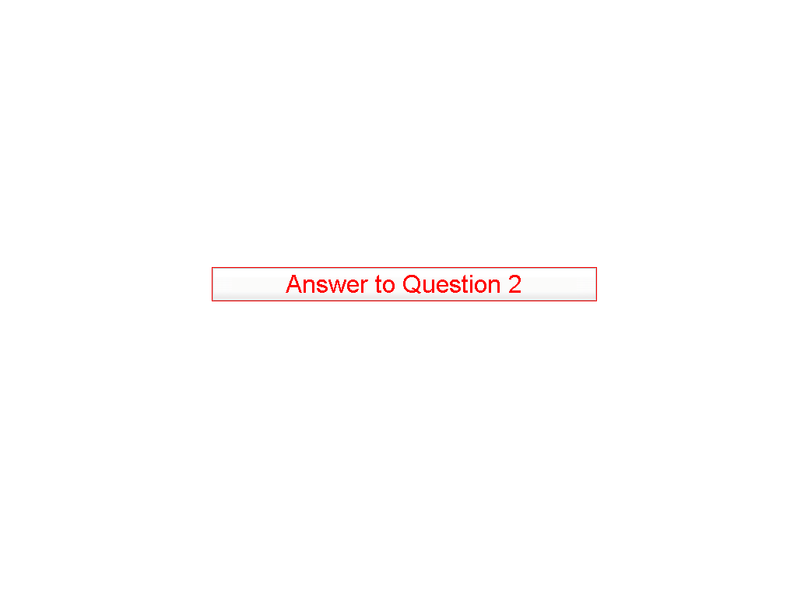

Answer to Question 2

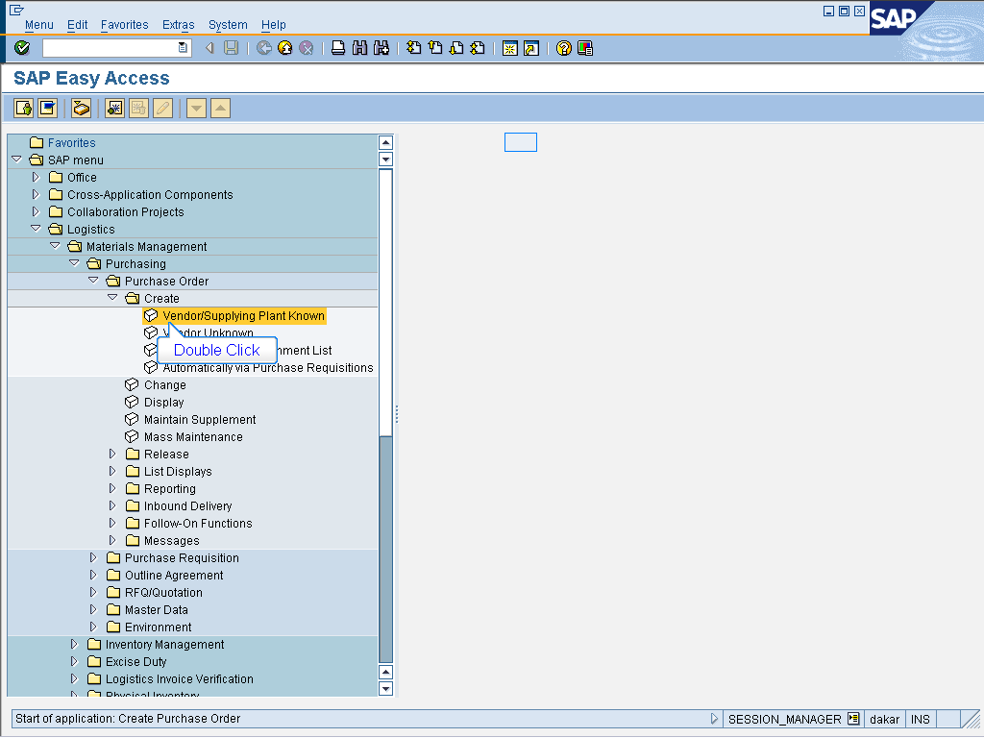

- Logistics > Materials Management
> Purchasing > Purchase Order
> Create

Double Click Vendor/Supplying Plant Known

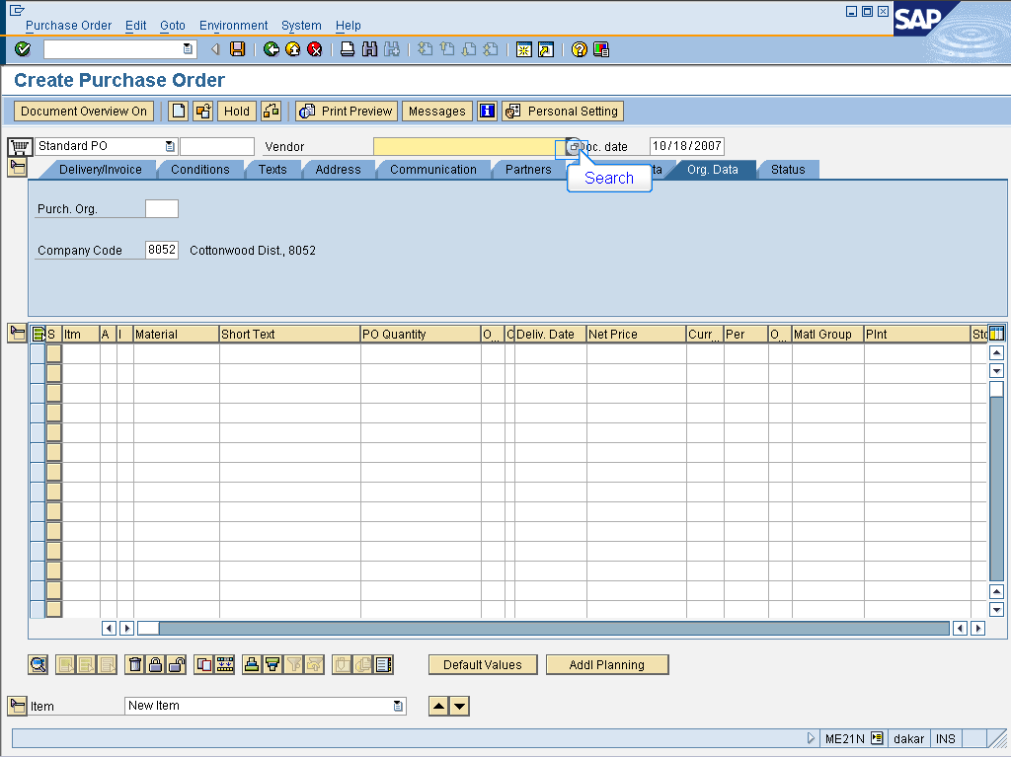

Search for Vendor

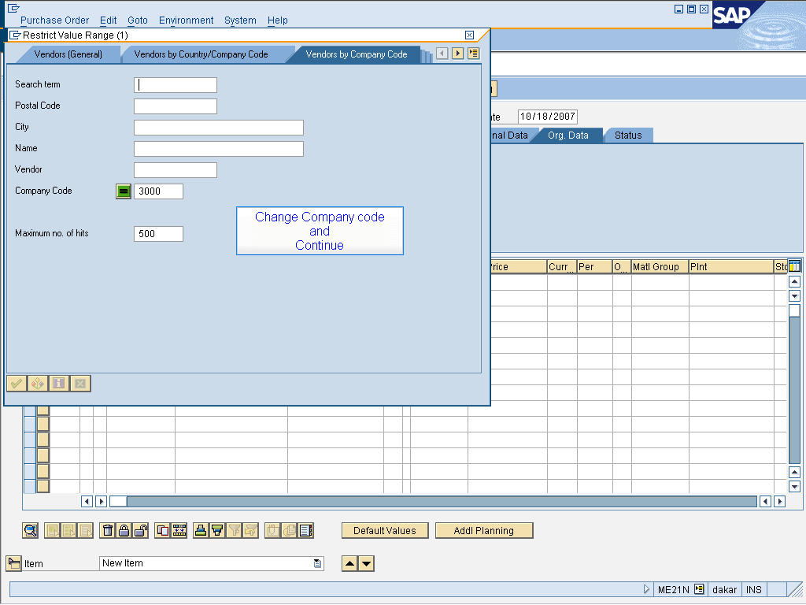

Change Company code
and
Continue

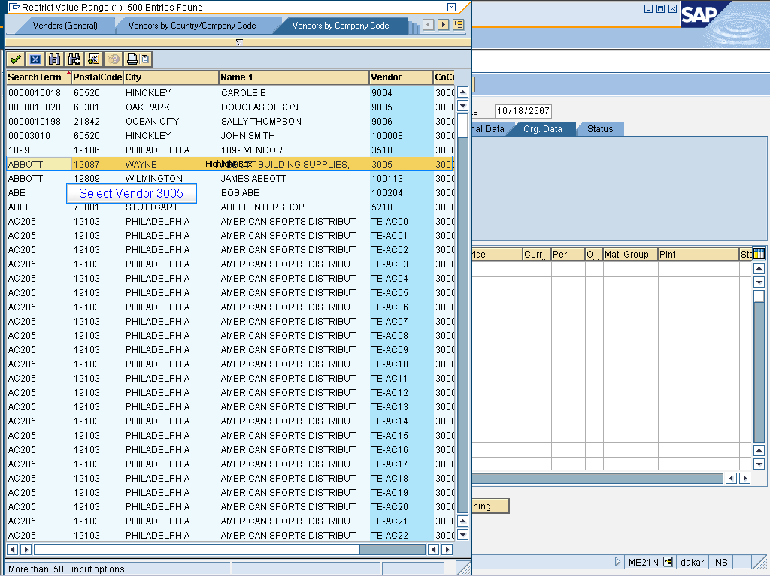

Select Vendor 3005

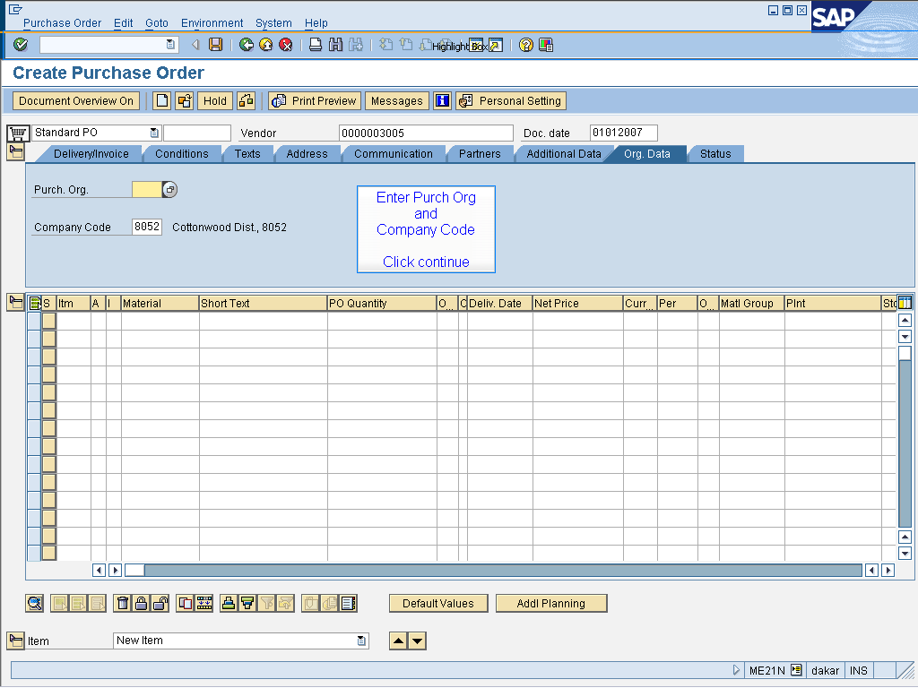

Enter Purch Org
and
Company Code

Click continue

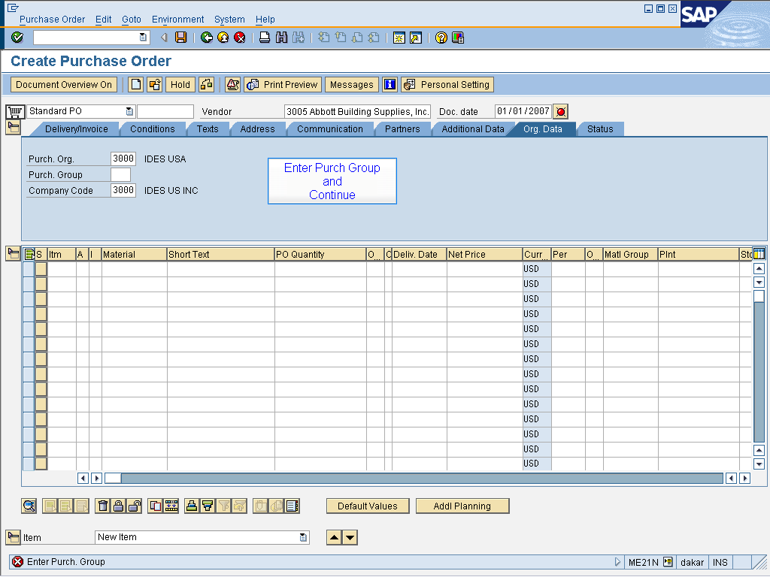

Enter Purch Group
and
Continue

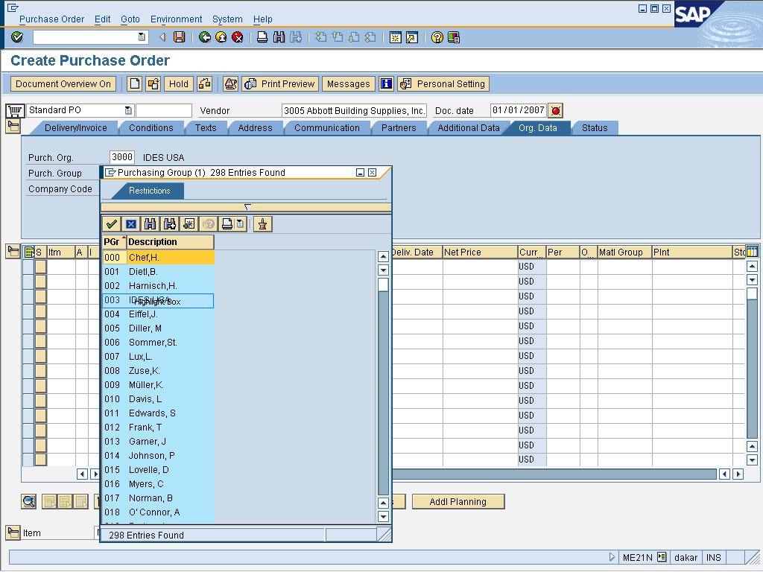

Select 003

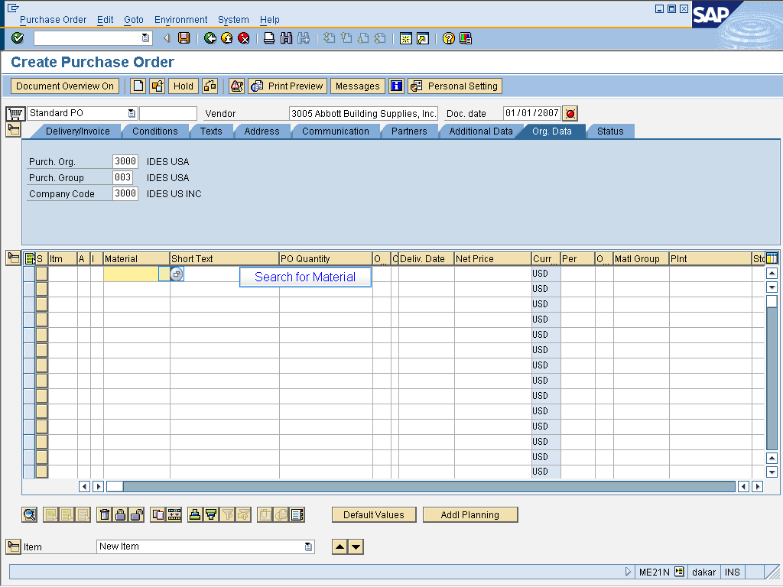

Search for Material

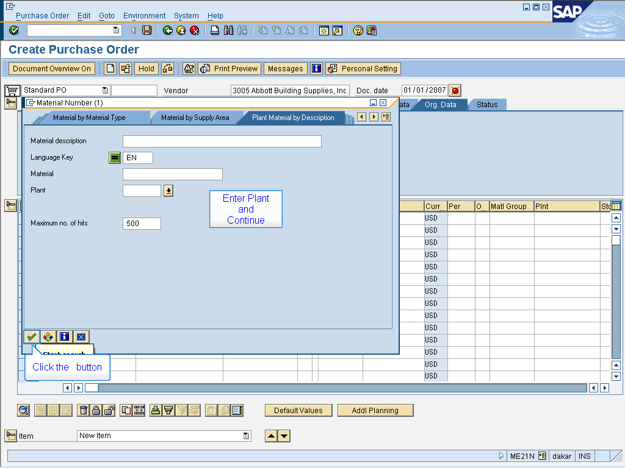

Enter Plant
and
Continue

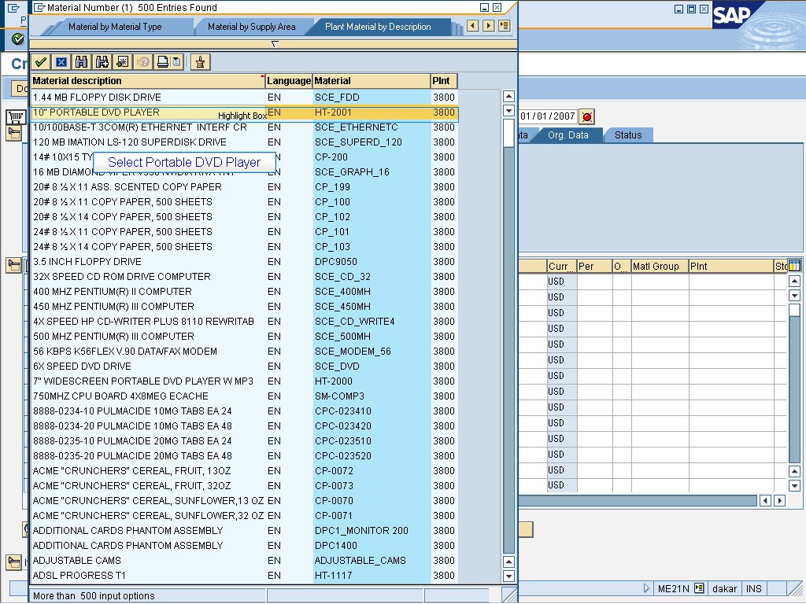

Select Portable DVD Player

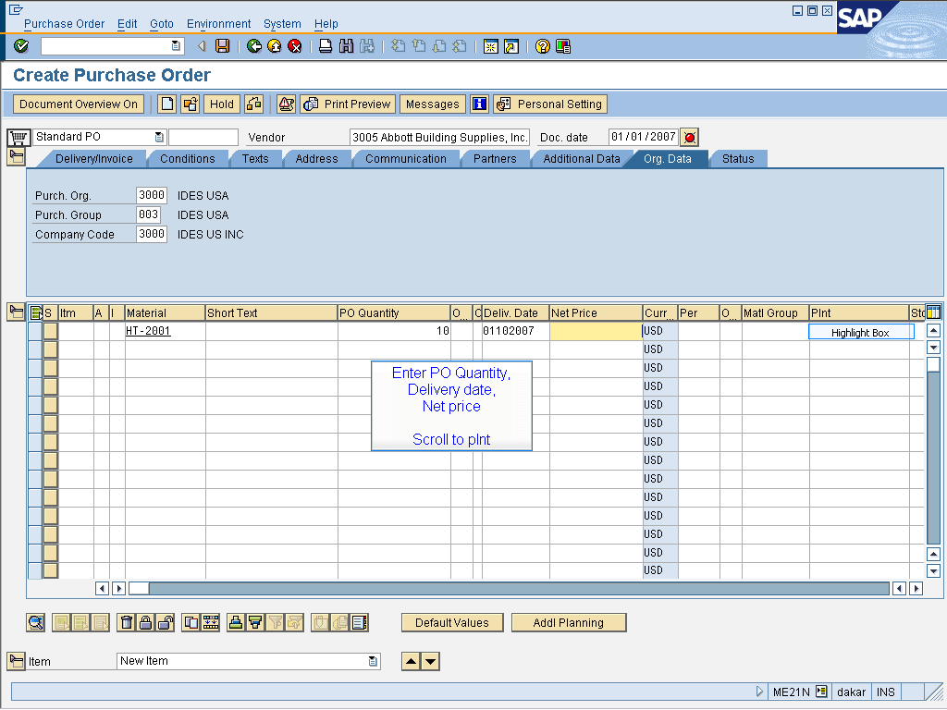

Enter PO Quantity,
Delivery date,
Net price

Scroll to plnt

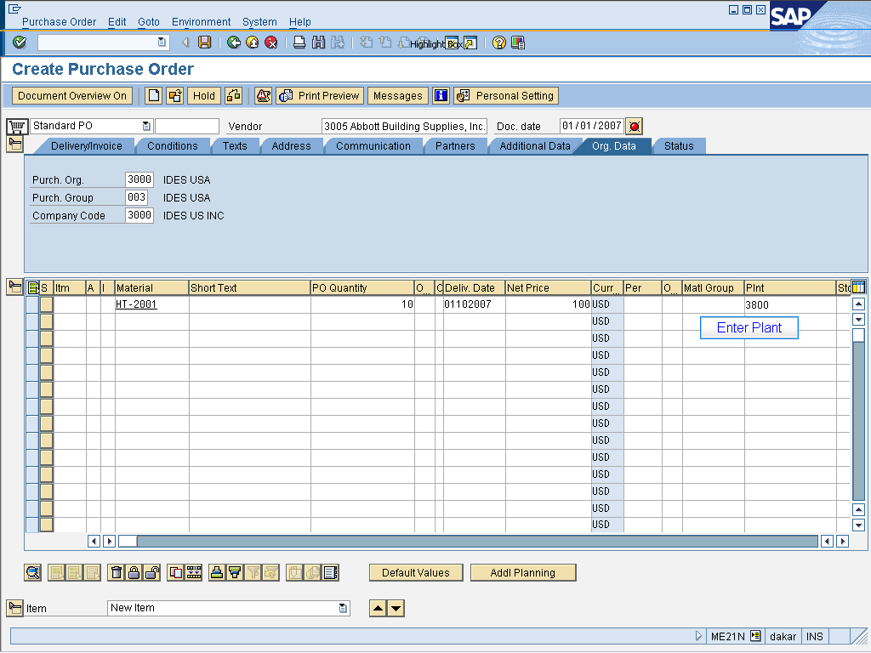

Enter Plant

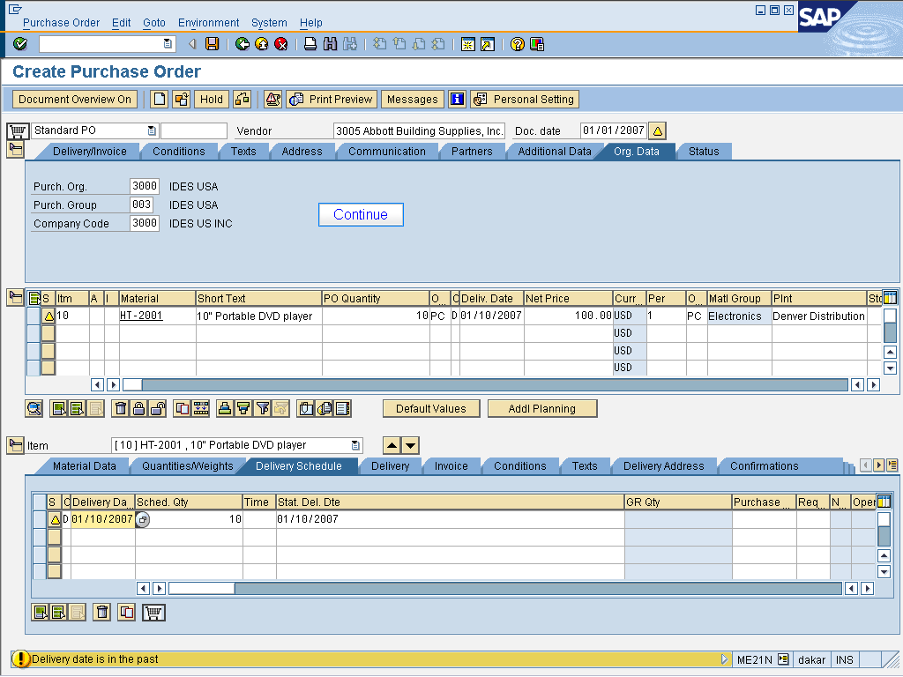

Continue

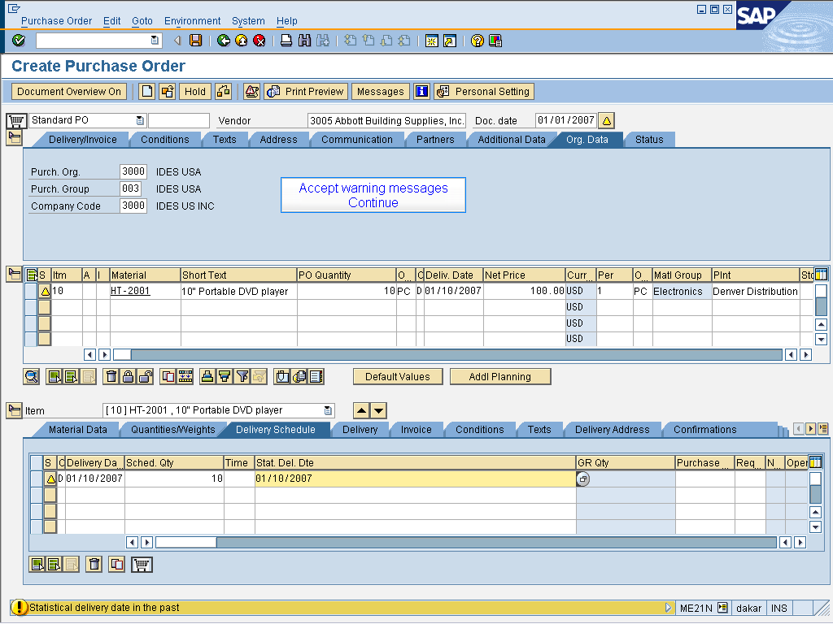

Accept warning messages
Continue

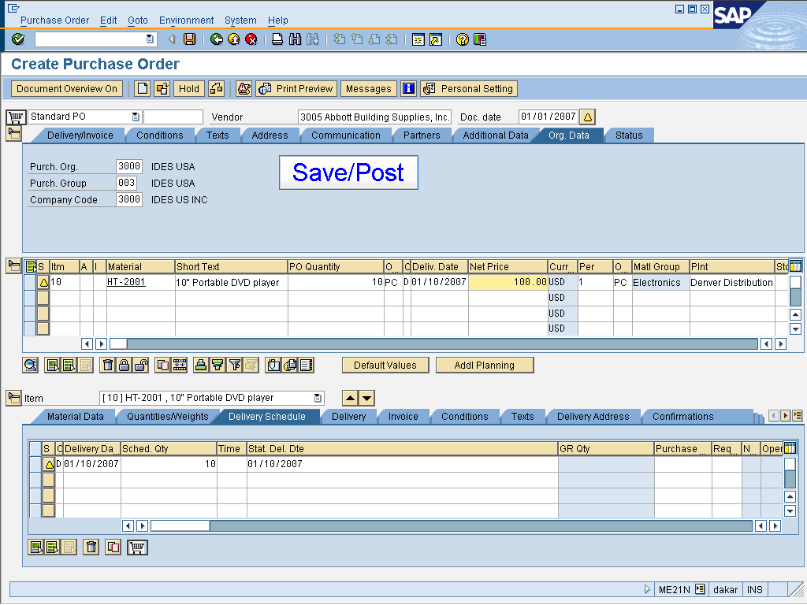

Save/Post

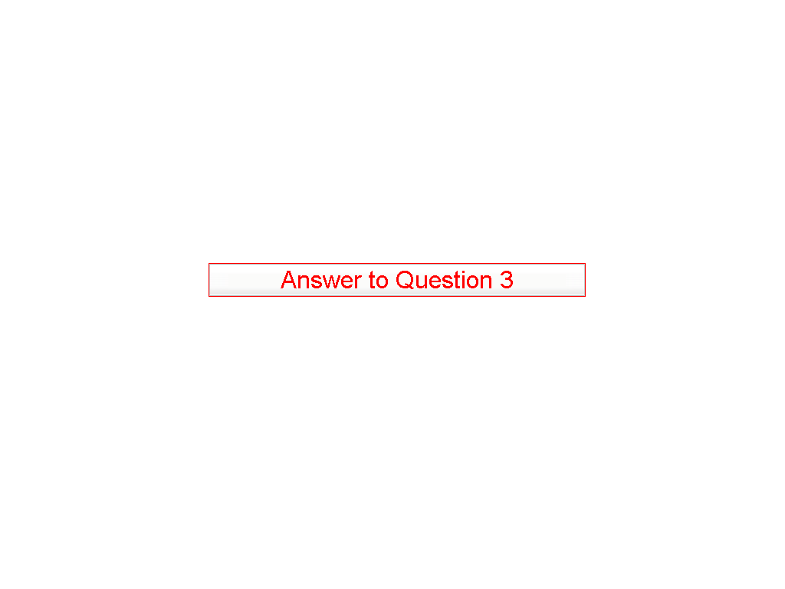

Answer to Question 3

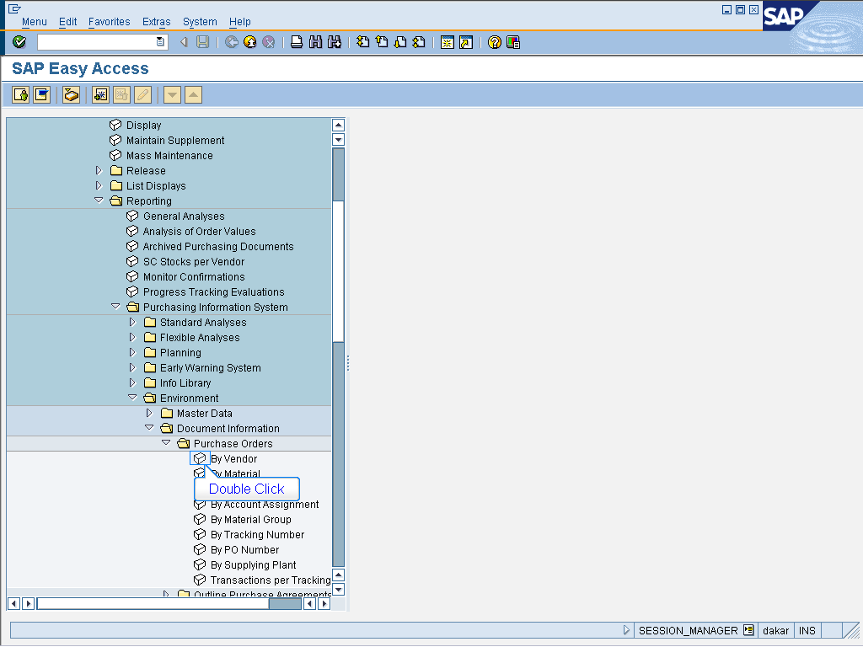

- Logistics > Materials Management
> Purchasing > Purchase Order
> Reporting > Purchasing Information System > Environment
>Document Information > Purchase Orders
Double click By Vendor

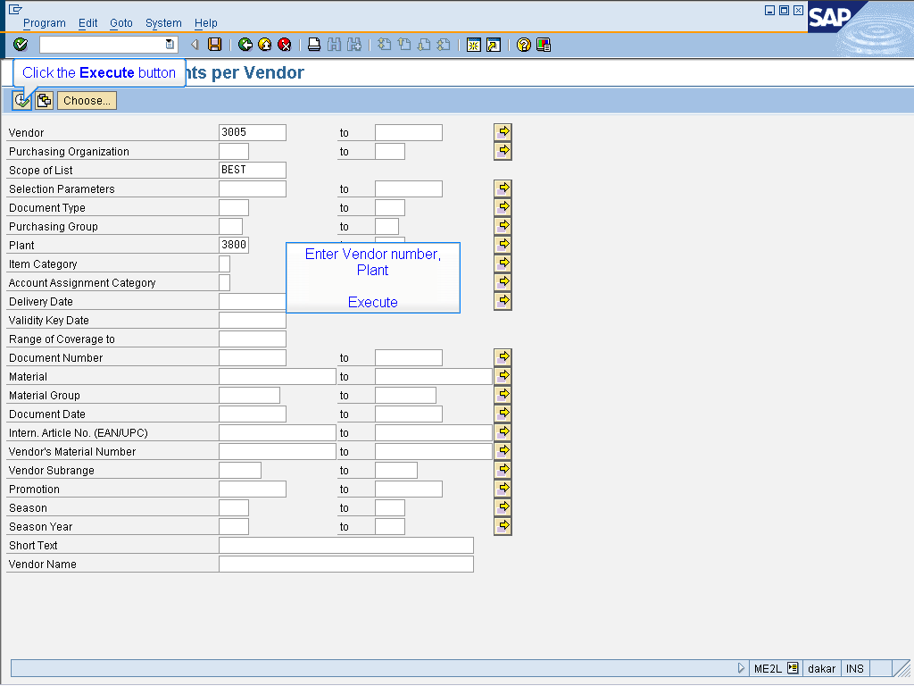

Enter Vendor number,
Plant

Execute

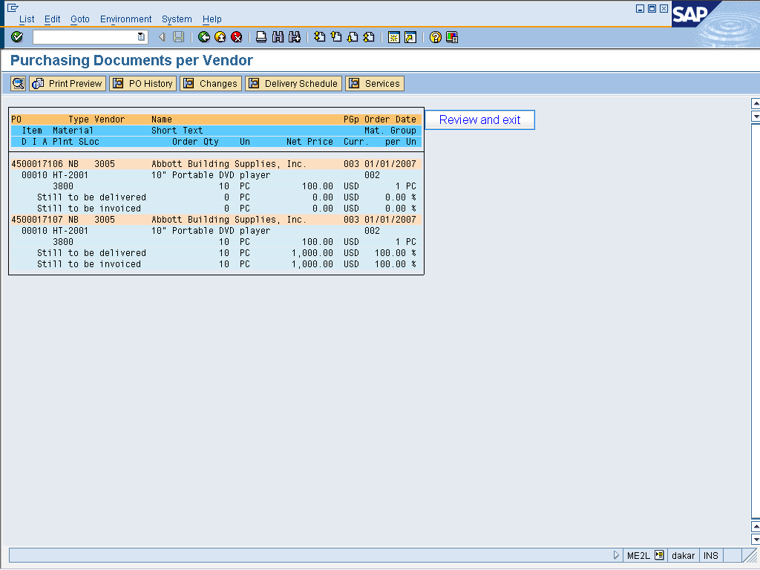

Review and exit

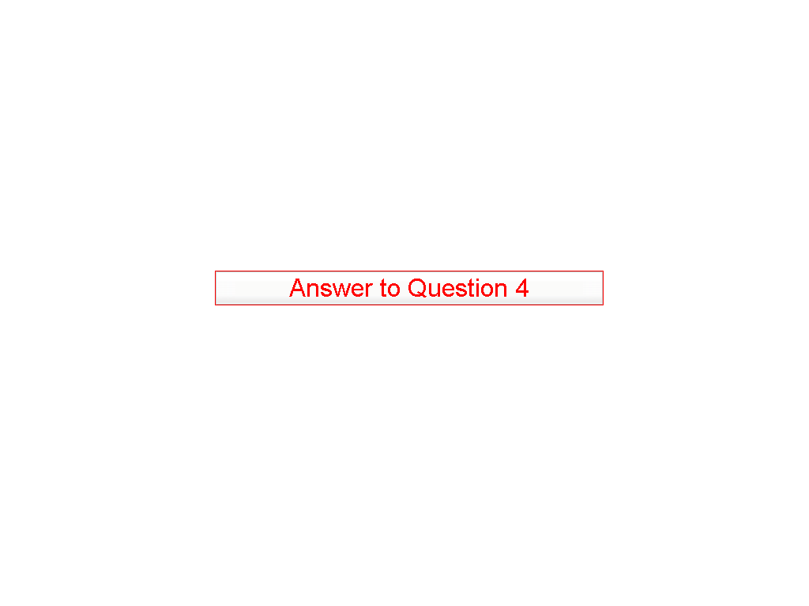

Answer to Question 4

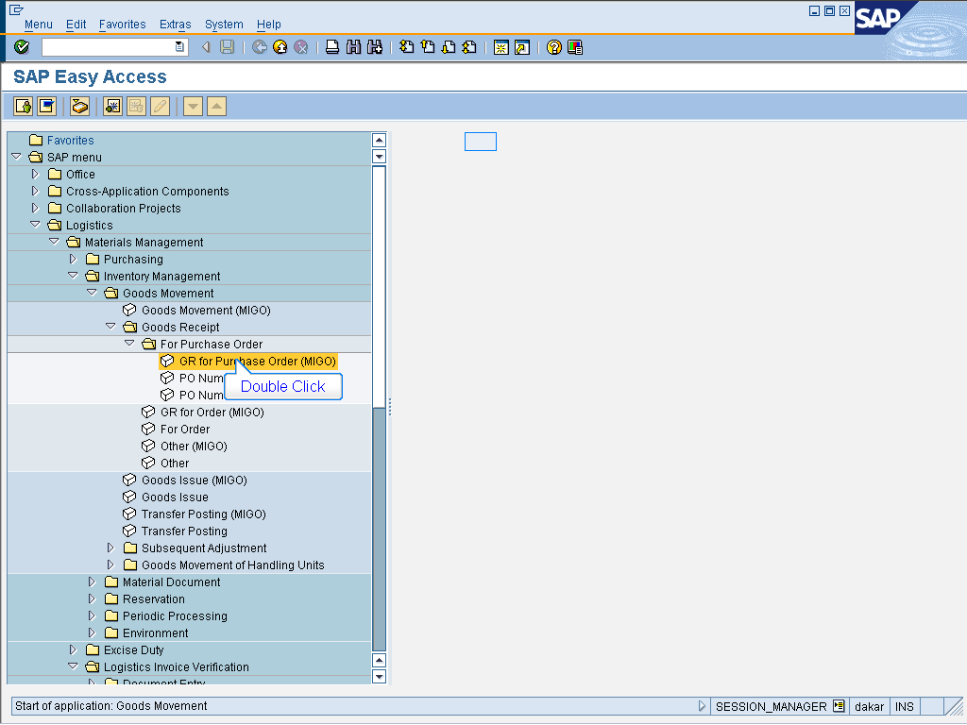

> Logistics > Materials Management
> Inventory Management > Goods Movement
> Goods Receipt > For Purchase Order
Double click GR for Purchase Order (MIGO)

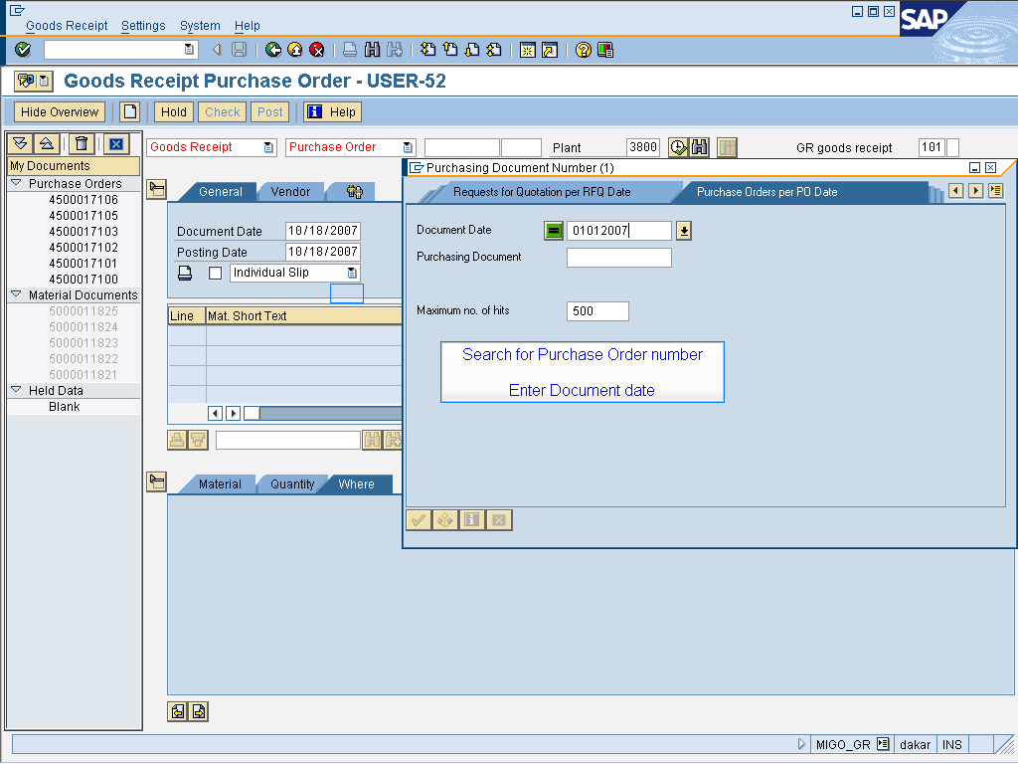

Search for Purchase Order number

Enter Document date

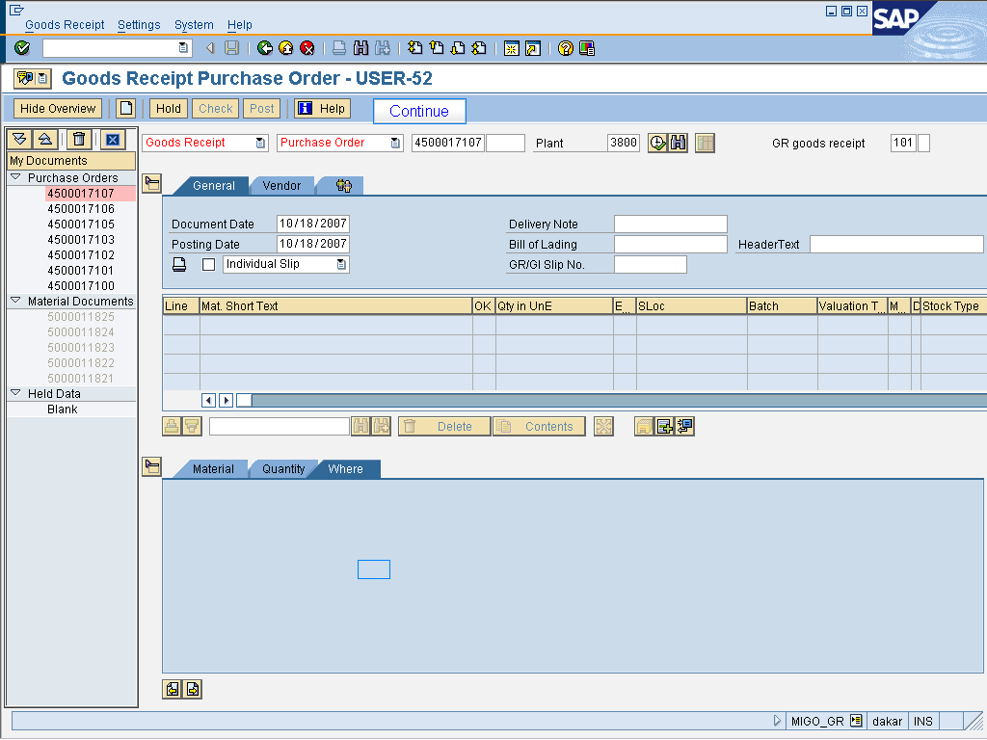

Continue

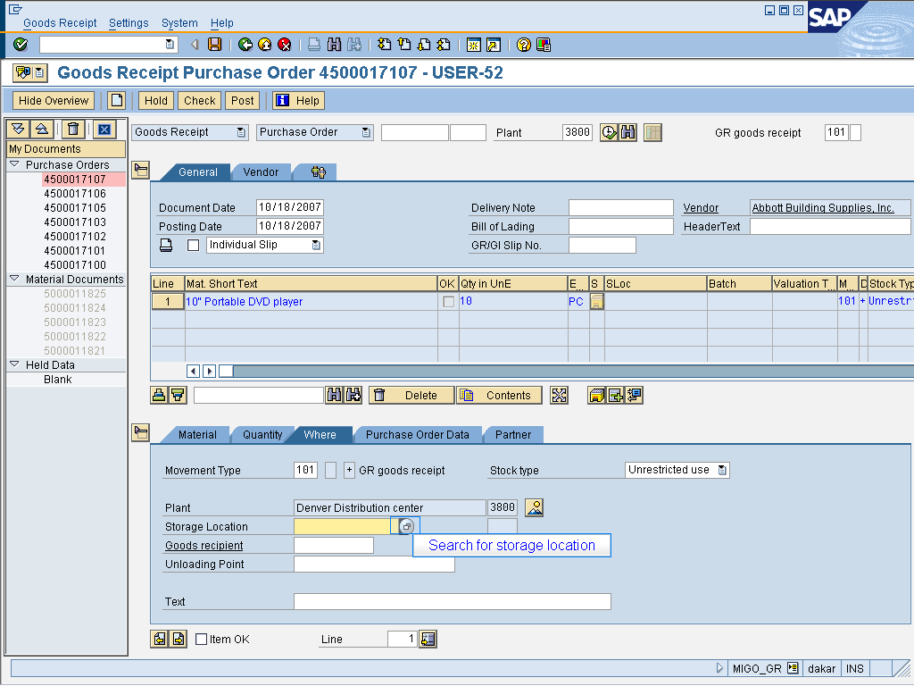

Search for storage location

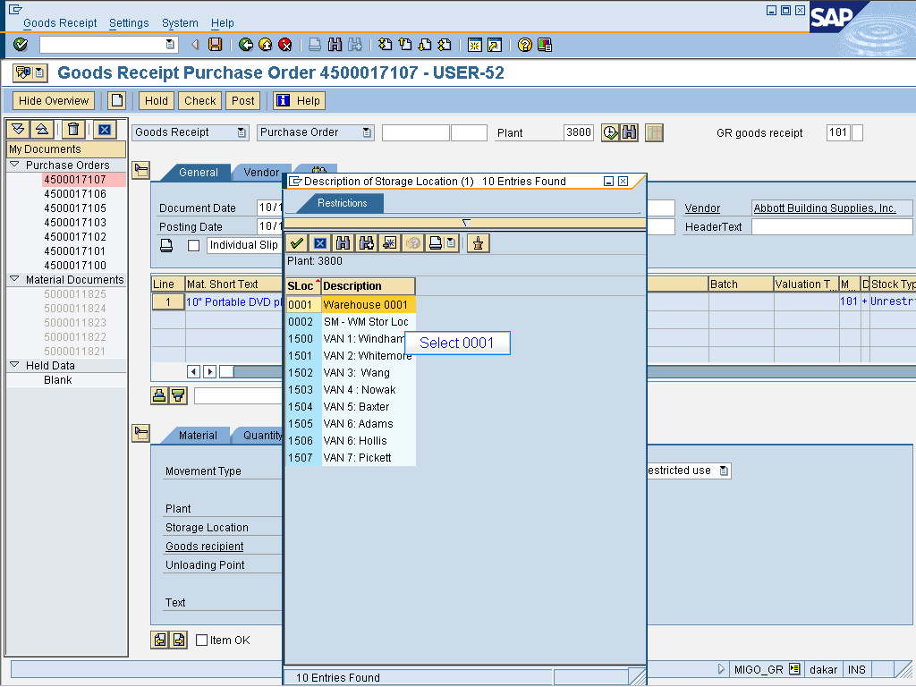

Select 0001

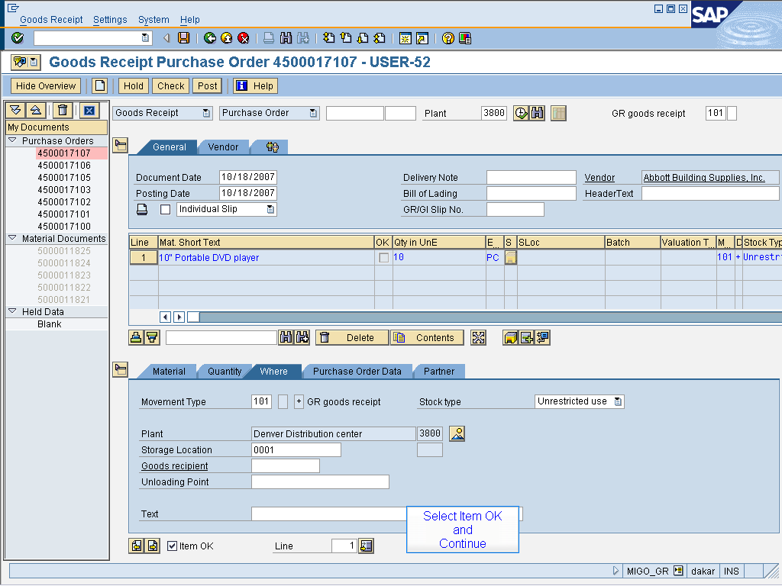

Select Item OK
and
Continue

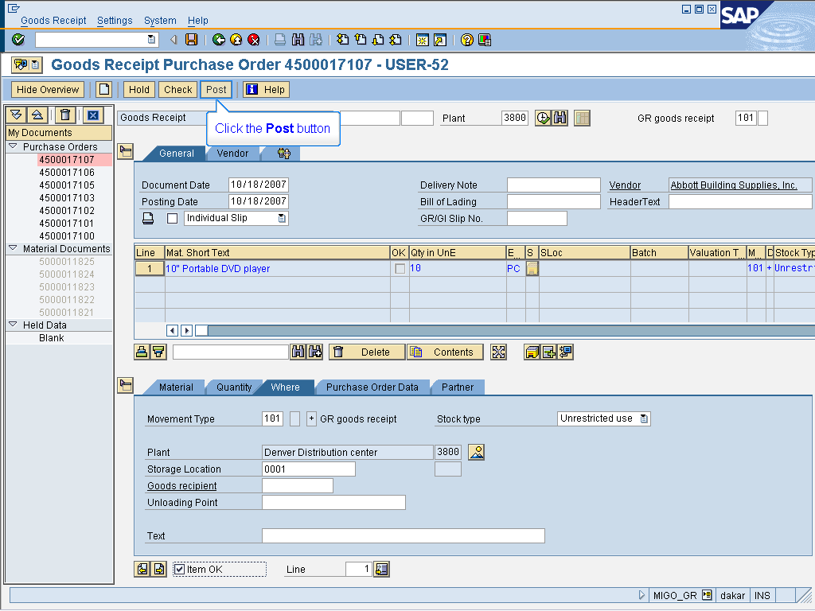

Click the Post button

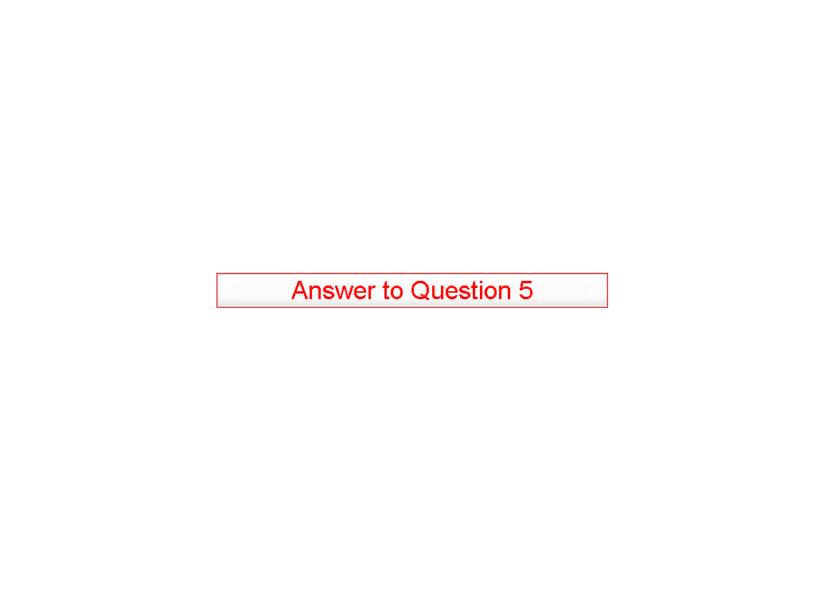

Answer to Question 5

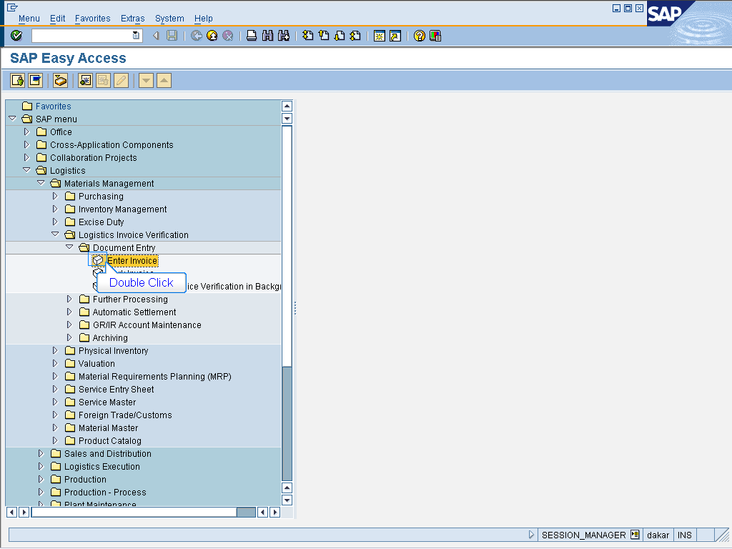

> Logistics > Materials Management
> Logistics Invoice Verification
> Document Entry
Double click Enter Invoice

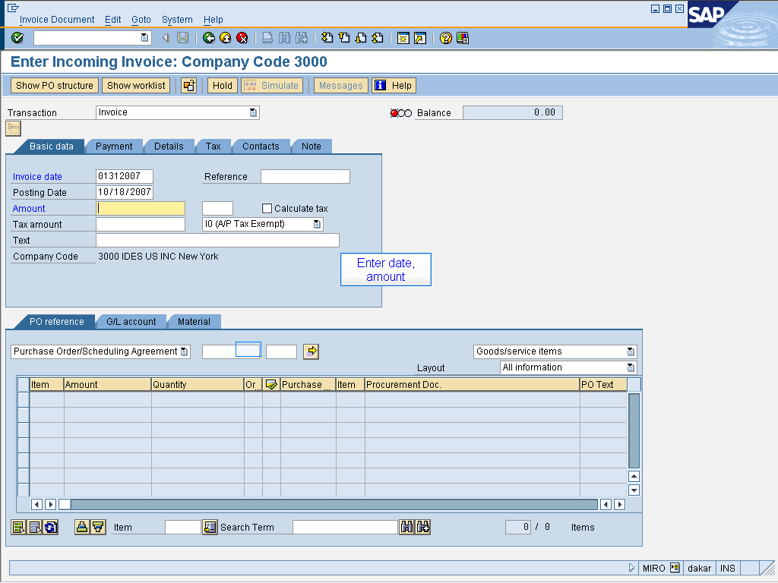

Enter date,
amount

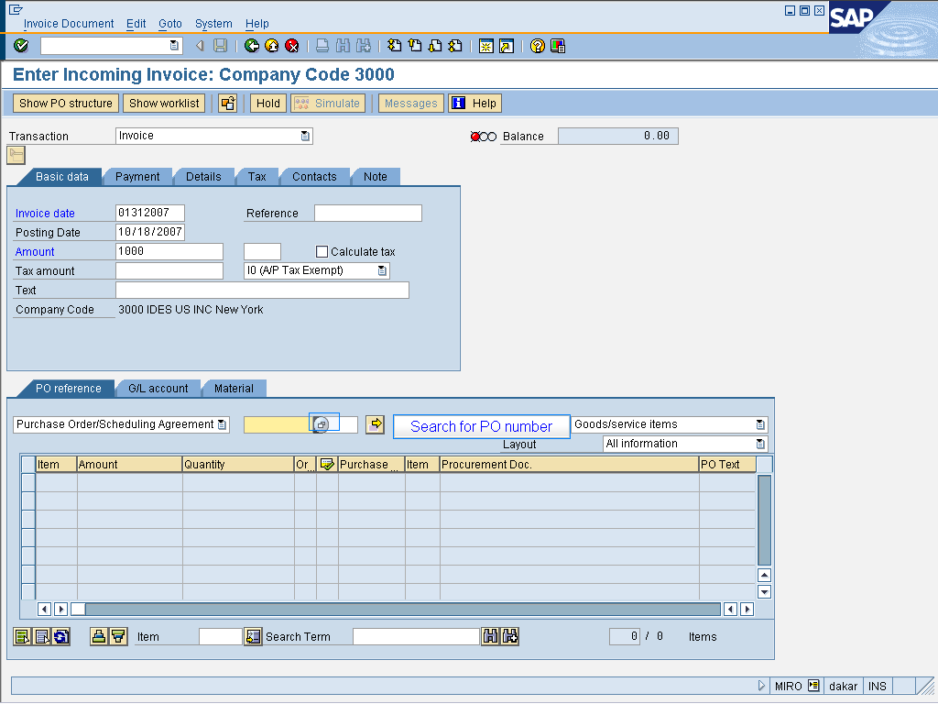

Search for PO number

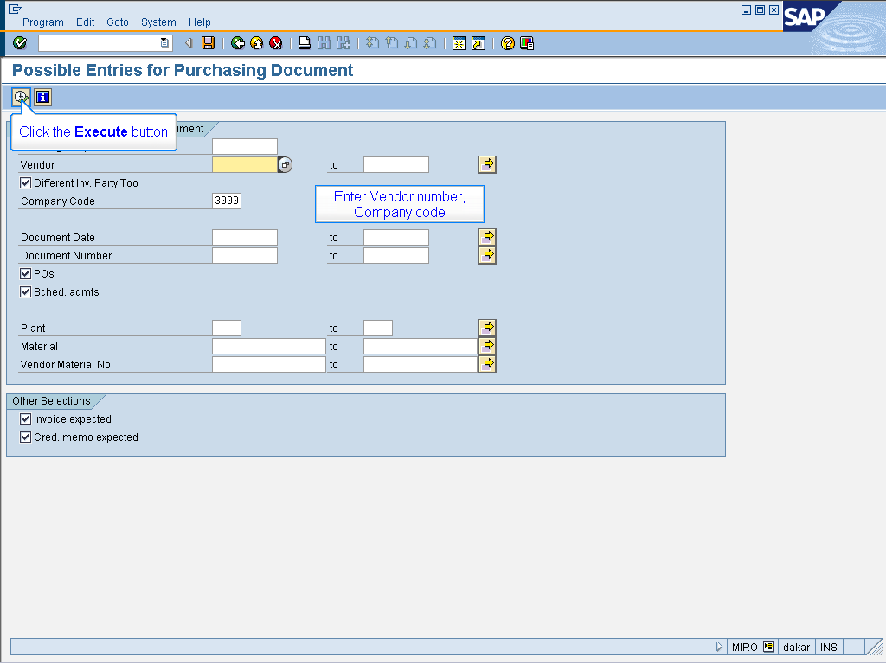

Enter Vendor number,
Company code

Click the Execute button

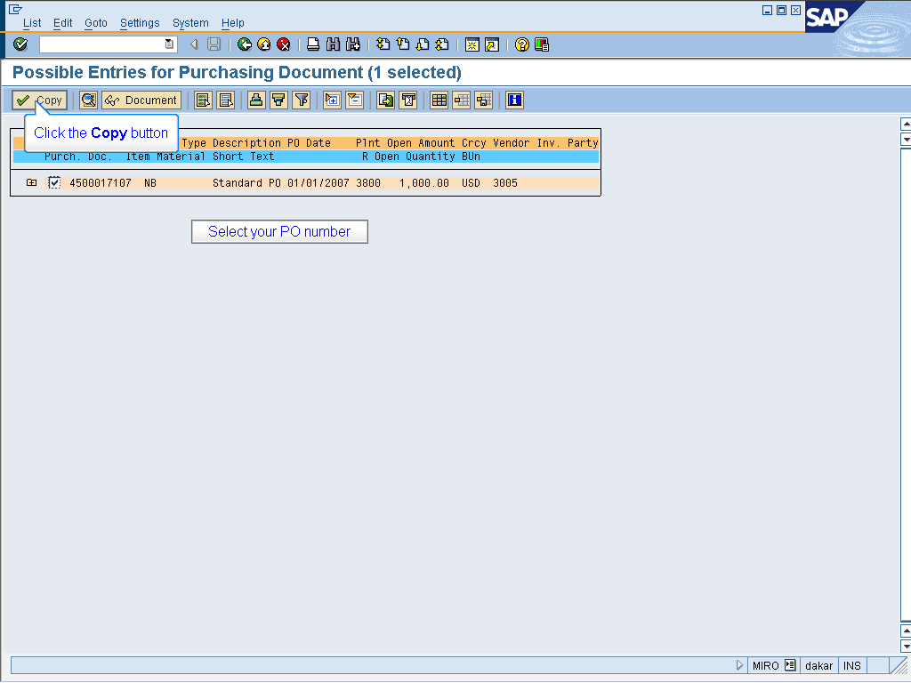

Select your PO number

Click the Copy button

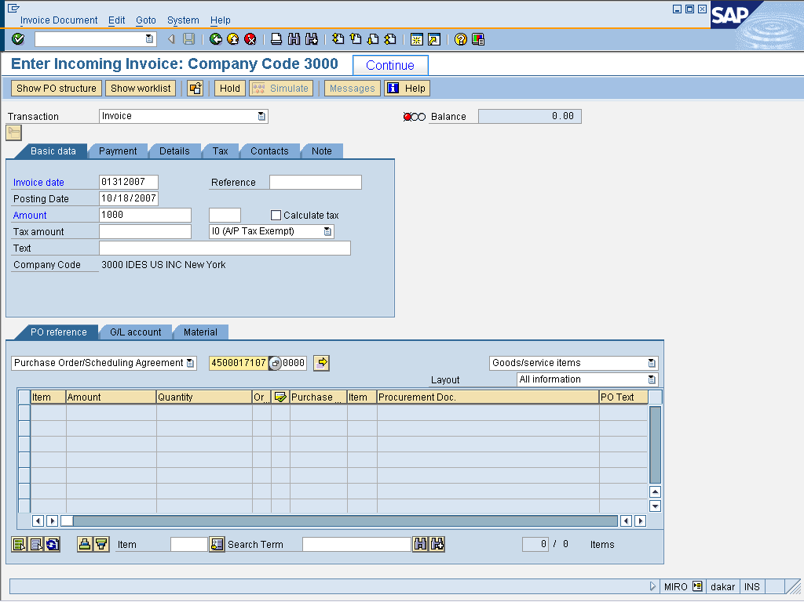

Continue

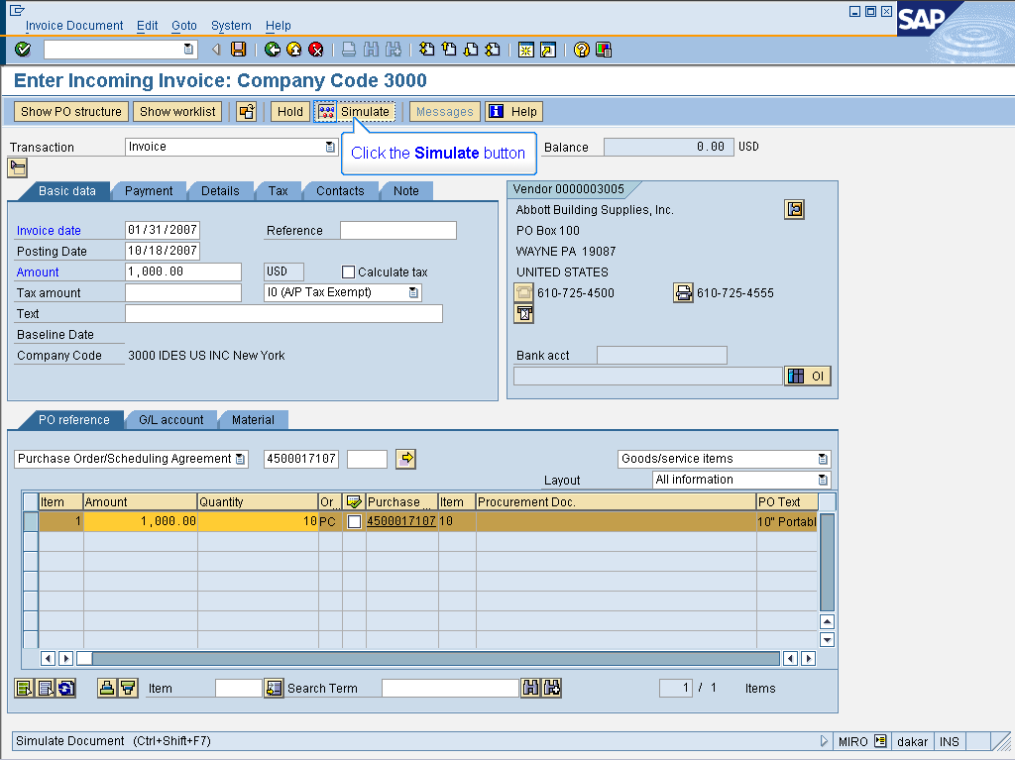

Click the Simulate button

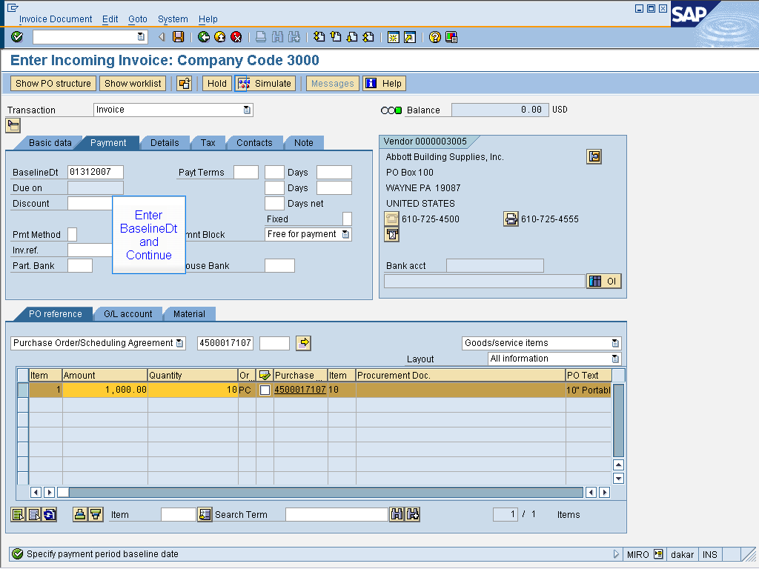

Enter BaselineDt
and
Continue

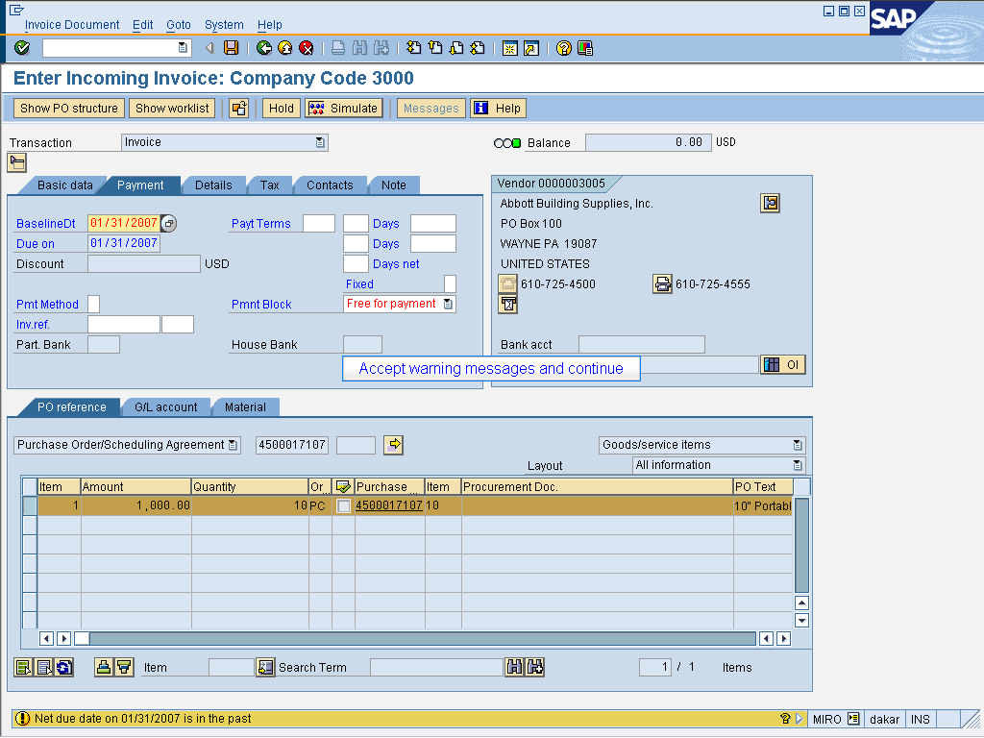

Accept warning messages and continue

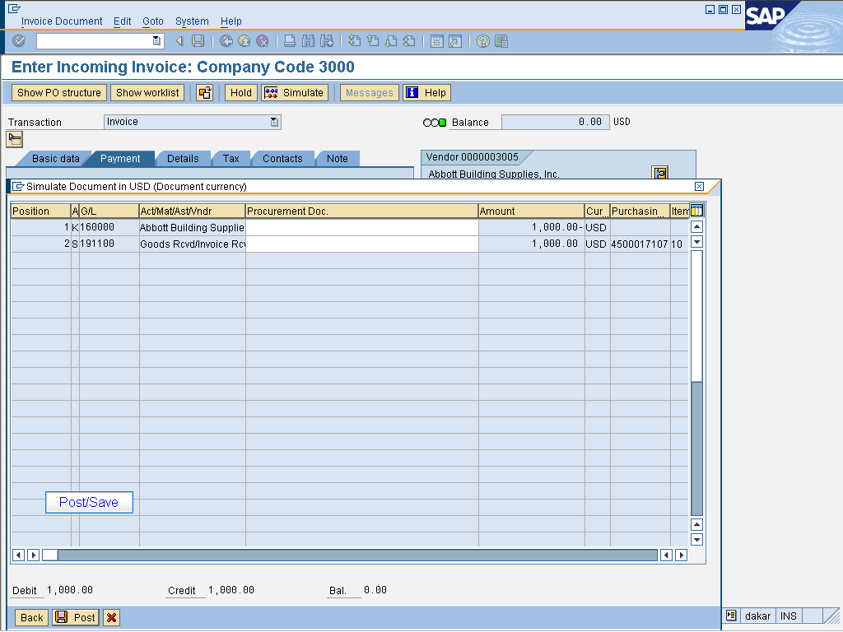

Post/Save

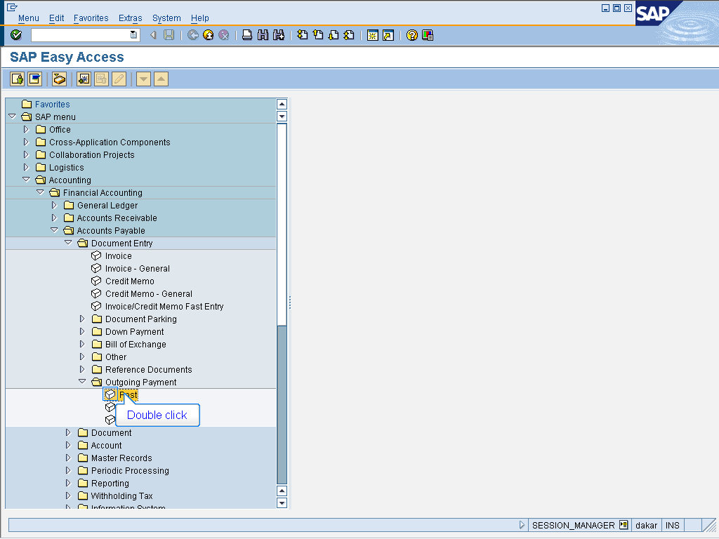

- Accounting > Financial Accounting
> Accounts Payable > Document Entry
> Outgoing Payment
Double click Post

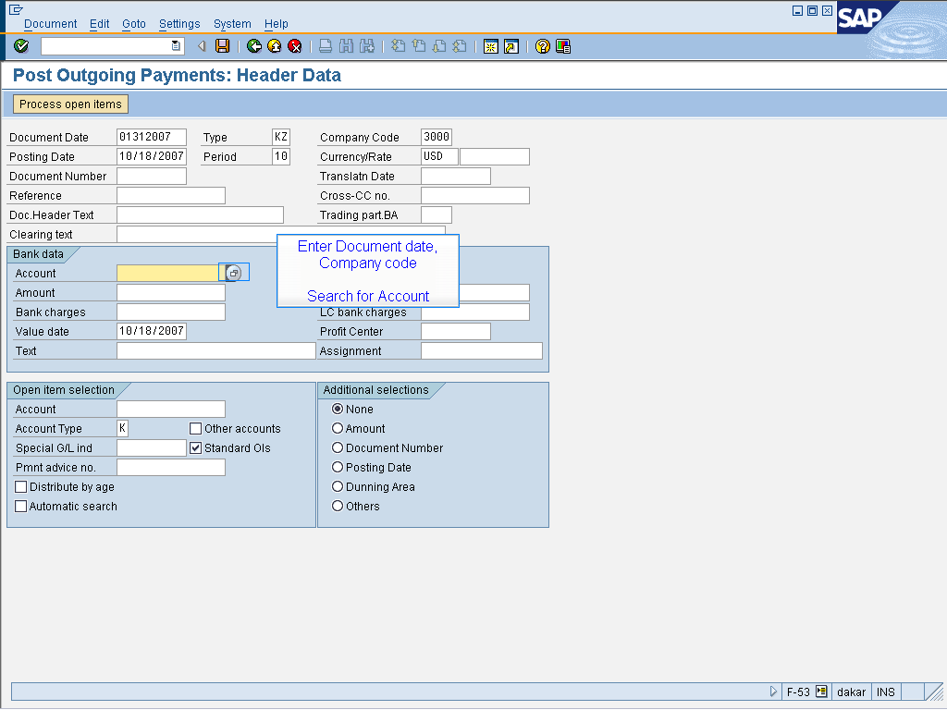

Enter Document date,
Company code

Search for Account

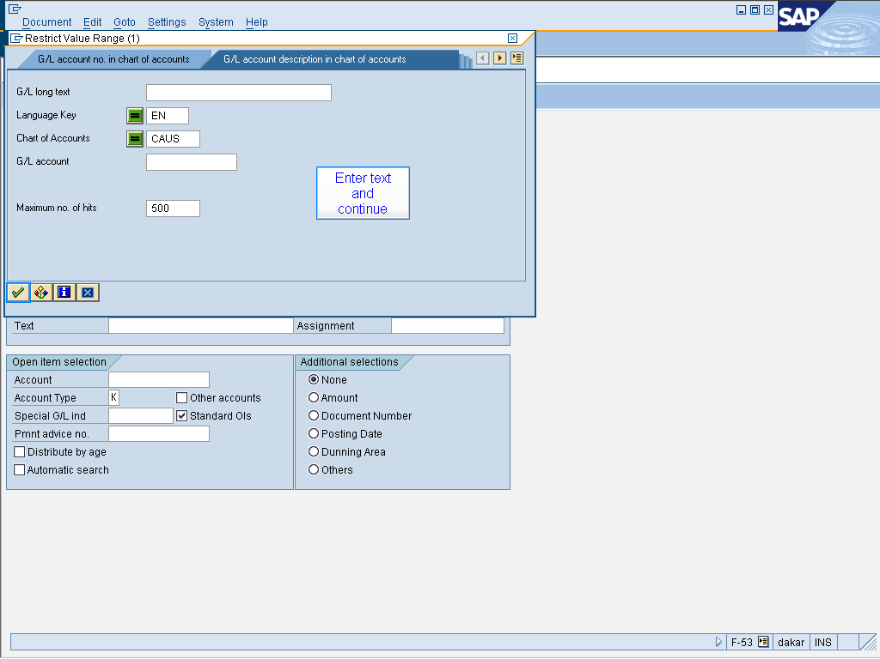

Enter text
and
continue

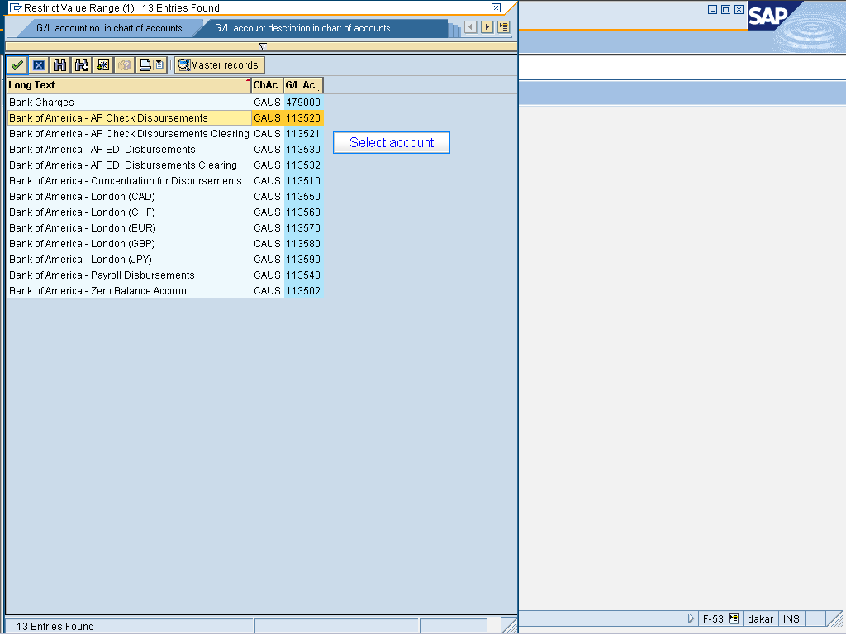

Select account

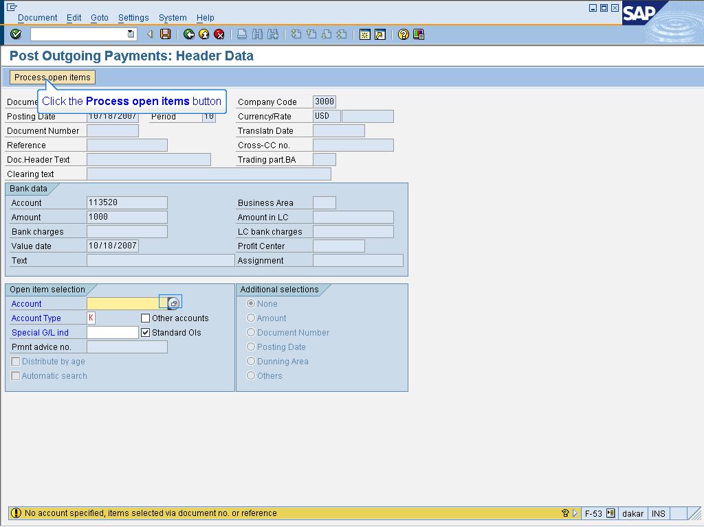

Click the Process open items button

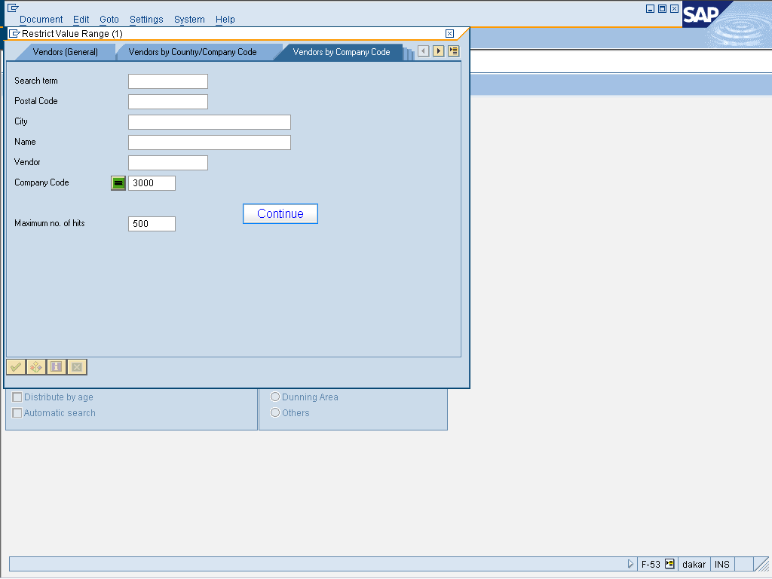

Continue

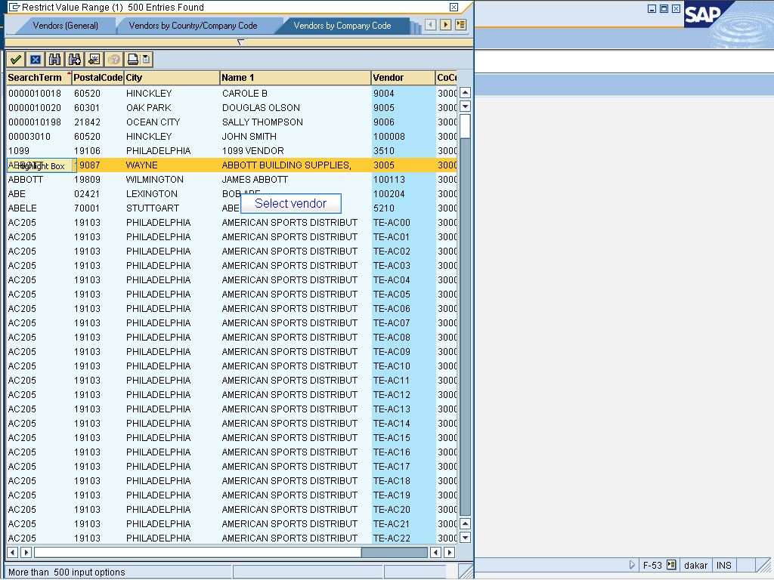

Select vendor

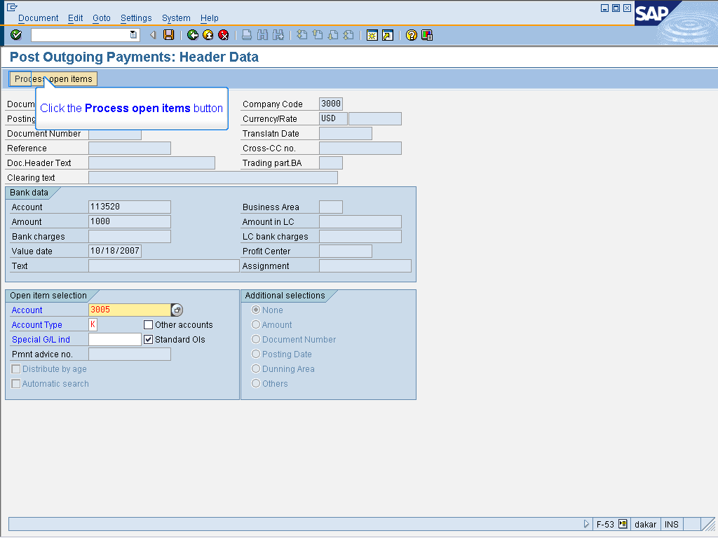

Click the Process open items button

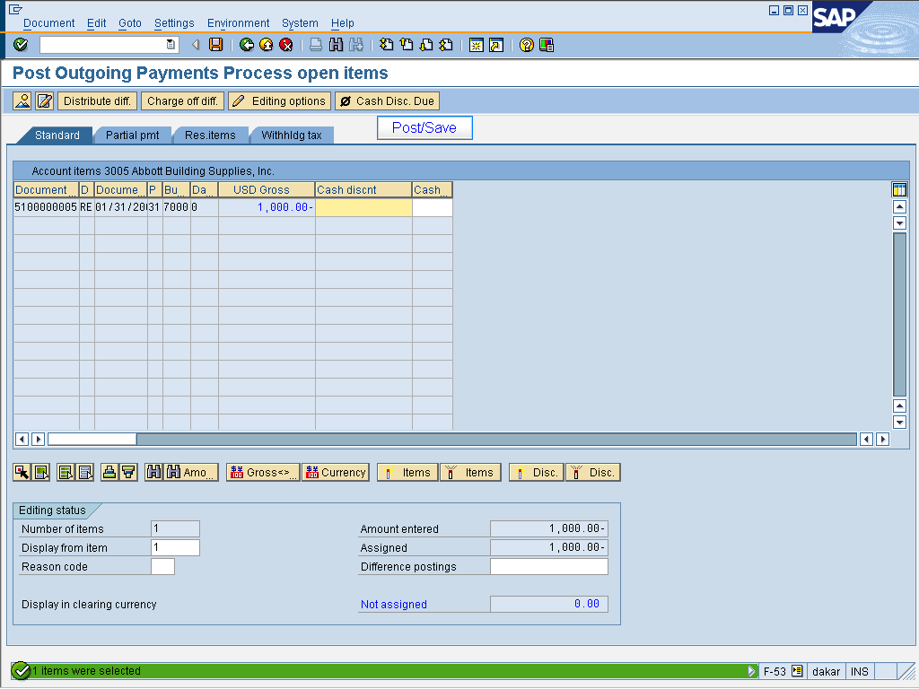

Select your PO Invoice from the list
Post/Save

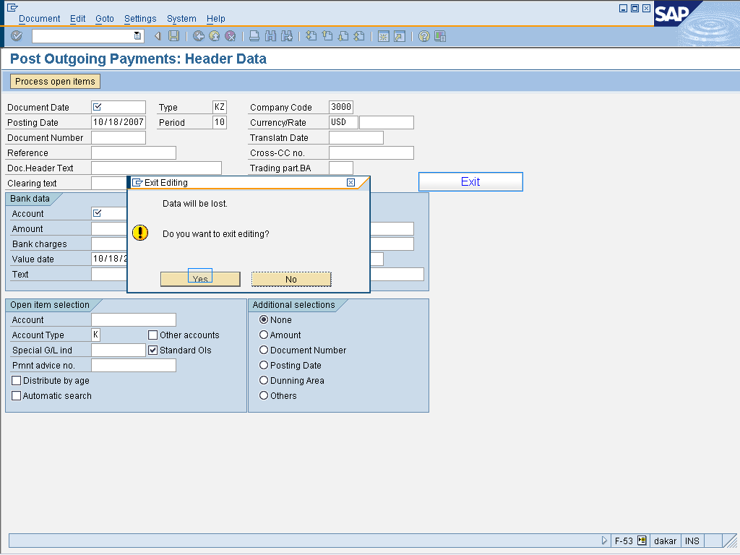

Exit

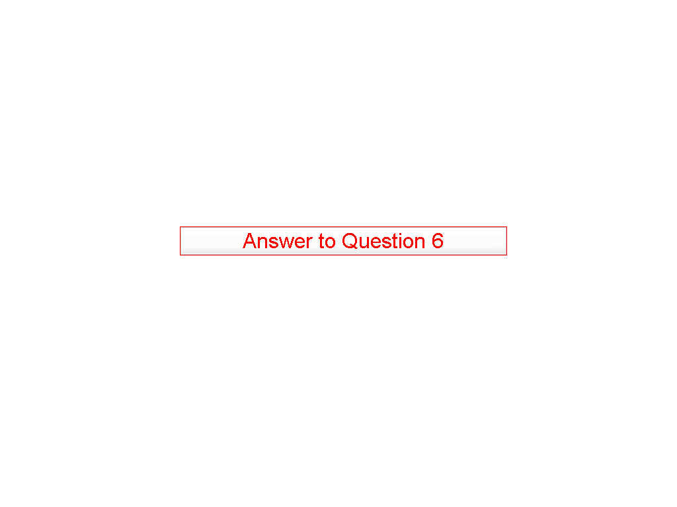

Answer to Question 6

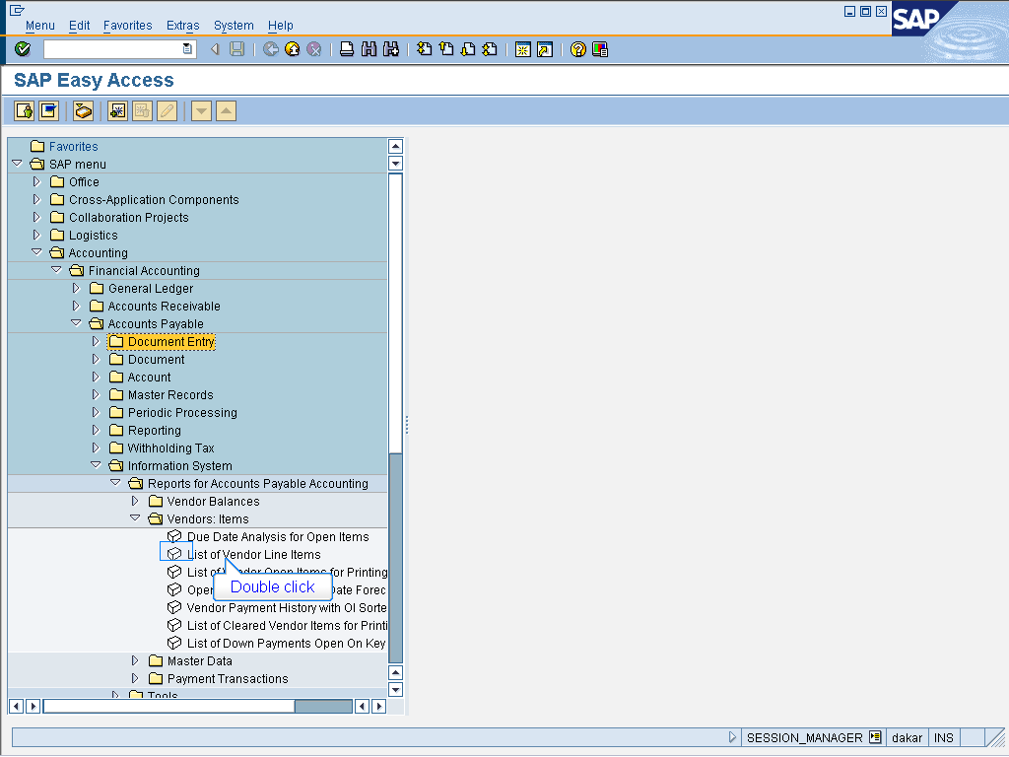

- Accounting > Financial Accounting
> Accounts Payable > Information System
> Reports for Accounts Payable Accounting
> Vendor Balances
Double click List of Vendor Line Items

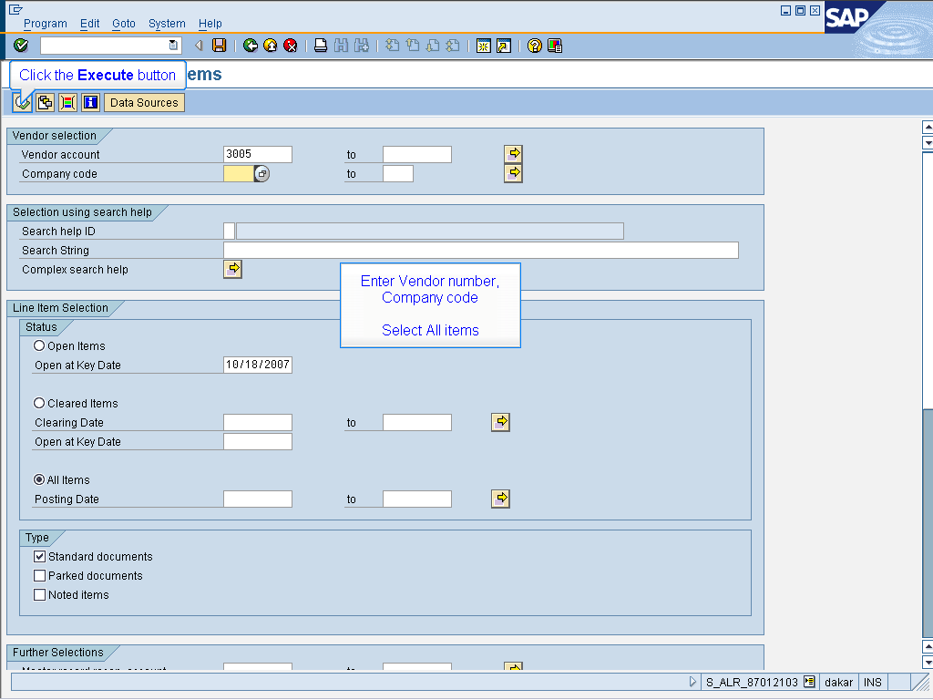

Enter Vendor number,
Company code
Select All items

Click the Execute button

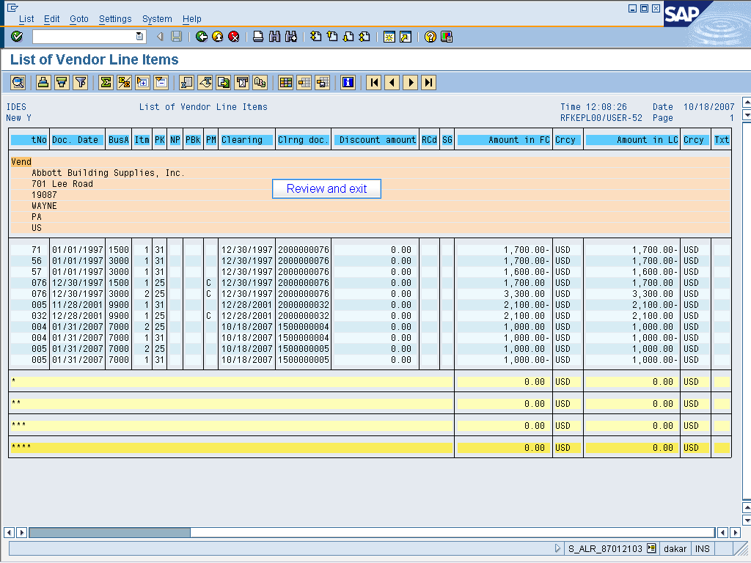

Review and exit

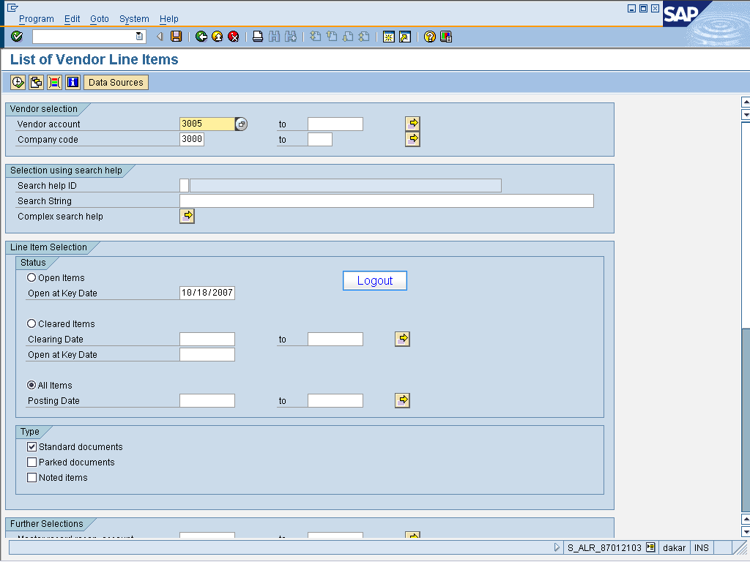

Logout

