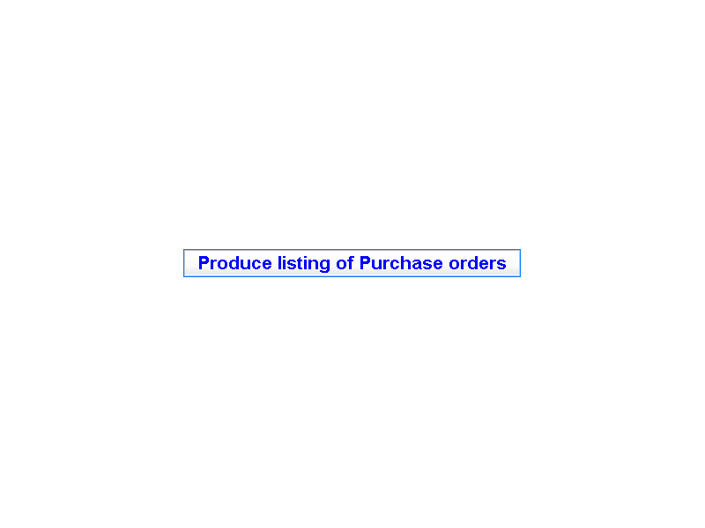

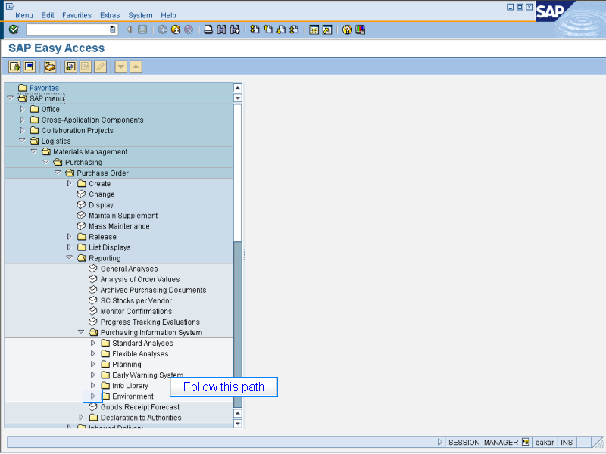

Follow this path
> Logistics > Materials Management
> Purchasing > Purchase Order
> Reporting > Purchasing Information System
> Environment

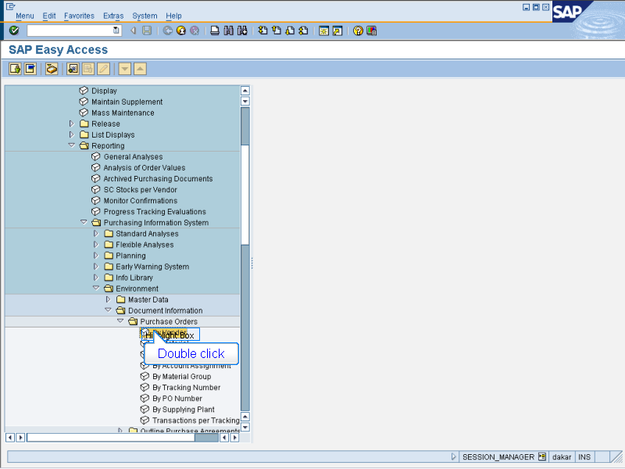

- Document Information > Purchase Orders
Double click By Vendor

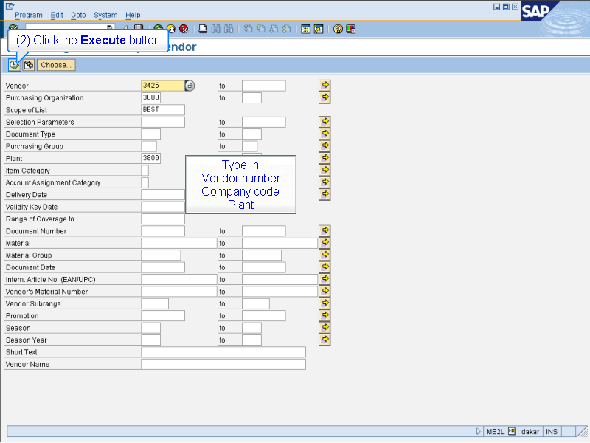

(1) Type in
Vendor number
Company code
Plant

(2) Click the Execute button

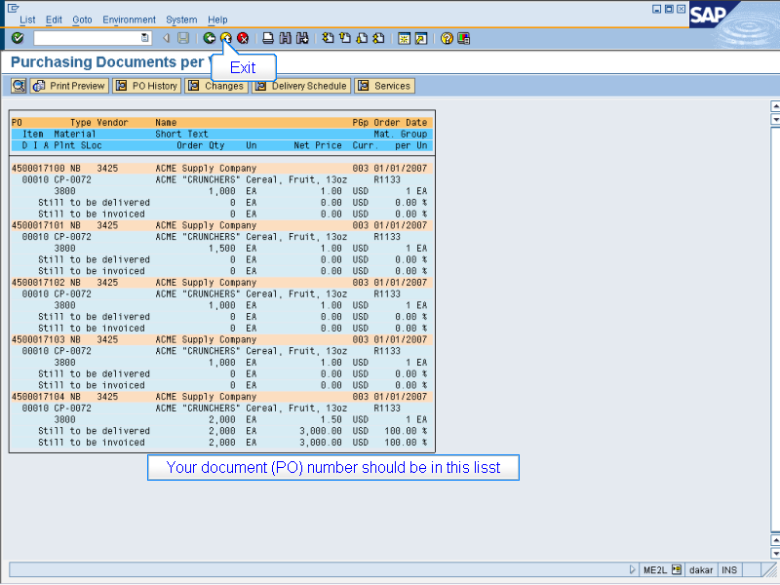

Your document (PO) number should be in this list

Exit when done

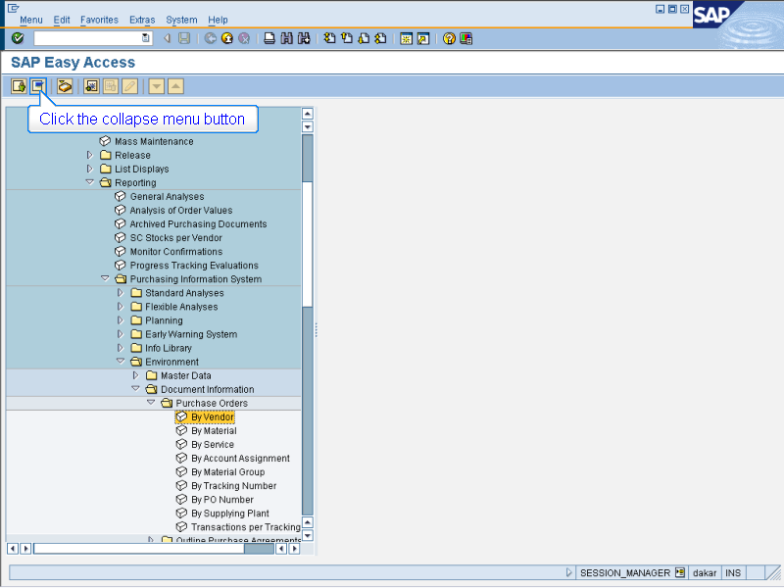

Click the collapse menu button

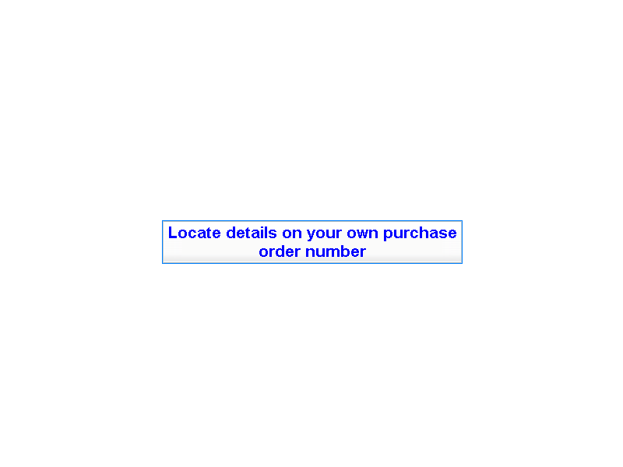

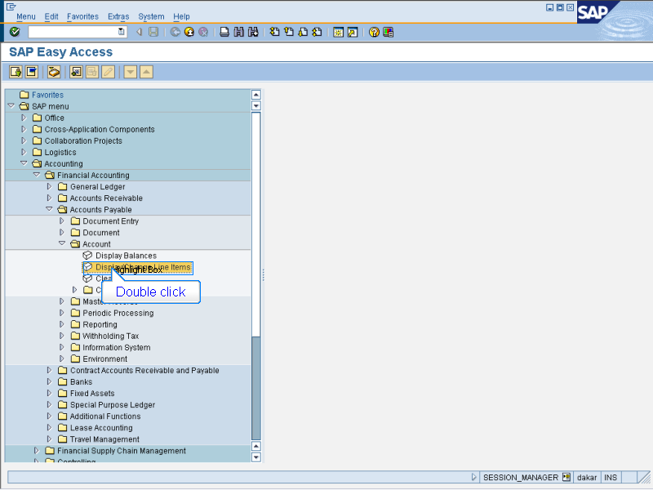

- Accounting > Financial Accounting
> Accounts Payable > Account
Double click Display/Change Line Items

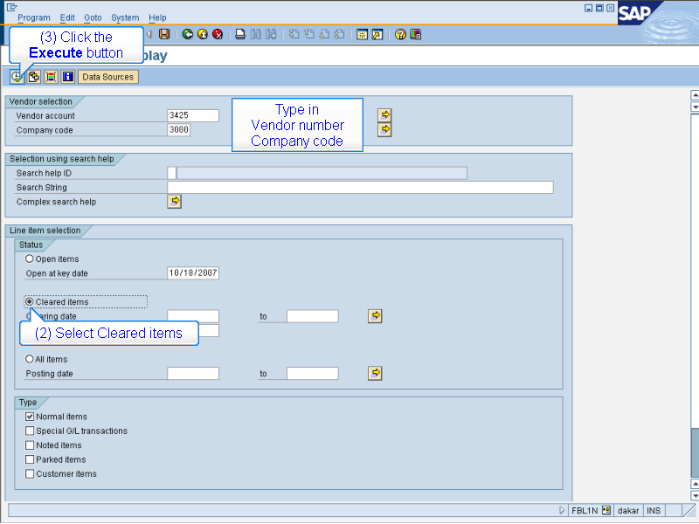

(1) Type in
Vendor number
Company code
(2) Select Cleared items
(3) Click the Execute button

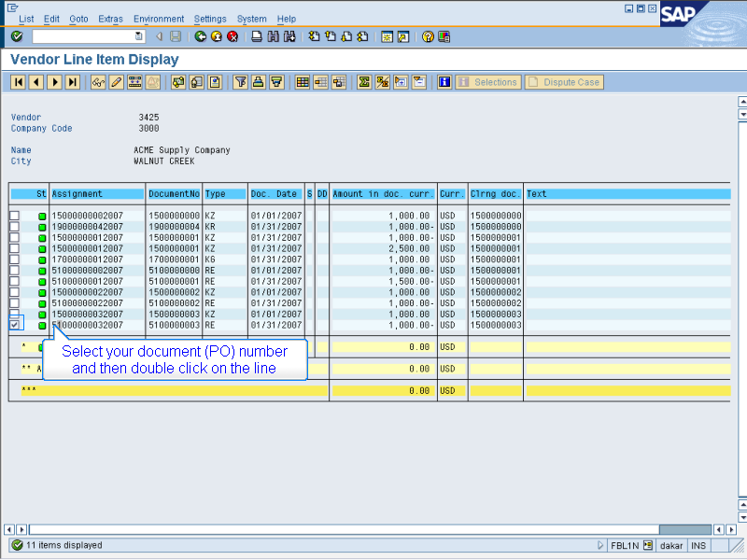

Select your document (PO) number
and then double click on the line

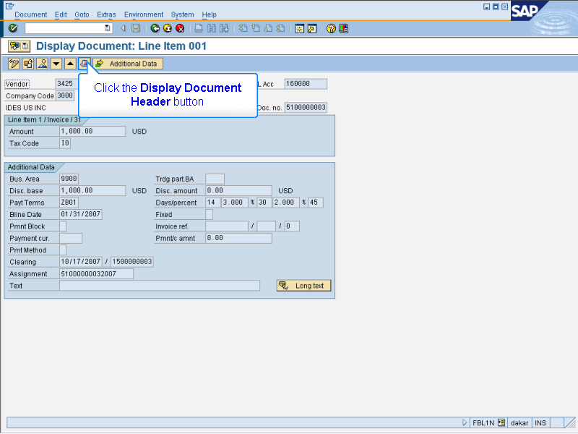

Click the Display Document Header button

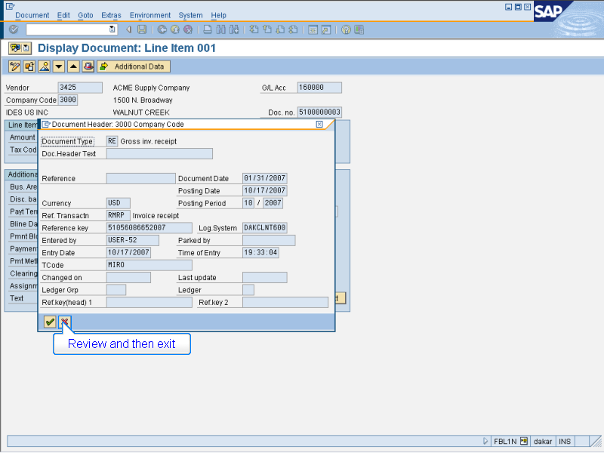

Review and then exit

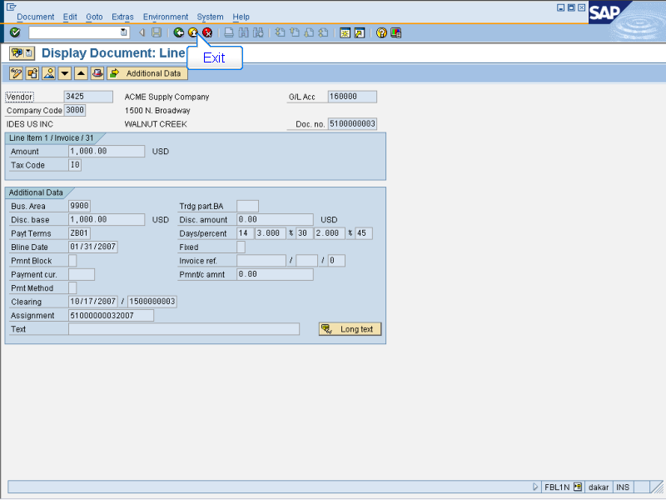

Exit

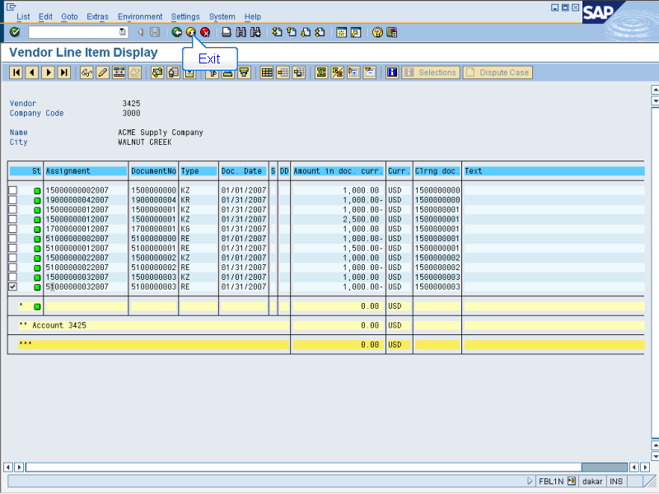

Exit

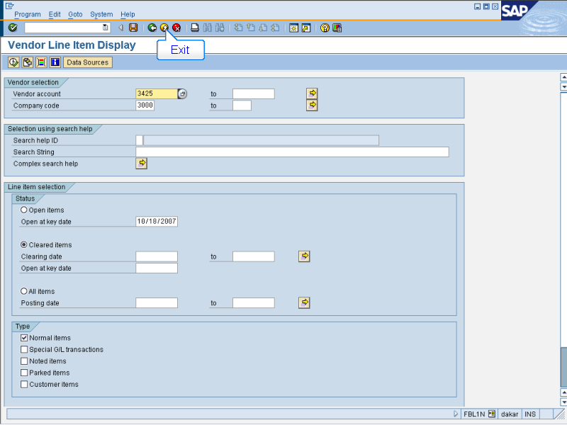

Exit

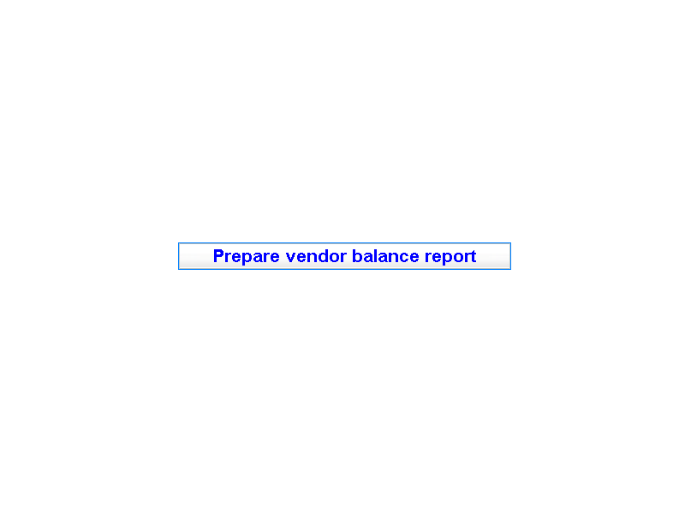

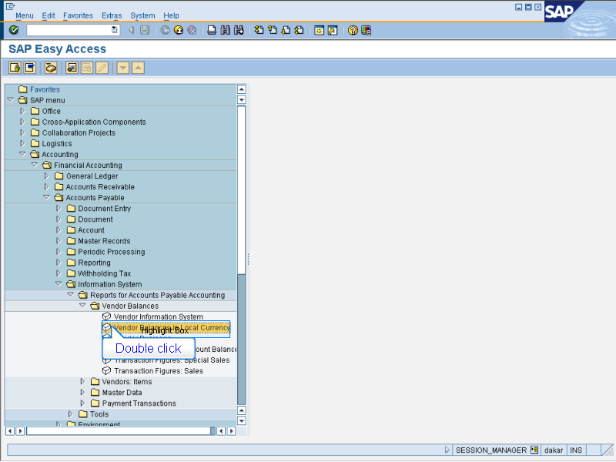

- Accounting > Financial Accounting
> Accounts Payable > Information System
> Reports for Accounts Payable Accounting
> Vendor Balances
Double click Vendor balances in local currency

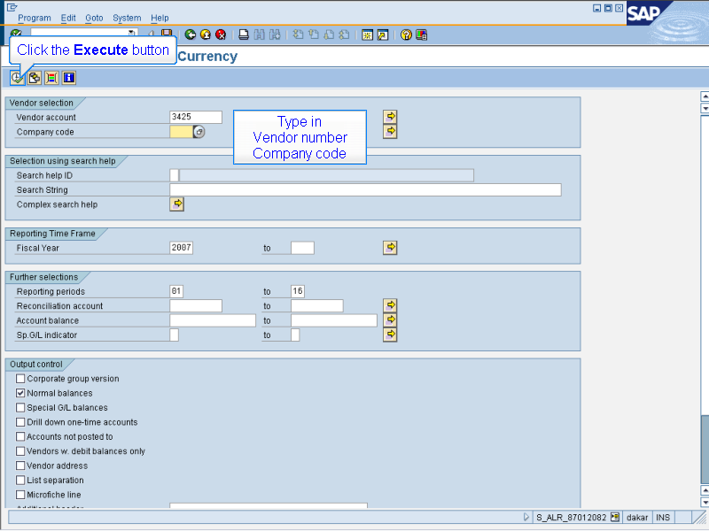

(1) Type in
Vendor number
Company code

(2) Click the Execute button

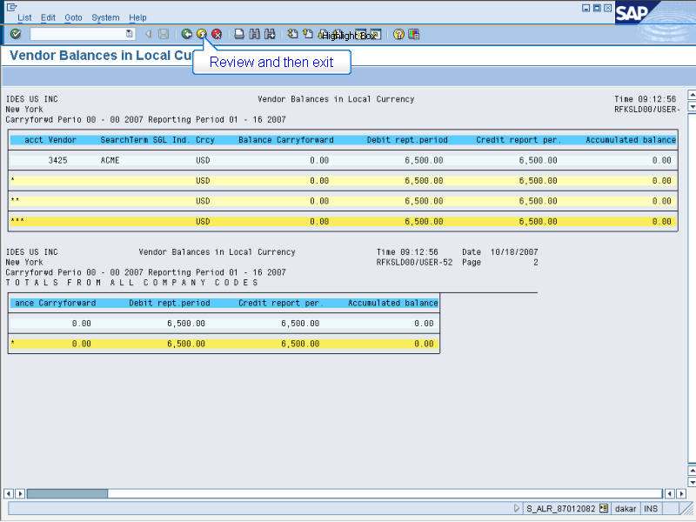

Review and then exit

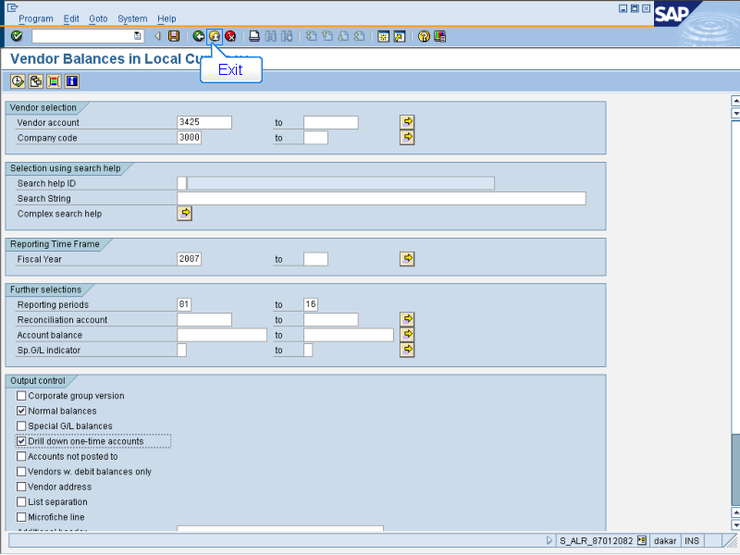

Exit

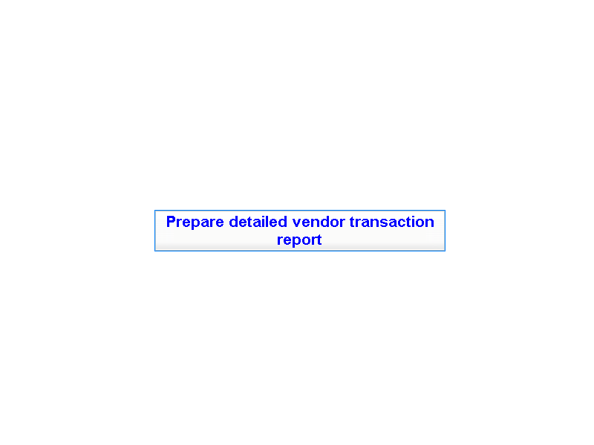

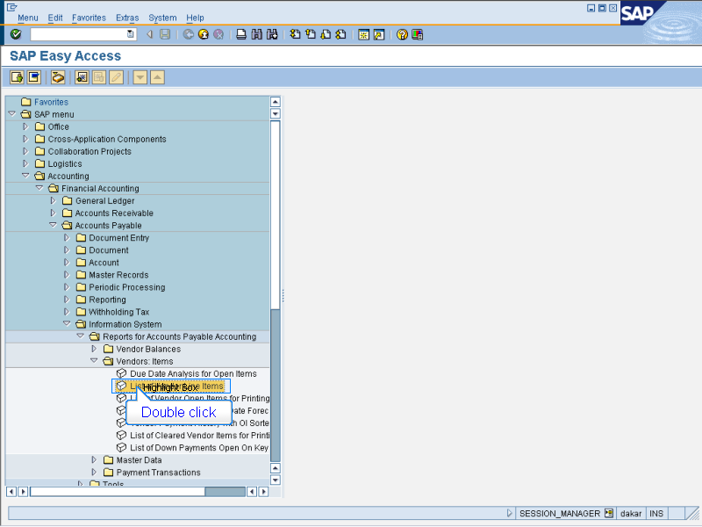

- Accounting > Financial Accounting
> Accounts Payable > Information System
> Reports for Accounts Payable Accounting
> Vendor Balances
Double click List of Vendor Line Items

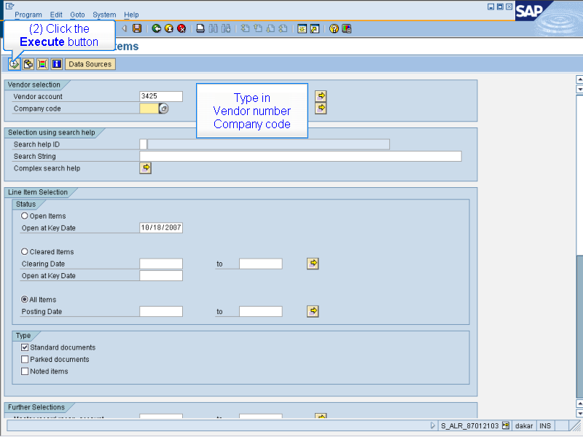

(1) Type in
Vendor number
Company code

(2) Click the Execute button

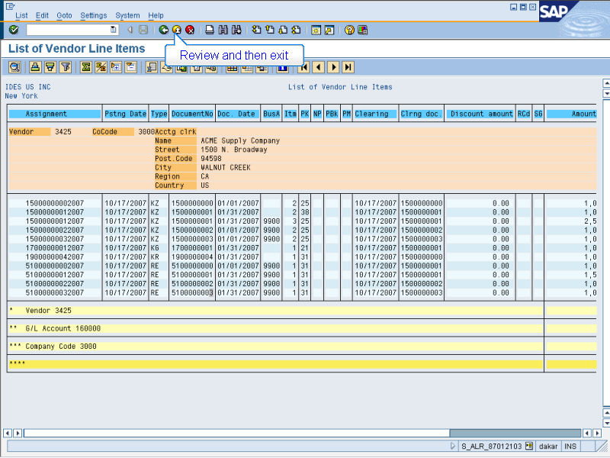

Review and then exit

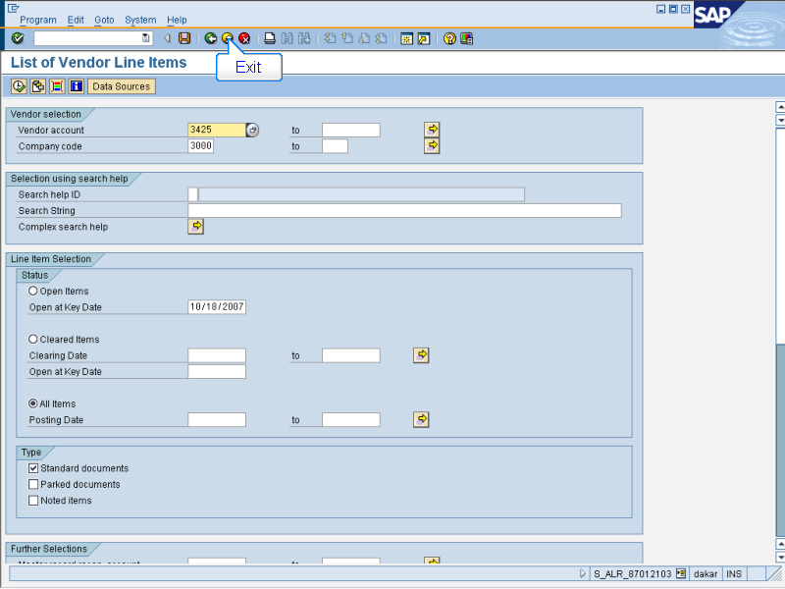

Exit

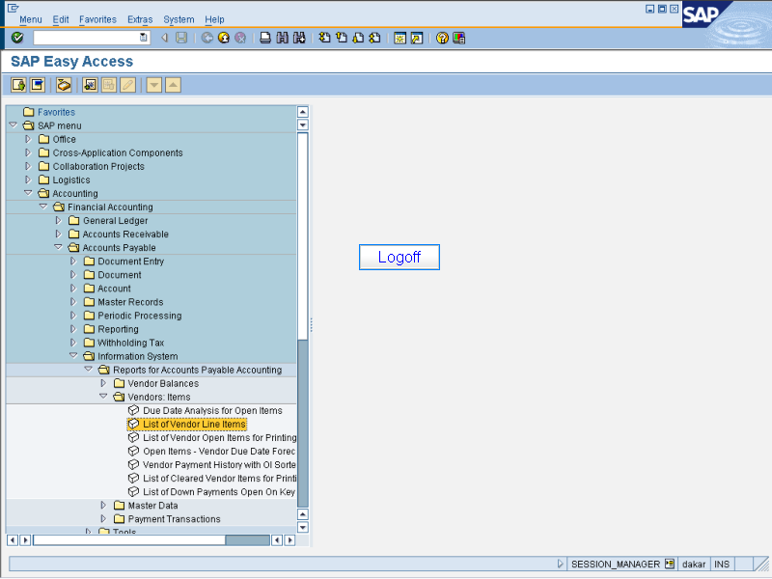

Logoff

