Accounts Payable Payment on Received Items from Module 6

Slide 26
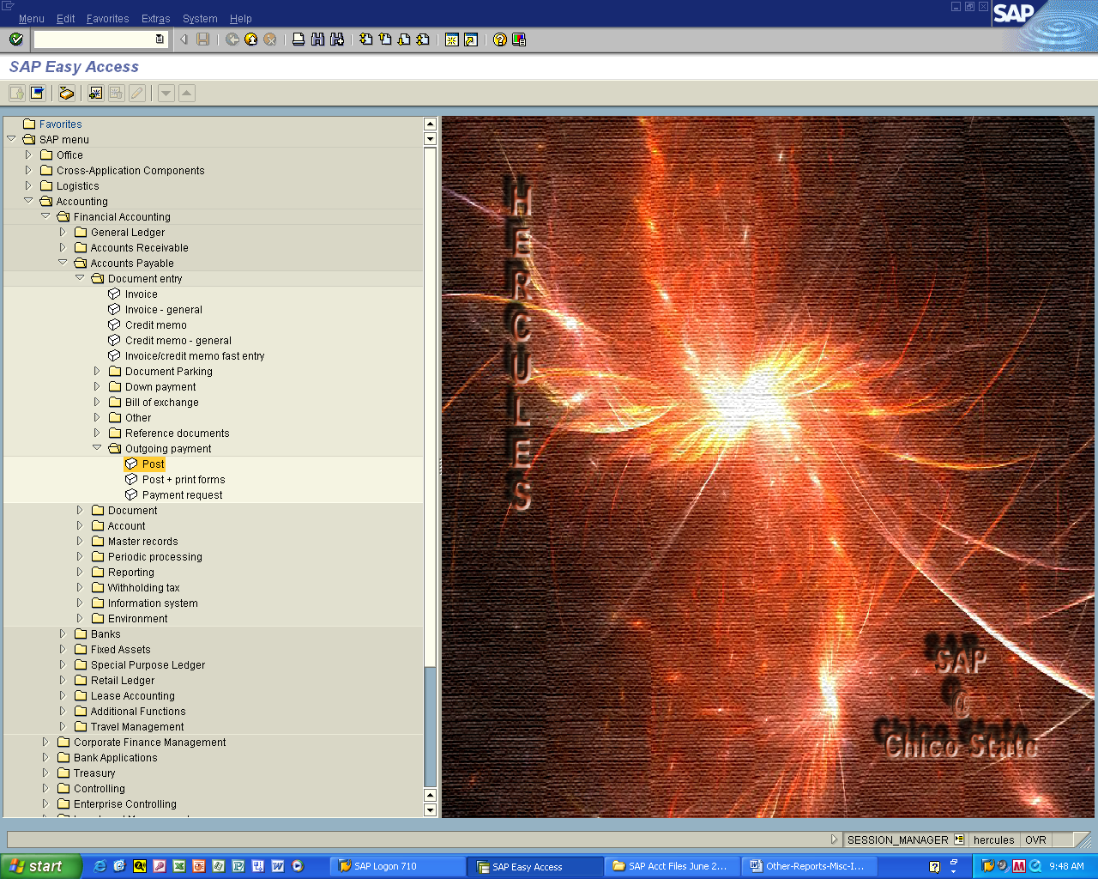

Accounting > Financial Accounting > Accounts Payable > Document Entry
- Outgoing Payment

Double click Post
Slide 27
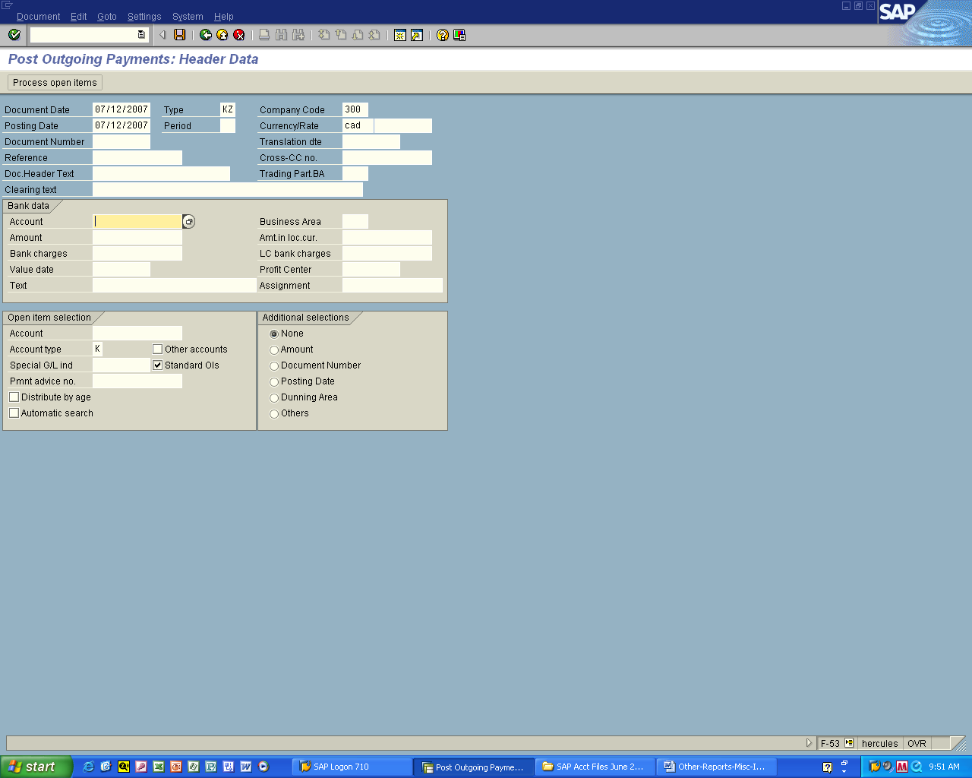

Use today’s date for Document Date and Posting Date
Type in Company code = 3000
Currency Rate = CAD

Search for Account under Bank data

Slide 28
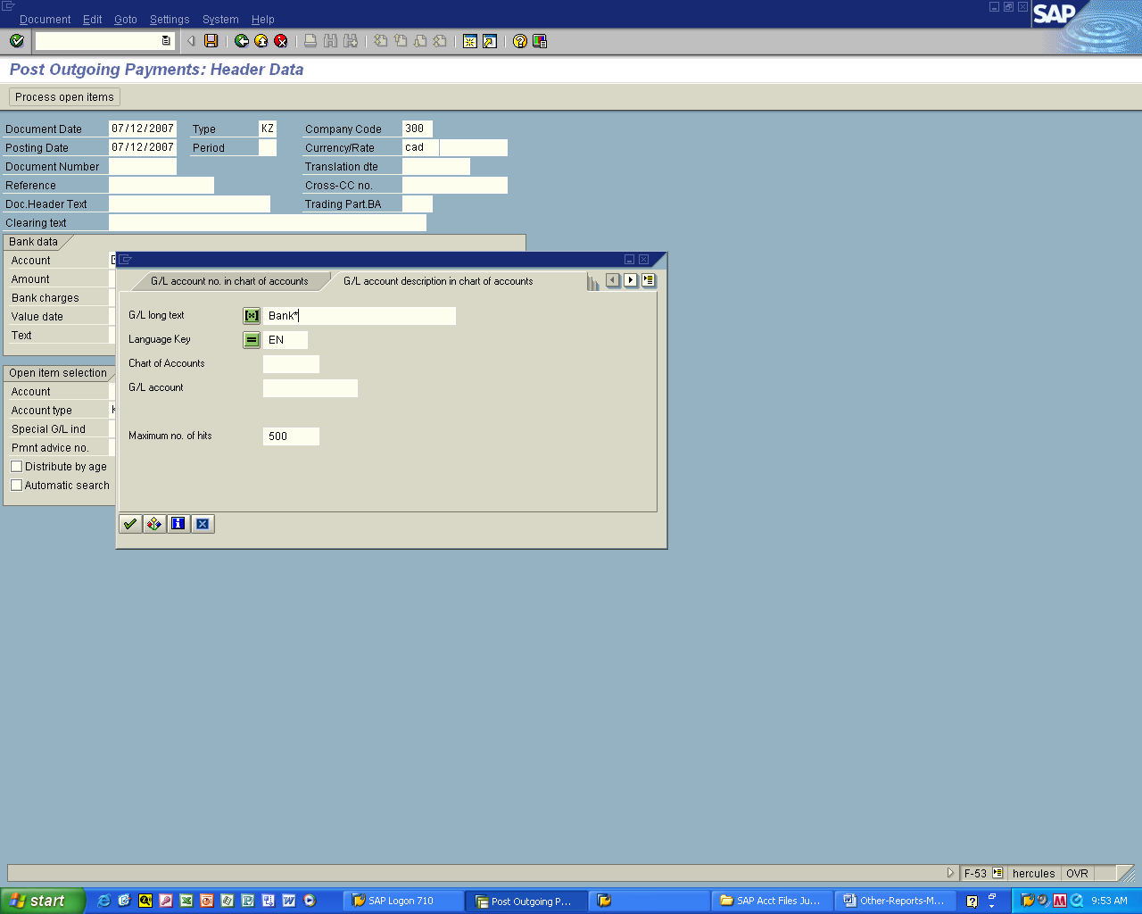

Select the G/L account description in chart of accounts tab

Type in bank*

Click on enter
Slide 29
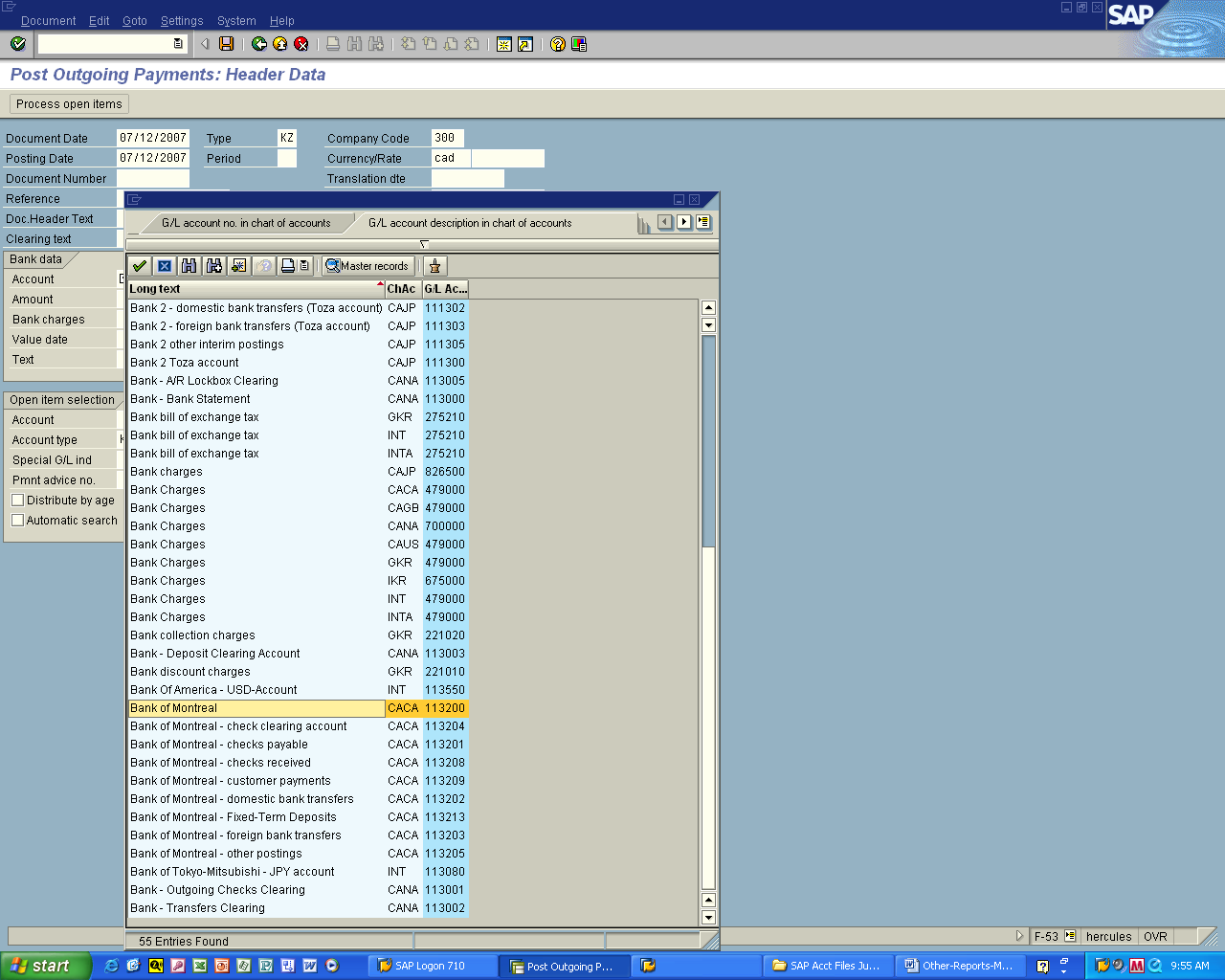

Double click on Bank of Montreal
Slide 30
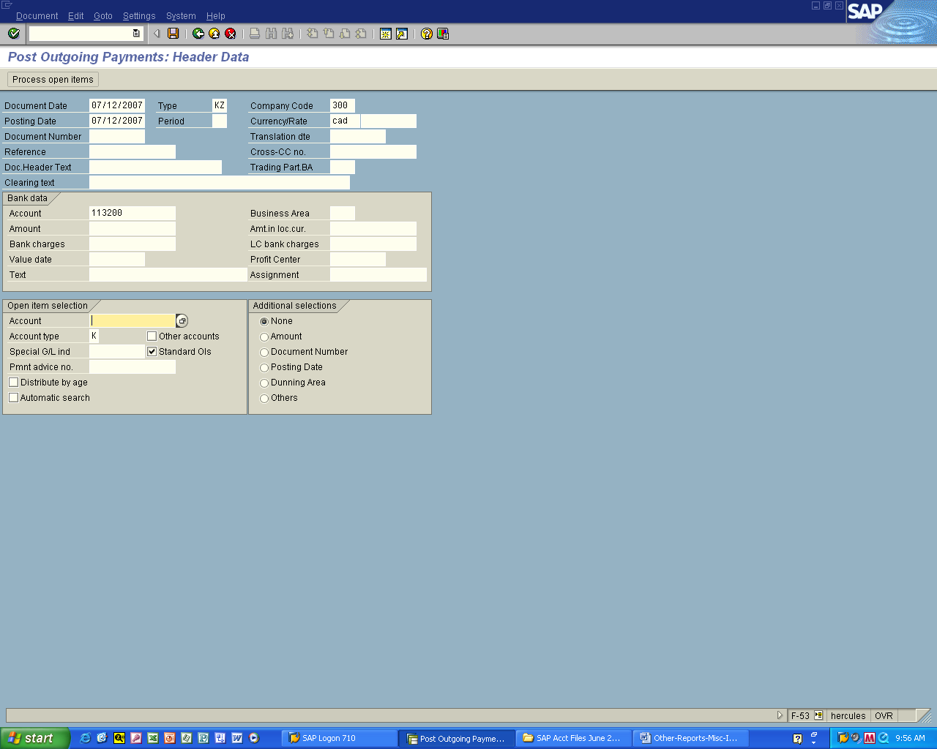

Search for Account under Open item selection
Slide 31
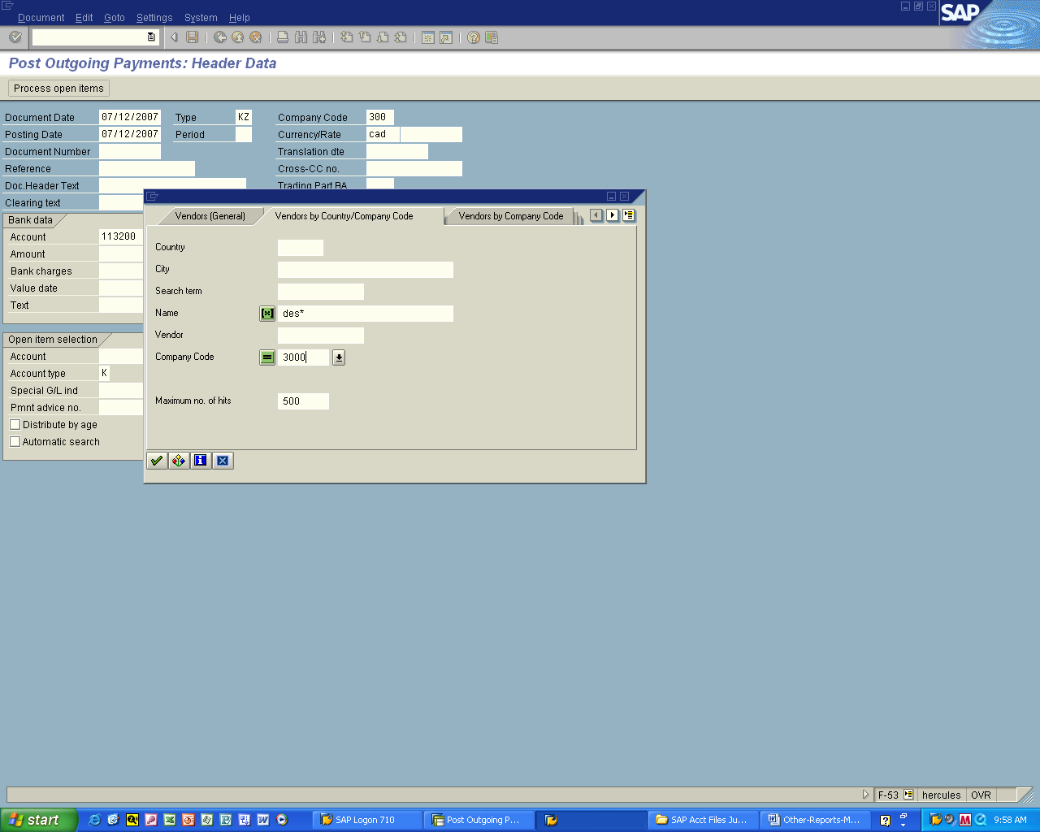

Select Vendors by Country/Company Code tab

Type in name = des*

Type in company code = 3000

Click enter
Slide 32
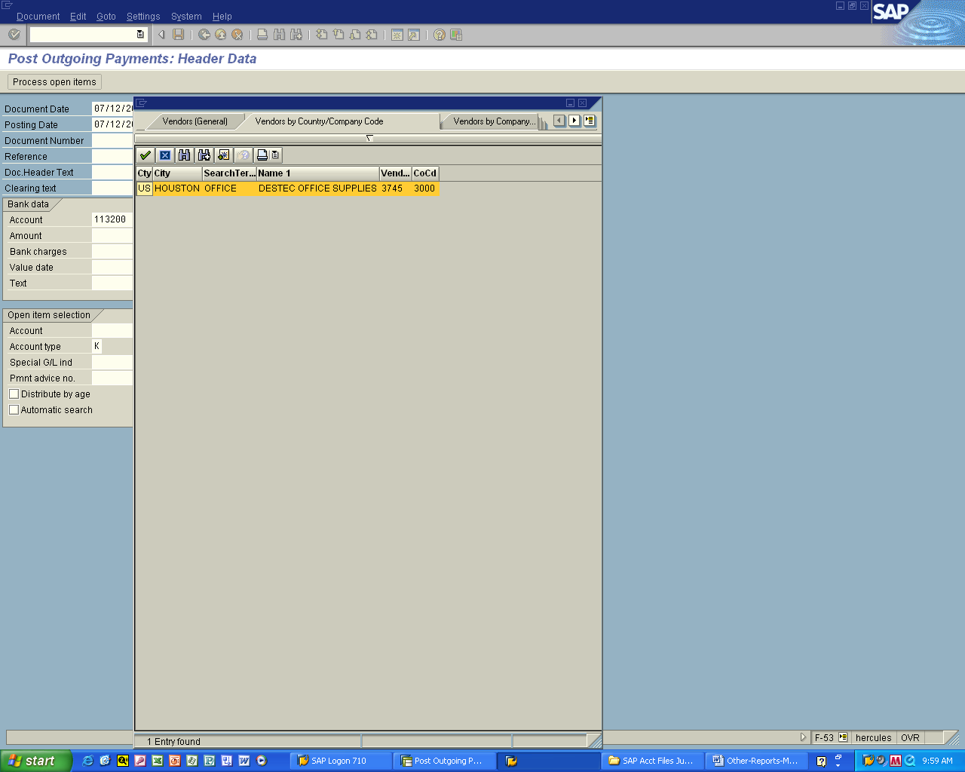

Double click on Destec Office Supplies

Slide 33
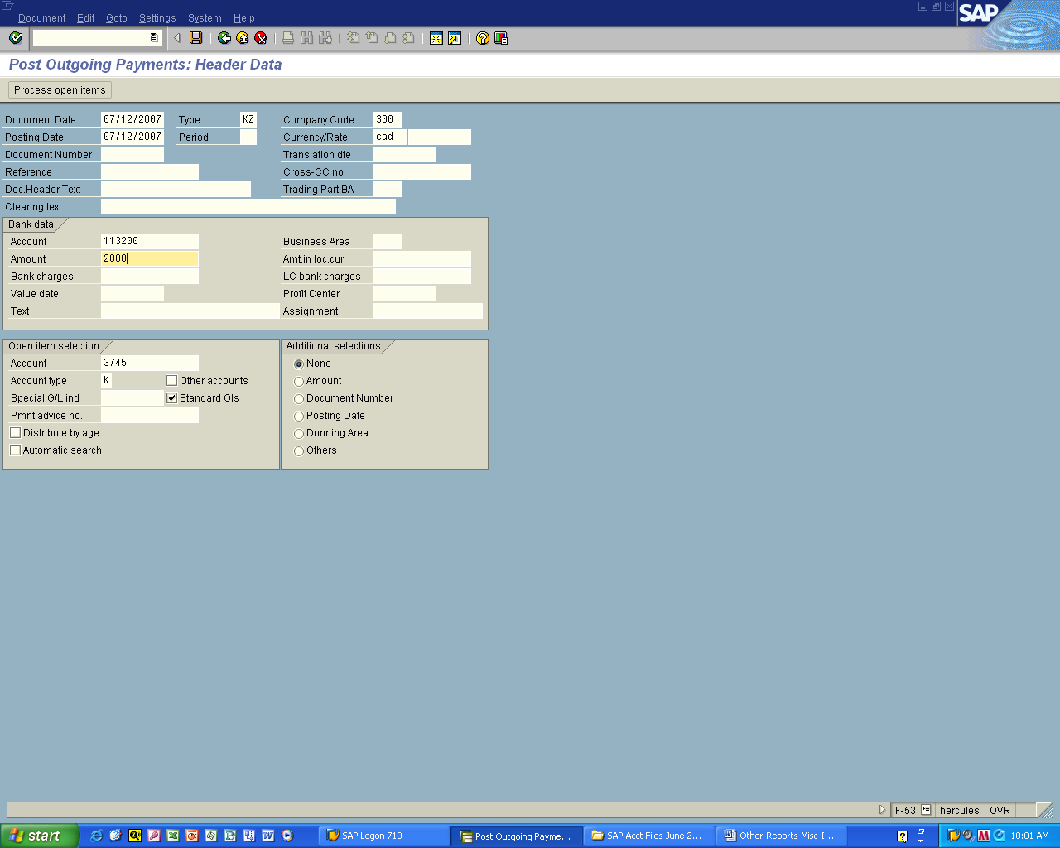

Type in amount = 2000

Click on Process open items

Click on enter to acknowledge messages regarding dates
(if you get any messages)

Slide 34
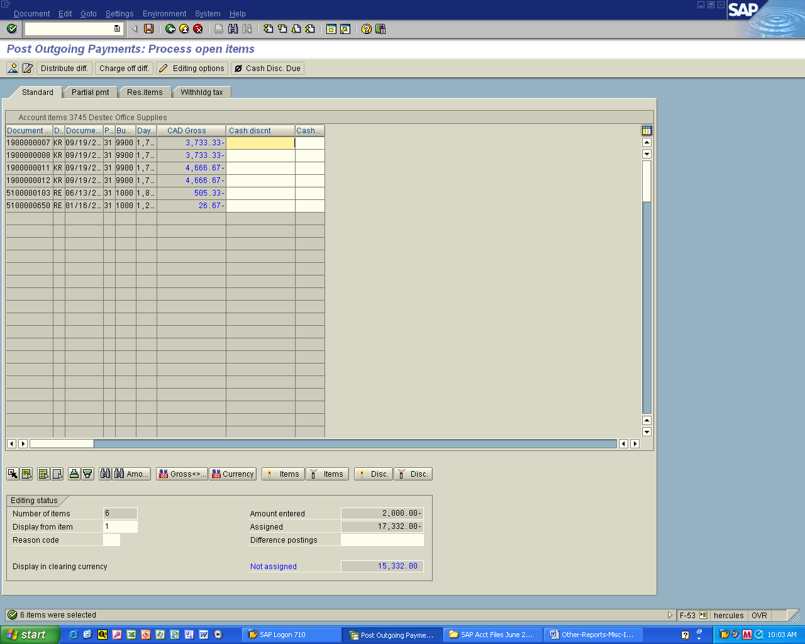

Payments recorded here

