How to process screen captures for Assignment

Slide 23
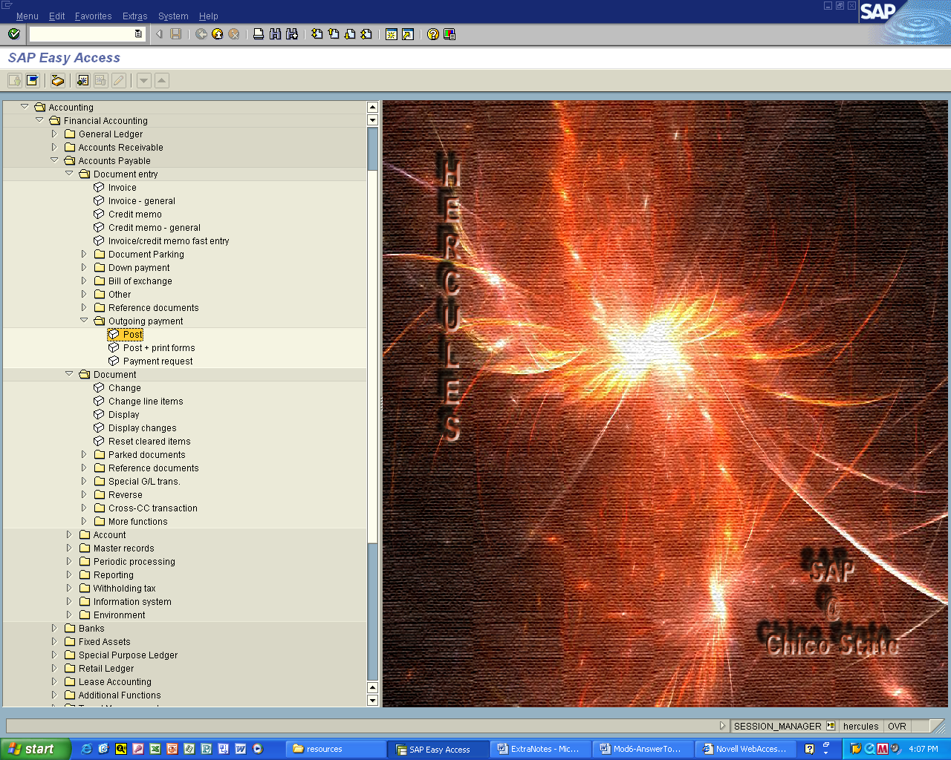

Once you have set up and completed the exercise

Press the Print Screen button on your keyboard

Slide 24


Open up a new Microsoft Word document

Then paste (EDIT, PASTE or CTRL + V)
Slide 25
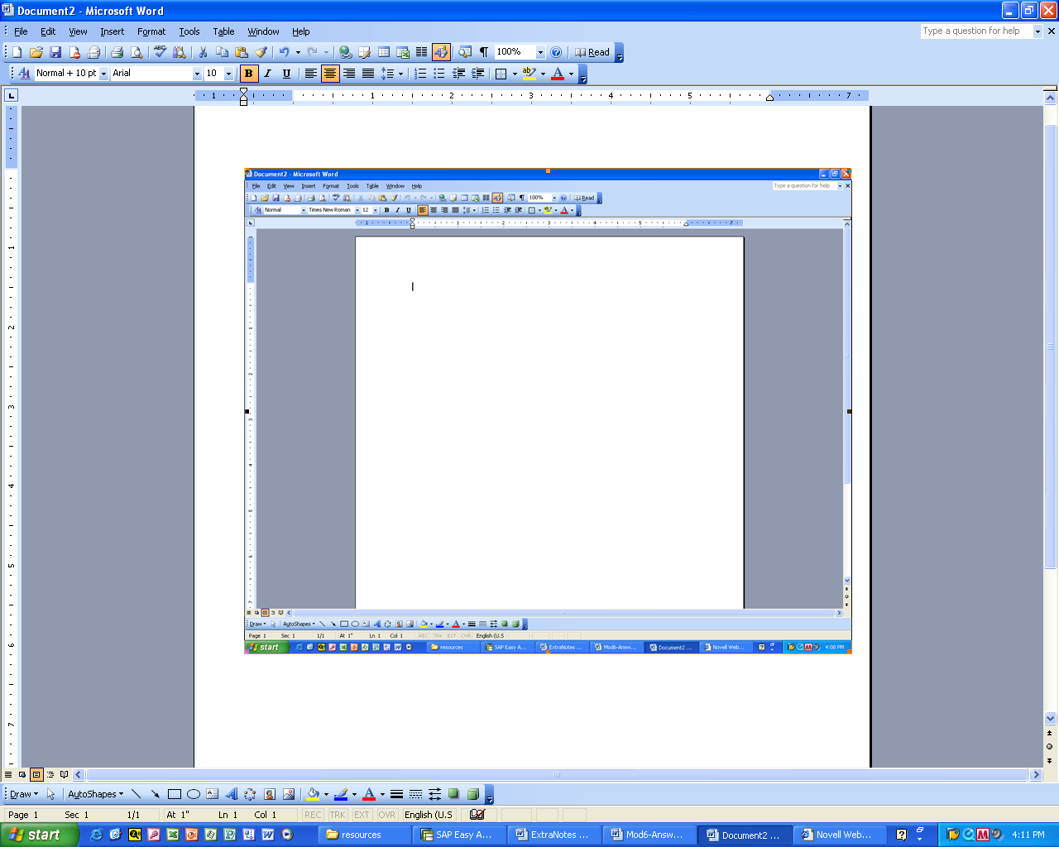

You now have the result pasted in.

Continue to add subsequent screen captures to this document

Save it and then submit to your instructor

