Report on Posting Totals

Slide 7
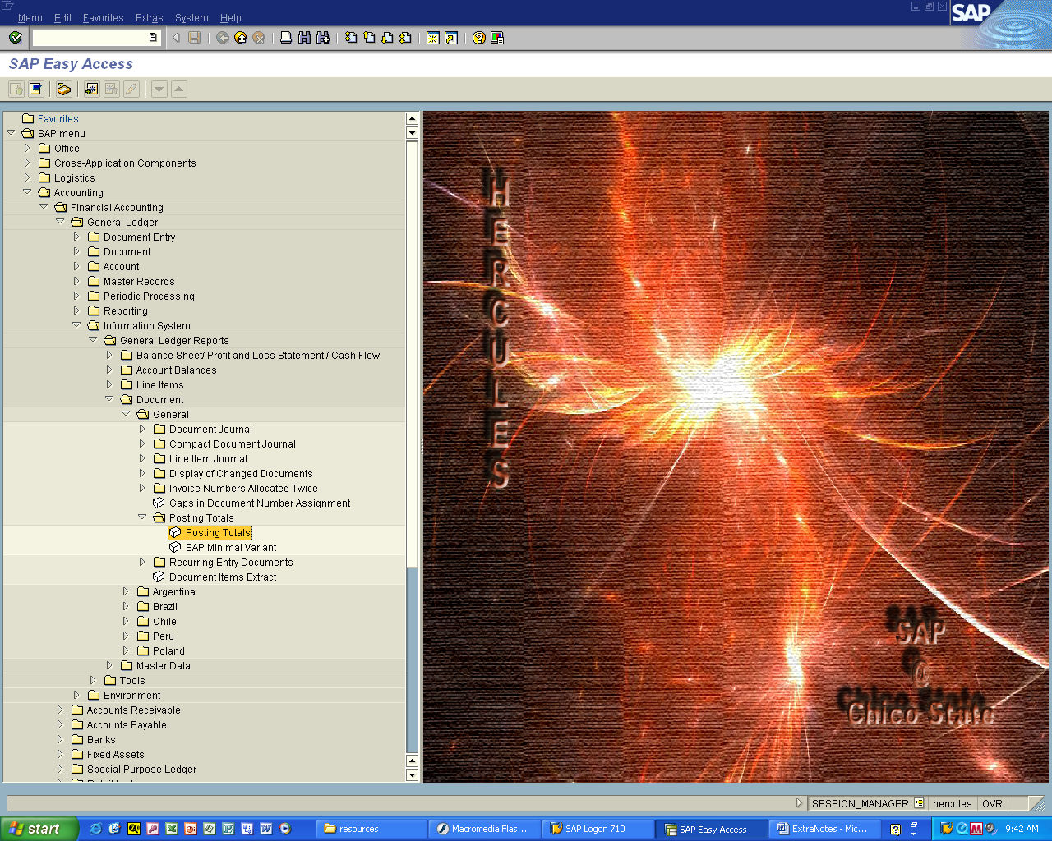

Accounting > Financial Accounting > General Ledger > Information System
- General Ledger Reports > Document > General > Posting Totals

Double click Posting Totals
Slide 8
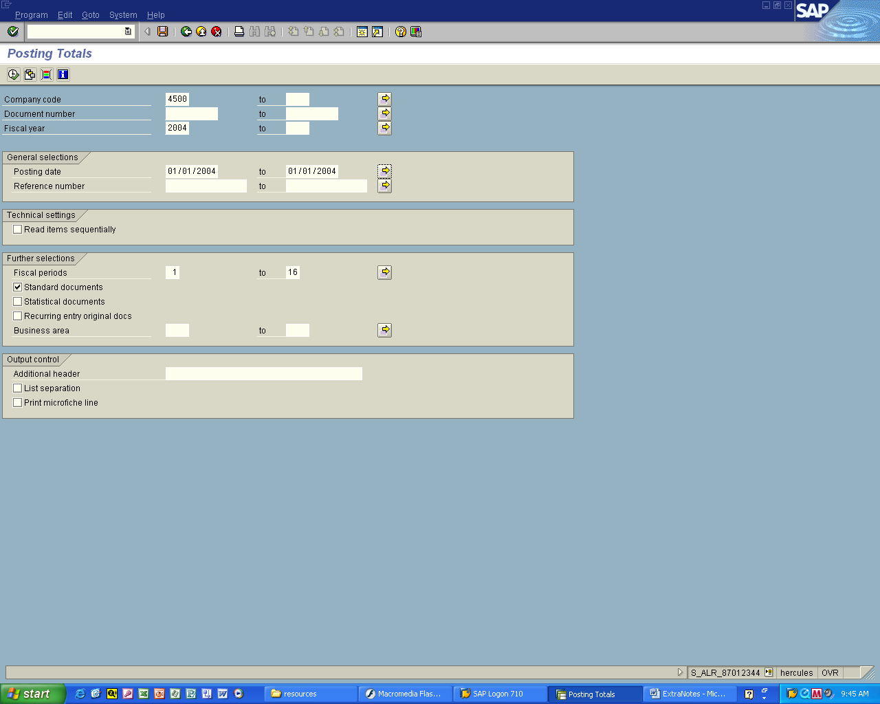

1. Enter company code
Fiscal Year
Posting date(s)

2. Click the Execute Button

Slide 9

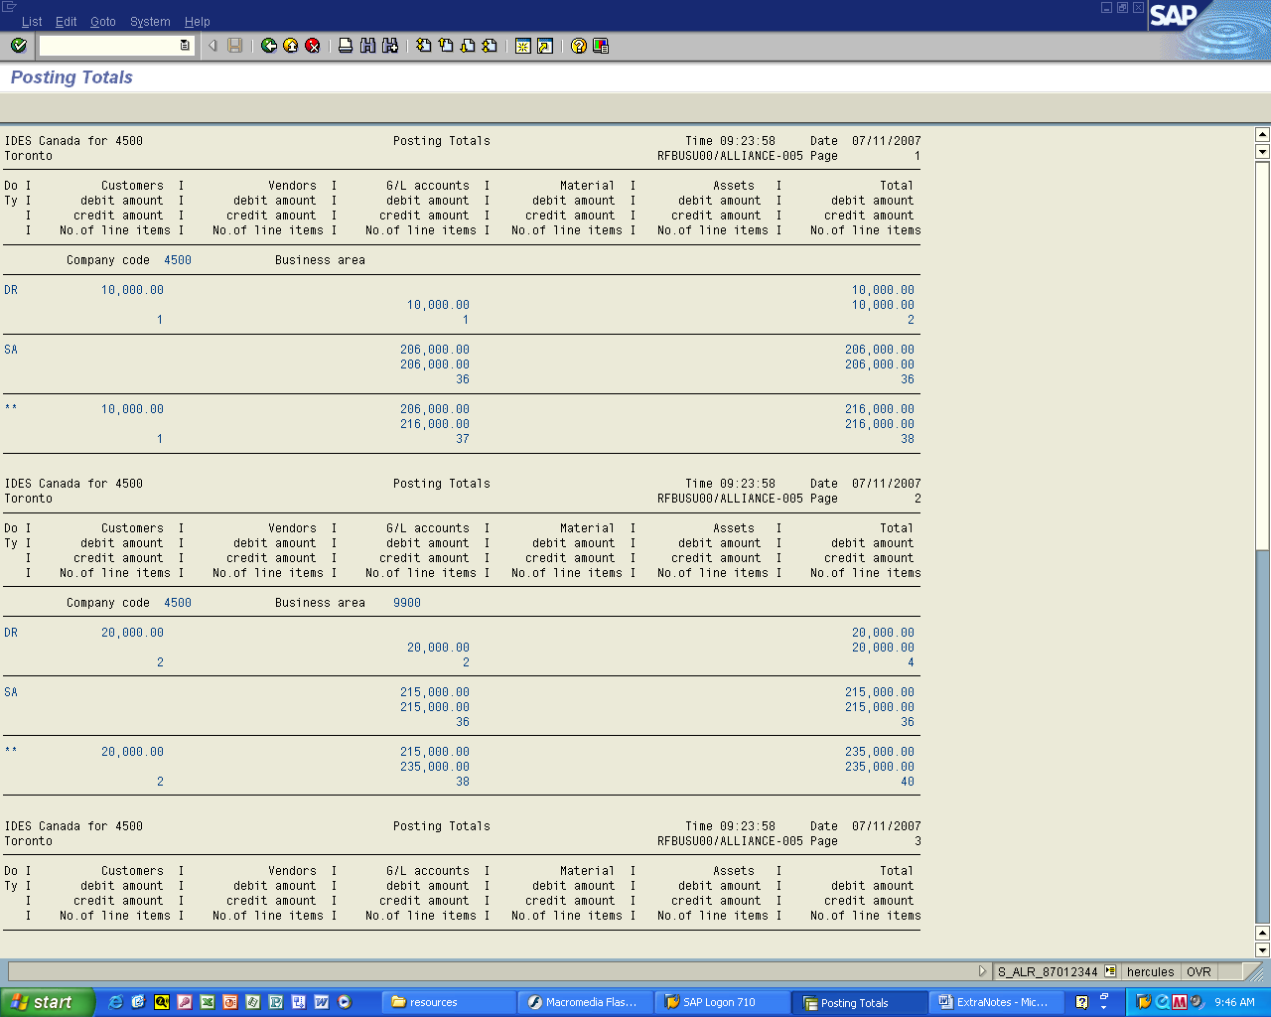

You will see the posting totals listing
By customer, vendors, G/L Accounts, ....
For their User account

