SAP Demonstration1-CreateAccounts
Mod4-Demonstration1-CreateAccounts takes students through the steps necessary to create and add a series of general ledger accounts to company code 3000.

SAP Demonstration2-HowTo
Mod4-Demonstation2-HowTo demonstrates to students how to prepare adjusting and closing entries in SAP. The students will be able to play this demo as often as they would like. It shows points to remember when they practice this on their own.

SAP Demonstration3-Closing
Mod4-Demonstation3-Closing demonstrates to students how to run the closing procedures in SAP. The students will be able to play this demo as often as they would like.
This must always be executed in TEST mode only.

SAP Simulation
Mod4-Simulation enables students to attempt to follow the Demonstration 2-HowTo example on their own. It requires students to match the correct selections to produce the desired end result.

Practice Exercises in SAP
Use January 1, 2007 (01/01/2007) for all dates in all entries unless indicated otherwise.

1. The accounts needed to allow for posting of adjusting entries in the SAP system are listed here. Each of these accounts must be created in SAP.
Note: for each account in the list insert your student number given to you by your instructor for the -52 number (ie: 10000-52 becomes 10000-01 for Student 01)

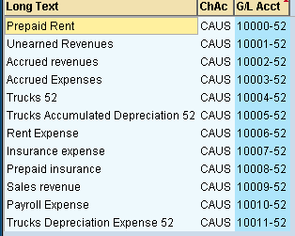

2. Produce the same adjusting entry as in the SAP Demonstration file.
Screen Capture and paste into Word document the Simulation screen prior to posting this entry

3. The company purchases a truck on January 1, 2007, for $25,000 by taking out an Other Loan, long term. The truck will last for 10 years with a $1,000 salvage value. Journalize the purchase and the depreciation for January 2007.
Screen Capture and paste into Word document the Simulation screen prior to posting this entry
4. On January 1, 2007, a cash deposit in the amount of $15,000 was received for work on a project (total revenue, $15,000) that will start January 1, 2007, and last for 10 months. Record the deposit and the first month’s income in from the project.
Screen Capture and paste into Word document the Simulation screen prior to posting this entry
5. The company’s payroll is calculated and paid one week after the end of each month. At the end of January 2007, 4 days of payroll have not been paid. Make the month end entry required (10 employees paid $200 each per day).
Screen Capture and paste into Word document the Simulation screen prior to posting this entry
6. Review the general ledger listing for 2007 to verify that the above entries have been made.
Screen Capture and paste into Word document the General ledger listing report showing these entries
7. Prepare a Balance Sheet and P&L (Profit and Loss) statement.
Screen and paste into Word document these two statements after producing them in SAP

