SAP Demonstration1-HowTo
Mod6-Demo1-HowTo demonstrates to students how to process inventory purchases in SAP. The students will be able to play this demo as often as they would like. It shows the steps to follow when they are entering transactions for inventory purchases. They are shown how to create a purchase order, receive the goods into inventory, validate the invoice from the vendor and then make a payment to the vendor for the goods purchased.

SAP Demonstration2-Reports
Mod6-Demo2-Reports demonstrates to students how to display inventory reports in SAP. The students will be able to play this demo as often as they would like. It provides examples of purchase order listing, accounts payable vendor report and a detailed listing of vendor transactions.

SAP Simulation
Mod6-Simulation enables students to follow the demonstration examples on their own. It requires students to match the correct selections to produce the desired end result.

Practice Exercises in SAP
Use January 1, 2007 (01/01/2007) for all dates in all entries
Except for the posting dates where you need to use the current date for the posting date.
1. Produce the same entries as shown in the SAP Module 6 Demo 1 file.
Capture the screens and paste into Word document the purchase order, receipt of goods and payment of the vendor invoice
2. Create the following purchase order.
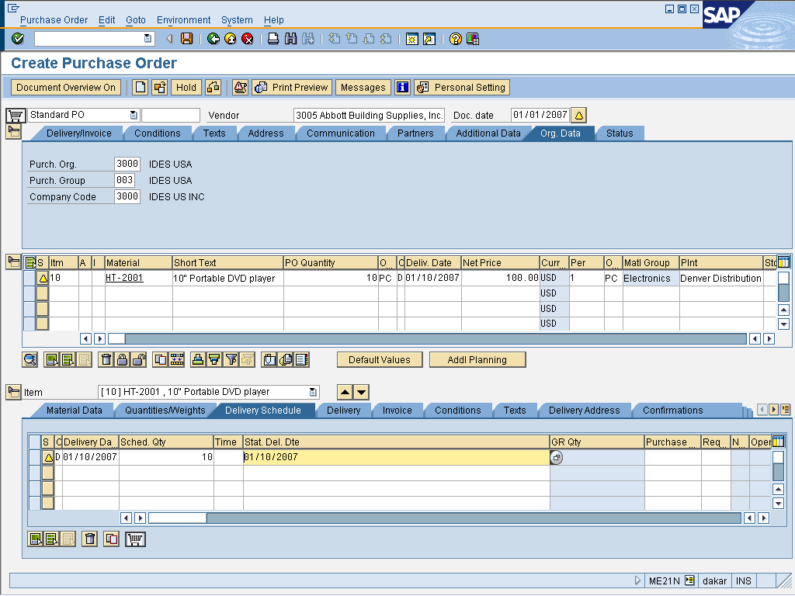
Capture the screen and paste into Word document the above purchase order before posting
3. Display the purchase order details.
Capture the screen and paste into Word document the report of the Purchase Order details
4. Receive the goods from the above order.
Capture the screen and paste into Word document the receipt of goods before posting
5. Validate the invoice and then pay it.
Capture and paste into Word document the invoice validation screen
6. Create a report that shows the vendor detailed listing.
Capture and paste into Word document the screen showing the Vendor detailed listing report

