Topic 26
Graphical Displays of Association

The final simple graphical display will be the scatterplot.

Let’s see how far we’ve come:

One dimensional
Categorical
Bar Graph
Quantitative
Few data points
Dotplot
Stemplot
Lots of data
Histogram
Two dimensional
One dimensional with categorical binary
Categorical
Bar Graph with groups
Quantitative
Few data points
Side-by-side stemplot
Lots of data
Population histogram
Categorical – Categorical
2-way table
Proportional bar graph
Bar graph with groups (limited number of groups)
Categorical – Quantitative
Stemplot
Stacked histograms
Quantitative –Quantitative
Scatterplot

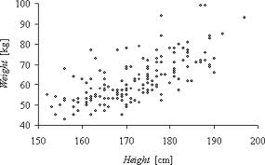
Scatterplot
- Two Quantitative (Continuous) Variables
- Explanatory Variable is on Horizontal Axis
- Response Variable is on Vertical Axis

Variables are Associated if one can be predicted (to some degree) from the other.

Direction of Association
- Positive – if they both move in the same direction (both up or both down)
- Negative – if they move in opposite directions (one up, the other down)

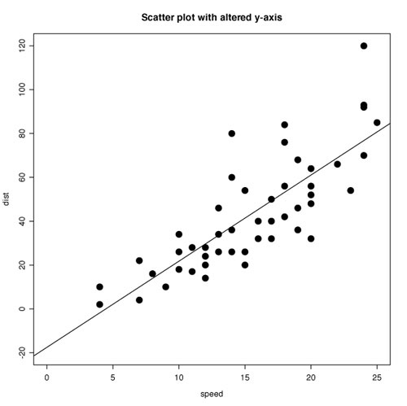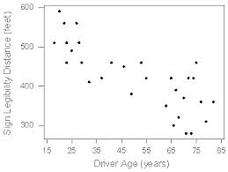

Strength of Association - How accurately one value (e.g. response) can be predicted from the other value (e.g. explanatory.

Strong
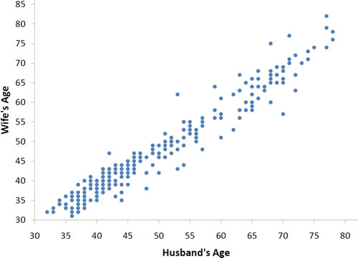

Weak
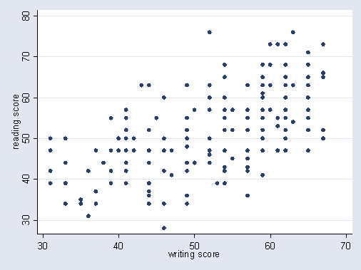

Sometimes Not at All
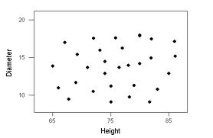

Form of Association
- Linear
- Curvilinear

